Advice for staff involved with administering the Coronavirus vaccine to blind and partially sighted people

We have put together some helpful suggestions about how to assist people with sight loss who are receiving the Covid-19 vaccine. This does not replace or override general guidance or policies, but it is intended to support those who come into contact with people with sight loss.

Sight loss is more common than you think
Some of those who are blind and partially sighted may already be known by various agencies. For example, they may be familiar to their GP practice. There are also people in the community whose sight loss is not recorded. If you are unsure, just ask the person you are supporting if they have any challenges due to poor eyesight.

Key recommendations
- Ensure information sent to a visually impaired person is available in their preferred accessible format for example; large print, braille or digital
- Ensure that anyone receiving a letter or other written information is made aware of the formats that are available to them and how they can request these
- Provide clear information on the location of the vaccine centre for example, public transport options
- Make sure the venue has clear, large print signage and good levels of lighting
- Ensure there are sufficient members of staff trained to provide support to people with sight loss and that these can be clearly identifiable by patients and other support staff

Providing information in the correct format
Sight loss is a spectrum and people use a variety formats and adjustments to read documents. This includes formats like braille, large print and audio but also specialist equipment like magnifiers and scanners and digital solutions like screen reader software.

When you are providing information in print follow the Minimum standards for clear and large print from the UK Association for Accessible Formats UKAAF. Ask the vision impaired person what format they would like the information provided in; large print, braille, audio, email. The following transcription services can help and are still operating during the pandemic:
Ecom a2i
Other transcription companies are available and many of these are listed on the UKAAF website.

Making people aware of how to request accessible formats
A simple and effective way to make more people aware of the available formats is to add a large print instruction at the top of every written document or letter with information on how to access an alternative format. We suggest point 14 font as a minimum but up to 18, if possible.

Here are some example letters produced by Welsh Government and UK Government containing this adjustment. Recipients should be able to request their preferred format by email and telephone as a significant number of blind and partially sighted people are digitally excluded.

Information about the location of the vaccine centre
The following information will help someone with sight loss when planning their visit to the centre:
- Public transport options closest to the centre (appointments after 9.30am are likely to be preferred)
- Information about the centre’s location and accessible entrance points (can someone be met outside the venue by a staff member?)
- What to expect when arriving at the centre
- Staff should be aware that many visitors will have conditions or disabilities that mean they may need further support and that all businesses and services have a duty to make reasonable adjustments for people with disabilities.
- Brief staff on the different types of assistance dogs to expect and different mobility canes
- Any issues relating to access for someone accompanied by their guide dogs should be discussed with the guide dog owner and reasonable adjustment requirements should be followed.

Providing assistance at the vaccine centre

Talking to a blind or partially sighted person
- Gain the person’s attention with a verbal greeting
- Introduce yourself and what you do
- Always talk to the person directly, rather than their sighted companion
- Use verbal responses, avoid nods and head shakes
- Verbalise your actions
- Inform people when you are walking away from them or leaving the room
- Remember if someone is blind, it doesn’t always mean they have no sight at all
- In a group conversation, always make it clear who you are and who you are speaking to
- Provide any printed information in an alternative/accessible way – digital, audio, large print or braille
- Ask the person what support they require, if someone requires sighted guiding follow the advice in the following section

Providing sighted guiding assistance
Guidance from Public Health Wales allows for support from family or friends in the same household, or from their support bubble. If that’s not possible, it allows support by volunteers or staff from organisations, such as hospitals or similar settings. This includes sighted guiding.

Sighted guiding provides support for someone whose sight is not sufficient to safely negotiate from another person, an unfamiliar environment. Ordinarily it involves the person being guided keeping light contact with a guider’s elbow, standing alongside and slightly behind to the left or right, depending on personal preference. While moving, the guider will also talk to the person being guided to provide additional information about any immediate hazards.

Verbal guiding
- When verbally guiding a person, ask them if they would like you to walk ahead of them, behind or on their left or right (2 metres distance). Their preference may allow them to use any remaining vision.
- Provide clear instructions when describing a route or when you would like the person to change direction e.g. Left and Right
- You may wish to use the ‘clock face technique’ when describing the environment in front of the person, for example, ‘directly in front of you at 12 o’clock is the main entrance, to your right at 3 o’clock is a table. On your left at 9 o’clock is the toilet door’.
- Let the person know before you carry out any procedure that involves physical contact, for example, ‘I’m going to touch your left arm’ or ‘I need you to roll up your left sleeve’, ‘Can I help you with that?’.
- It is important to make someone with sight loss aware of the environment they are in when. Particularly when discussing personal information or administering any medical procedure, particularly in an open area where other people are present.
- When walking always let the person know about differences in the floor surface, such as steps, and any changes in surface such as moving from tiles to a carpeted area.
- Inform the person of any obstacles near them that could be trip hazards or that they could accidentally bump into, for example, furniture.
- Finally, consider asking how the experience was for them or if there is anything that could have been done differently. If there is, this could not only benefit you but also the next person with sight loss for whom you provide assistance.

The organisation proving the support should:
- have already followed Welsh Government guidance for working safely during coronavirus to minimise risks for staff and customers;
- have provided any necessary training and equipment to their staff;
- on the day, check the person being supported hasn’t got COVID-19 symptoms and hasn’t been advised to stay at home or quarantine themselves, before providing support; and
- maintain records of the people who have been supported by each member of staff for 21 days and be prepared to provide this information to NHS Wales Test Trace Protect if needed.

In addition, people needing sighted guiding support should:
- where possible, book support in advance;
- set out what support you need;
- be prepared to give your name and contact details; and,
- if contacted by NHS Wales Test Trace Protect follow their advice

More information on sighted guiding can be found on the Guide Dogs website.

Lighting
Here is a Lighting Guide developed by Thomas Pocklington Trust is designed to assist visually impaired people to improve lighting in their homes, increasing their independence, comfort and safety, but much of the advice is relevant to any settings where a person with a visual impairment may come to.

Face coverings, exemptions and social distancing wearables
It is also important that staff are aware that disabled people, including people with sight loss are exempt from wearing a face covering as these can impair their remaining useful vision. They may be carrying a card or badge to show they are exempt, but this is a personal choice and is not required by law. If a person informs a member of staff that they are exempt from wearing a face covering, staff should respect their explanation and allow them to enter.

Disabled people, people with sight loss, older people and people with mobility issues may find social distancing challenging. There are a number of wearable products that people may use to indicate to others that they want to maintain their distance but find it difficult.

Mass vaccination staff should be aware of these resources and it will be helpful for them to identify a person who may need some additional support.

Please give me space: https://pleasegivemespace.uk/

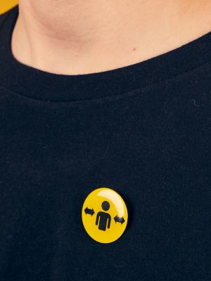
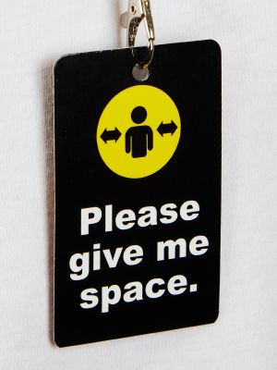
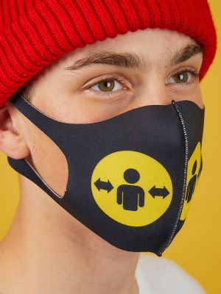
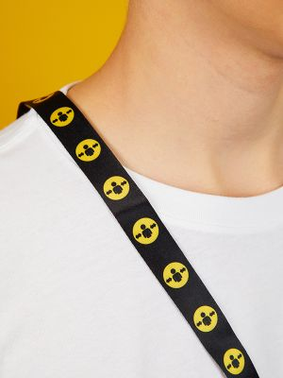

[images show wearable social distancing resources including a badge, lanyard and face covering]

Distance aware: https://www.bevancommission.org/distance-aware

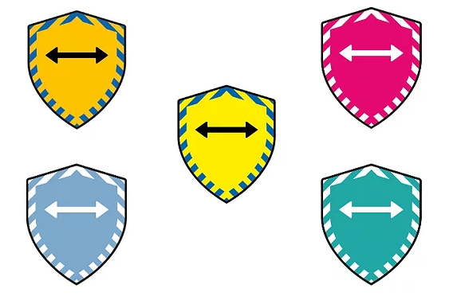

[image shows distance aware social distancing symbols]

Hidden disabilities sunflower: https://hiddendisabilitiesstore.com/

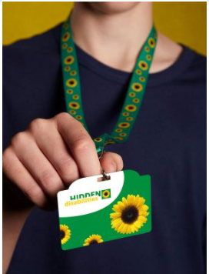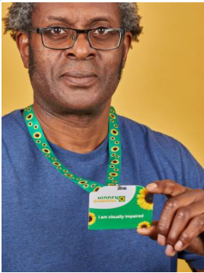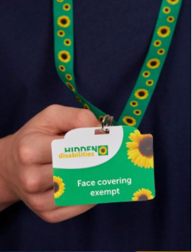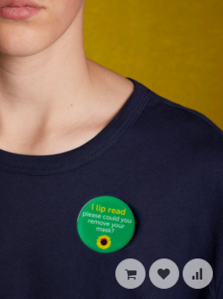

[images show hidden disabilities sunflower lanyards and badges with ‘I am visually impaired, ‘face covering exempt’ and ‘I lip read please could you remove your mask’ instructions]

Further information
http://www.wcb-ccd.org.uk/coronavirus.php
https://www.rnib.org.uk/wales-cymru-1
https://www.guidedogs.org.uk/guide-dogs-cymru

Contact
Nathan.owen@rnib.org.uk
Andrea.gordon@guidedogs.org.uk
owen@wcb-ccd.org.uk

