 |  | NEWSLETTER  #5
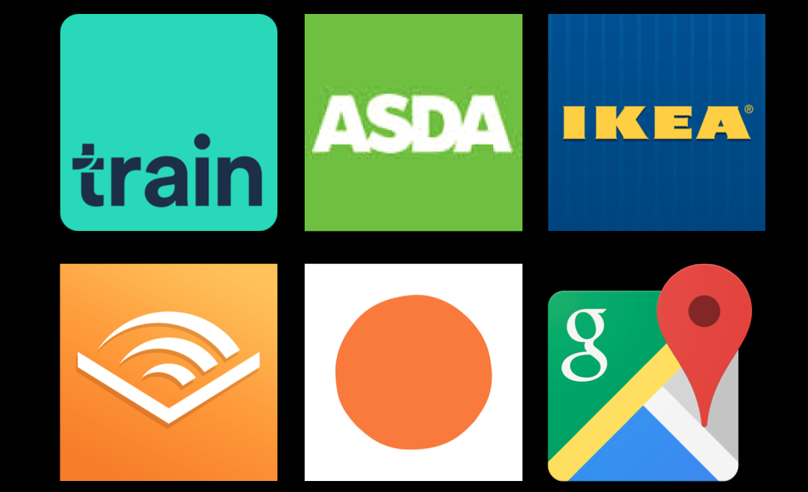 | Top Apps for Everyday Use

So as Visually Impaired people ourselves Mared and I thought we’d share with you our top apps that we use for our everyday use. These apps make it possible for us to do those annoying everyday activities as simply as anyone else would. From reading, to travelling and doing your weekly shop this list of apps might help you out in the future.

1. Audible - Free (Free 30 day trial, then £7.99 a month)

Audible is an app we both absolutely love! It’s got the world’s largest selection of audiobook and premium spoken-word entertainment. A monthly subscription of £7.99 gives you one credit a month allowing you to purchase any book in the library. You can buy anything else at an additional cost. We are both keen readers and love that we can still have access to this experience at any moment of our day. If you struggle to read or thought if wasn’t possible to do now you’ve lost your sight I highly recommend giving the free trial a go.

2. Trainline - Free

Trainline, another one of our favourites. If you travel by train a lot and don’t use this app then I’d suggest having a look in to trying it out. This app allows you to look up your train times, plan journeys and purchase tickets in advance. You can also check what platform you need, track the train’s progress as its approaching your station or while you’re travelling. There is also new feature to this app that allows you to purchase e-tickets so that can be scanned from your phone.

3. Shopping Apps - Free

There’s isn’t a specific app to list here as it depends on what supermarket or type of online shopping you want to do. Any apps like Asda, Tesco or Acado offer the ability to use the app to do an online shop that can be collected or delivered. We both use these apps to do our shopping as the apps are far easier to navigate than a desktop website. It also saves items you’ve previously purchased to your ‘favourites’ so no need to go searching for them the next time you go to make and order. This app can also be used to help familiarize yourself with certain items you’re looking for that when you get in-store you can find them with a little more ease. Other apps such as ASOS, H&M or IKEA are also great apps to use as, again, there apps are far easier to navigate than the web versions that are available.

4. Google Maps - Free

Ok, so i’m sure you all know about Google Maps but we wanted to mention it because it’s saved us on several occasions. Whether you’re walking to somewhere new or familiar, having the reassurance that you are in fact going the right way is invaluable. If you’re travelling in a car with someone and you’re somehow in charge of navigating, just let Google take over for you. You can also plan your journey, which everyone with sight loss knows is the key to getting anywhere successfully. Planning well in advance is super simple on this app, you can get familiar with the complexity of the journey, how long it will take you and what sort of area you’ll be walking around.

5. Festival - No.6 - Free

Festivals are one of the best parts of summer and an opportunity - finally - to do some stuff outdoors, even if our Welsh weather is still as unpredictable. Visiting a festival or two is a great thing to do but for a lot of Vision Impaired people navigating them or seeing the programme can be totally inaccessible. This is where an app can come in. Some festivals create apps for their festivals and Festival No. 6, which is held in Portmeirion every year, is one of them. Here you will find all the information you need to have the best experience and get all the same info that your fellow sighted festival goers get from just looking around. You won’t miss those little things tucked away. Next festival you go to have a check and see if they have an app, you may discover some hidden gems.

6. Colour ID - Free

There are several versions of this app floating about but it’s a great tool to have to hand. This app you can hold up to an object, item of clothing or a wall to identify its colour. For anyone who has trouble identifying colours especially where they are next to others this is the app for you. I know from experience that telling the difference between navy and black can often be tricky but this app eliminates that difficulty after only a few seconds. A handy app to have.

7. Headspace - Free

Now as young Vision Impaired people ourselves we know the struggles of living with sight loss everyday and the struggles of just living with everyday life. It can be stressful and we all need that little bit of down time to decompress from the day. If you haven’t tried mindfulness or meditation before it’s a great way to relieve anxiety and relax either at the beginning or end of your day. Headspace is a great app to try especially if you’re a beginner, it gives you a step-by-step guide and a few tips and tricks to help you get started. Once you’ve done this you can choose specific things you’d like to focus your meditation on. Give it a go - see what you think.

So that’s our top apps we thought would be useful to share with you, we hope that it helps you discover some more accessible ways to do those day to day things. Let us know if you think we’ve missed out an important app to the list.

The Queen’s New Website

Once upon a time in a land far, far away, there lived a Queen who was visually impaired. She was very kind and caring – for a Queen at least. She never had anyone’s head cut off and only occasionally had evil-doers thrown in the castle dungeon.

One day, the Queen had a very good idea. In some ways, not seeing very well didn’t affect her that much, because she had servants to do everything for her. But the Queen knew that life could be hard for her subjects who were visually impaired. They didn’t have servants to do things for them and many struggled to find work and make ends meet.

So the Queen called a meeting of her top health advisers in the castle’s executive conference room. The meeting’s purpose was to come up with ideas on how they could help all the visually impaired and blind people in her Queendom. One idea the Queen liked was having two big websites listing all the help and services and information available on eyes and seeing.

One website would be for oculists and other professionals working in eye health. It would have lots of technical information and big words. The other website would be for visually impaired and blind people and would be much easier to understand.

Conforms to the highest standards

“What an excellent idea!” said the oculist-in-chief. “That will be very convenient for my colleagues and I. And, of course,” he added quickly, glancing at the Queen, “We will make sure the website for visually impaired and blind people conforms to the highest standards of accessibility.”

Everyone agreed and there was much nodding and smiling around the big table in the executive conference room. I say everyone agreed, but actually when the self-congratulatory hubbub died down, one person timidly put up her hand and asked quietly: “May I say something? I think we may have overlooked a small point.”

Everyone turned and stared at the person who had dared to speak. She was a rehabilitation officer and - some thought - the most junior person in the room. Some of the oculists thought she shouldn’t have been there at all and glowered at her.

The glowering did not in fact have much effect, since the rehabilitation officer was visually impaired herself. She could not see the daggers (both real and metaphorical) pointing at her. Nor, of course, could the Queen, who invited the rehabilitation officer to make her point.

The rehabilitation officer cleared her throat: “I only wanted to ask whether the website for professionals should conform to the highest standards of accessibility too?”

Expense and bother

The oculist-in-chief started to say he didn’t see any reason why they needed to go to all that expense and bother, but stopped in mid-sentence. The Queen had raised her hand ever so slightly indicating that she wanted to speak.

Even before the Queen said a word, the oculist-in-chief realised his mistake and his face became pale and ashen. He tried to splutter some words of apology, but the Queen cut him off: “Of course the website for professionals should conform to the highest standards of accessibility too,” she said. “Otherwise it would appear that we had made the assumption that visually impaired people could not work as professionals.”

At this point, it’s traditional to say that everyone had a fine post-meeting lunch and lived happily ever after. But that was not the case for the oculist-in-chief and many of his senior colleagues.

A few days later, the oculist-in-chief announced that he had been thinking of retiring for some time. So, with deep regret, he had decided to hang up his occluder and spend more time with his family. Many of his senior colleagues discovered that their families had been missing them too. Others talked of the need to pursue new exciting opportunities or, in a few cases, were diagnosed with sudden, pressing health concerns.

The Queen, however, lived and reigned for many wise, peaceful and prosperous (for herself and her subjects) years. The once timid rehabilitation officer became oculist-in-chief and oversaw a vast improvement in services and support for all the visually impaired and blind people in the land. So they at least did live happily ever after.

© John Sanders, February 2018

For more other work by the author please see http://www.northwickbear.com/index.html

Cardiff Storm Event - Health and Wellbeing

Our most recent Storm Event happened in February in Cardiff. We hosted the event at Chapter Arts Centre and it focused around the theme of Health and Wellbeing.

Mared and I felt this was a really important theme to cover and inform young people about. We firstly had Marcia Morgan from Public Health Wales come in a talk and discuss with the group about their Accessible Standards Information Project that they’d been running. This project was focused on making doctors surgeries more accessible to people with sensory loss and improving the patient experience. This is something they are continuing to work on and were keen to get people’s opinion on their experiences with surgeries. Following on from Marcia we had Emma Richards from Sight Cymru come in and talk about their emotional support mental health project, Great Minds, and the ECLO (Eye Care Liaison Officer) service.
Sharon Beatty an Accredited Low Vision Practitioner came with a suitcase full of Low Vision Aids to explain to the group what the Low Vision Service was, how it could benefit them and what you need to do to get assessed. All the equipment was laid out so everyone could get up close to have a look and try out the sort of products that are available. Lastly Alastair Sill from Cardiff Institute for the Blind came to talk about his role as a connector and specifically the hard work he’s been doing to make Hub Centres in Cardiff accessible to people with Sight Loss.

This session was really informative and very valuable for learning about the services available and work that’s being done to make healthcare accessible to people who are Vision Impaired.

Keep an eye out on the website or in our next Storm Newsletter about other events we run and what we get up to.

The Museum Experience

I found my career path in the tourism sector diverse and interesting with many elements. Studying in Cardiff Met I had the opportunity to undertake research for my final year dissertation. Being visually impaired and someone who enjoys culture I decided my topic would centre around the experience visually impaired people have in museums and how they can be enhanced. Which is actually an under-researched area in the sector that needs to be addressed more.
I was able to talk to many different visually impaired people of different ages, backgrounds and sight conditions to learn what their thoughts were on visiting museums and the experience. There were a lot of mixed responses to the people I interviewed and that really showed that the museum experience is different for each person because of the different wants and needs as a visually impaired tourist. Yet the facilities available to help make a better experience are not as diverse and does not fit every individual with a visual impairment.

Large print guides/information and audio description are two very well-known ways of enhancing the experience. But is this what everyone who has a visual impairment wants? Not from what I’ve found in my research: more alternative methods seemed to be the focus and what people I interviewed wanted. Tactile experiences, use of technology and visual awareness training for visitor attractions were three key points that the people I talked to wanted from an attraction visitor experience.

I feel that the tourism sector needs to do more to give people with visual impairments and disabilities of all kinds a visitor experience that can be as inclusive for them as it is for those who don’t have any disabilities. Why should one person get to enjoy something more than another just because it’s easier to standardise everything? They shouldn’t. Tourism is supposed to be enjoyable and relaxing, a break from normal routines, not a task that’s negative and difficult to achieve. The tourism sector is growing and changing each day, and the visitor experience is changing more to every individual, personalising experiences for everyone. Further research in to this area can help to voice the needs and wants of the visitor experience and make changes for the better in the future.

Hannah Matthews

Contact us

Email
megan@wcb-ccd.org.uk
mared@wcb-ccd.org.uk

Telephone
029 2047 3954

Facebook
facebook.com/StormWCB

Twitter
twitter.com/StormWCB

Website
www.stormwcb.org.uk
In the next issue ….

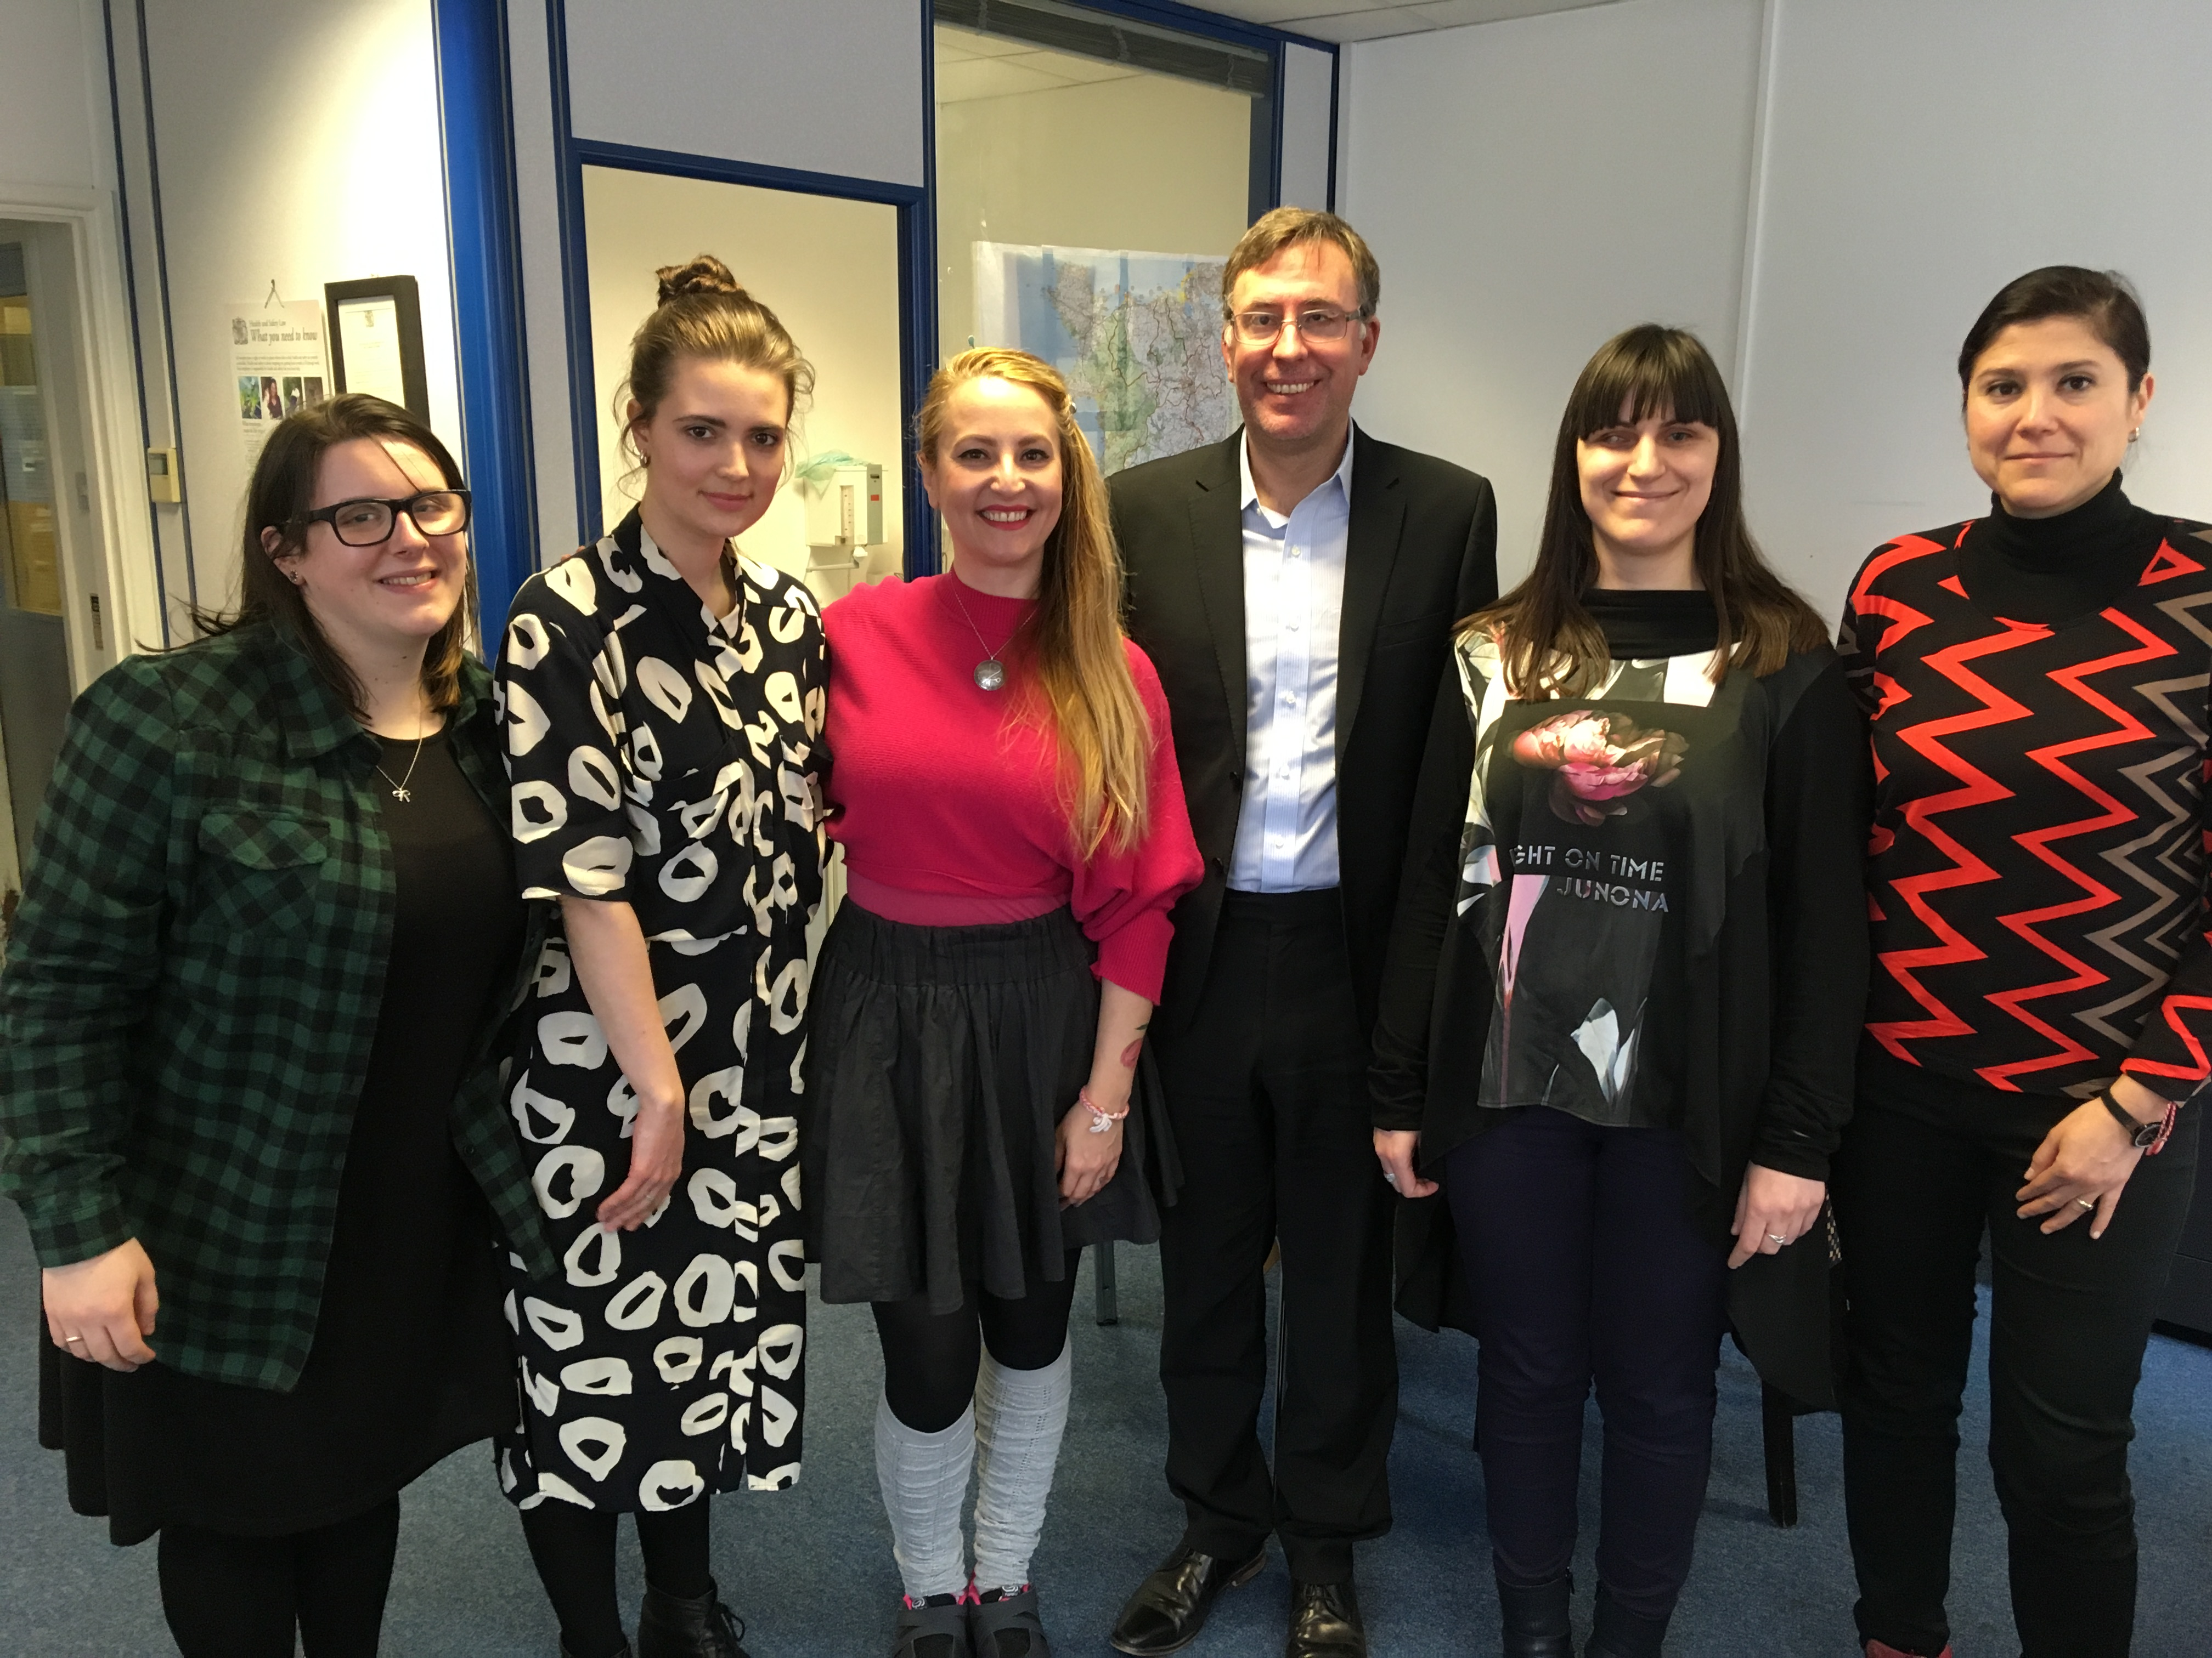
L-R: Megan John, Mared Jarman, Tzveta Baliyska-Sokolova, Owen Williams, Milena Kostadinova, Zornista Staneva.

Visitors from Bulgaria: a report on their visit to Wales.

StormWCB at the Eisteddfod: what we’ll be up to and how you can get involved.

Jake Sawyers on 360 Film and how he uses it to explore perceptions of sight loss and how we can use it gain a better understanding of living with an eye condition.

