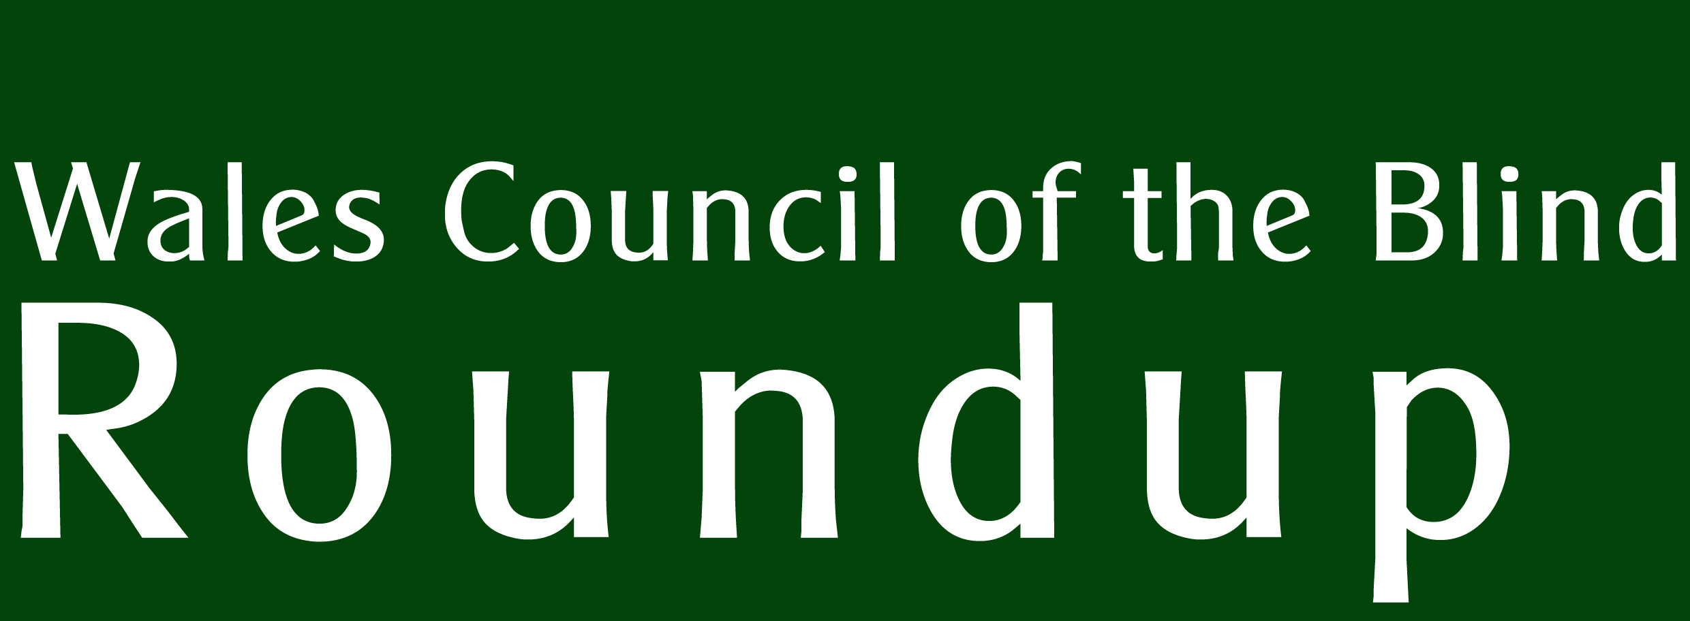  Incorporating WCB Storm | Supported by  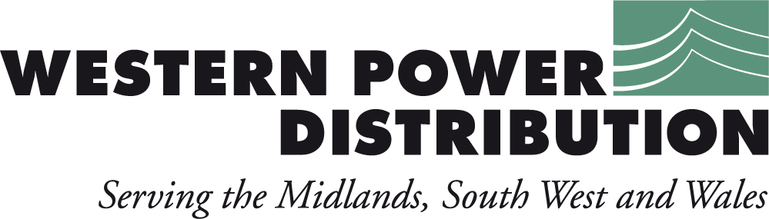  No. 37
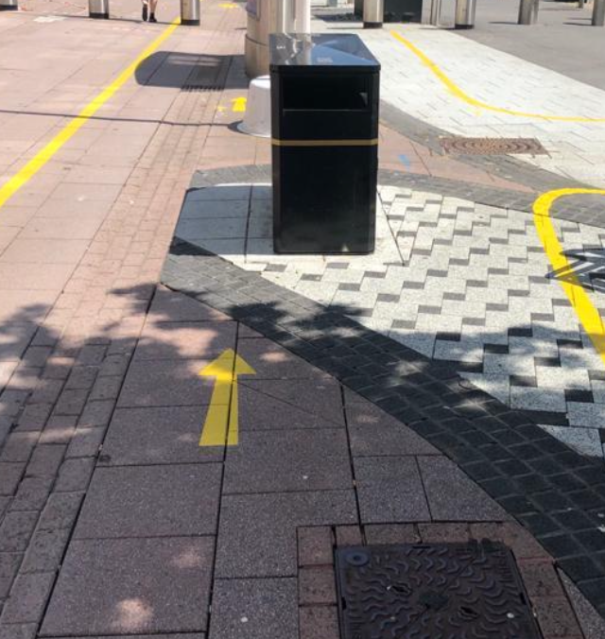

THE NEW NORMAL? Inequalities and challenges after lockdown
WCB Roundup is published quarterly by Wales Council of the Blind, 2nd Floor, Hallinans House, 22 Newport Road, Cardiff CF24 0DB.
Tel: 029 20 473954.
Email: richard@wcb-ccd.org.uk.
Further copies, in audio CD or large print formats, are available. All editions are online at
http://www.wcb-ccd.org.uk/roundup.php
Advertise in WCB Roundup
WCB Roundup is sent to more than 2500 people, in a variety of formats. We are a not-for-profit organisation that hopes to recoup its costs. We seek advertisers for our newsletter so that we can continue to produce this valued journal. Advertisers will reach a readership of individuals with sight loss, optometrists, ophthalmologists, rehabilitation officers, social workers, and organisations working for blind, partially sighted and disabled people.
Our rates are (per edition):
Full A4 page: £150 (black and white) £250 (colour)
1/2 A4 page: £100 (black and white)
Enclosures: single sheet A4, supplied in a ready-to-go format: £200. Ask for quantity required.
Larger enclosures (such as booklets): please ask for quote.
To advertise in many editions, please contact us for discounts. Contact Ann via ann@wcb-ccd.org.uk or telephone 02920 473954.

Editorial

It hardly needs to be said that these past few months have been challenging and worrying times. What does need saying it that they have exposed the cracks beneath the paper when it comes to delivering equal services to disabled people. The hard-won battles must to be fought again as we emerge from ‘lock-down’ and shops are beginning to open with their new restrictions.

This edition looks at some of the comments from individuals about their experiences in recent months and their concerns for the coming months. The landscape is changing but we must make sure the notion of ‘the new normal’ is being challenged whenever a new disabling barrier is put in place.

Therefore, to represent the broad range of views of people with sight loss, this document was made in consultation with Wales Vision Forum. Through this forum we consulted and quoted the following organisations: Guide Dogs;
Care and Repair Cymru; Macular Society; RNIB Cymru; International Glaucoma Association; Blind Veterans; Welsh Rehabilitation Officers Forum; North Wales Society for the Blind; Vision Support; Sight Cymru; Sight Life; Visual Impairment Merthyr Tydfil; Ceredigion Association for the Blind; BridgeVis; Carmarthen Area Blind Society; Pembrokeshire Blind Society; Radnorshire Association for the Blind; Visual Impairment Breconshire; and Vision Impairment West Glamorgan. We have also consulted our own focus groups in West Wales. We are most grateful to all of these contributors.

Megan Price gives us some the latest from WCB Storm young people’s project and we with service updates concerning optometry practices and the Low Vision Service in Wales.
- Richard Bowers

The new normal? Inequalities and challenges after lockdown.

Upon ‘lockdown’ Wales Council of the Blind immediately gathered the Wales Vision Forum for weekly meetings to discuss what the sector was doing to address the restrictions imposed by our governments. Consequently, over a dozen meetings have been held to share concerns and new working practices so that WCB could maintain a web page giving the latest situation for the benefit of professionals and individuals (www.wcb-ccd.org.uk/coronavirus.php). It was our intention that these meetings enable the sector to work collaboratively and to deliver information in the timeliest manner. This has been its great success. Also WCB, through the forum, assembled 22 local authority booklets (see 7 below) giving information on contacts and the availability of local support: optometry; volunteer deliveries; local sight loss charities and so on. These were distributed through the Welsh Local Government Association to each authority and to each contact - professionals and individuals - held by WCB on a county-by-county basis.

As ever, accessible information is the key enabling factor for people with sight loss. The pandemic has put that into sharp focus; we hear that not enough services are making their information available in accessible forms, yet this is needed more than ever. WCB has continued to produce Sylw, its weekly e-bulletin and print / audio monthly, so that people are kept up-to-date with changes. It has also held a series or regional telephone meetings with its West Wales Forum to gather opinion there.

What do we want to see happen?

+ It is essential that Local Authorities, and others delivering services such as transport, shopping centres, leisure centres and so on, consult local Disability Access Groups and other disability advisors to ensure the old access errors are not reintroduced under the cloak of expedience.

+ Service providers in the Third Sector have experienced a much higher demand on telephone support services. The lockdown measures have forced a revised way of working for many charities and support services whereby home working has resulted in staff being deployed into telephone support work. However, this has set up an expectation amongst clients for a service that may be unsustainable as ‘normal’ work practices resume. Third Sector organisations are therefore concerned about what funding is available to continue these services. Indeed, funding has proved hard to get under the present measures, resulting in material threats to the very existence of the organisations delivering such services. There are likely to be cost savings with telephone and online emotional support that would take pressure of social care services in the long run. They are worth investing in.

+ The demand for rehabilitation and mobility support will be huge as we emerge from ‘lockdown’ and the environment is being reconfigured. As the inevitable waiting lists grow, the cases become more complex. What funding shall be made available to expand the already stretched rehabilitation services across Wales? And how can the demand for the services be met? Failure to provide ways to re-orientate people with sight loss to the changed towns and cities will create a disproportionate impact on their independence and wellbeing, particularly at a time when Covid-specific services are being withdrawn, such as volunteering networks. A possible solution is to include the role of the rehabilitation officer within the Apprenticeship Levy within Wales, as is the case in England. This will enable Local Authorities’ workforce planning.

+ Any cuts being made as a result of the economic impact of the pandemic should not disproportionately affect disabled people. Indeed, there is likely to be a need to positively channel funding towards services that empower disabled people such as rehabilitation and local third sector support, and towards independence-enabling features such as accessible information and signage. This is so that disabled people are not excluded from the reintroduction of services.

+ Remember that information for disabled people does not stop at accessible forms of general public information – it must include information about the disabling barriers that temporary measures have introduced, where they occur and what the impact would be on Disabled people. Changed routes, for example, create problems for people with sight loss that are non-existent for sighted people. This is additional information.

EQUALITY.
One thing is certain, the response to the Coronavirus pandemic has brought inequalities to the fore. Despite decades of work to break down disabling barriers in society we find them still evident in some aspects of public life and even reappearing by the back door as society implements rapid adjustments to service delivery and the built environment. Therefore, the guiding principle of this article is to stress the importance of not letting our guard down on equality when the stresses and urgency of the situation risk it being conveniently ignored.

People with sight loss must not be the last to benefit from the reintroduction of services. This is an equality issue. Public and commercial sector authorities have a duty under the Equalities Act to deliver services that are as equally accessible to disabled people as they are to non-disabled people. Any guidance issued to these sectors must stress the importance of the Act to ensure that public information and adjustments to the environment are designed in a way that gives disabled people the fullest opportunity to enter the newly-configured services on an equal footing.

For this to happen, disabled people – including people with sensory loss – must be consulted meaningfully at the earliest opportunities. For example, Equality Impact Assessments must only be undertaken where input from disabled people is assured.

ACCESSING INFORMATION.

Public information on Covid-19 and the perceived health risks to people with sight loss.

‘I’ve got a hospital appointment but I’m worried about how to get there safely.’

First of all, there needs to be clear, non-alarmist messages going out about health risks. There is a lack of robust data that is currently forcing emergency measures that are likely to be incommensurate with the actual risks, particularly when compared with the risks emerging from the side-effects of the lockdown and social distancing measures: mental health, loneliness and isolation, unemployment, poverty, and health inequalities. Many disabled people are afraid to leave their homes and, coupled with precautionary measures by health workers and social care workers, are not getting the support they need for healthy and independent living. An RNIB impact paper (1) quotes a service user:

‘Will it become a choice of starvation or corona as we can’t leave our homes? I live on my own and cannot ask others to jeopardise their safety by getting my shopping.’

The majority of people with sight loss are, statistically speaking, in the over-70 age group and therefore most at risk of the ill effects of Covid-19. Also, individuals in this age group are most likely to be isolated and in need of additional care and support. It is essential, therefore, that the information given to them is in an accessible format so that they are properly informed about developments as they arise, including any changes to the official guidance on the coronavirus risks.

Do not rely on digital communication alone. Many people with sight loss do not have access to the internet or find the information there often to be inaccessible. However, recognising that online information is timelier than door drops, the websites must be accessible, clear, and well-organised.

Other information.

It is important to impress upon service providers - be they local authorities, other public bodies or owners of commercial facilities – that they have a duty to provide equality of service under the Equalities Act and must ensure, therefore, that any instructional information be provided in an accessible form for all disabled people. We are concerned that there will be new prescriptive pathways through buildings and public spaces that could arise in collisions or more serious accidents due to a blind person, for example, being unaware of instructions. This could arise in legal complications where the blame could be apportioned to the venue, so it is in their best interests to heed the Act. Therefore, accessible information and a thorough public awareness-raising campaign are crucial to ensure the venue reduces its liabilities in this regard.

As services and spaces are reintroduced for public use, the information provided at them, and about them, must ensure that people with sight loss are fully informed of changes that impact on their prior knowledge of - and familiarity with - the service. Information on changes to pathways, roadsides, ingress and egress from shops and so on must be available in accessible formats. Also, this information would ideally be available on the service’s website so that people are able to approach the service informed and confident.

Accessible information must be accurate as well as accessible. For example, people need to now that there are now safe ways to access optometry practices. Information such as this will help people immeasurably, but only if it is accurate.

It is important to consider that information for disabled people does not stop at accessible forms of general public information. As can be seen below, additional information must be provided specifically to people with sight loss as they require a better knowledge of what changes have taken place to environments and services in order to increase their confidence to enter such environments and take up services. This is information that sighted people obtain directly through markings, signage and notices. People with sight loss need much more prior information to know how to work in an environment that has changed from the one they had taken great pains to understand previously.

‘The layouts of the shops have been altered to allow for one-way systems making my usual shopping more difficult. I often forget items whilst shopping so go back on myself which you are unable to do now. I also struggle with being very aware not to pick up too many items to take a closer look at with my magnifier.’

DIGITAL TECHNOLOGY.
Guide Dogs Cymru made the following observations: “In the ‘keeping in touch’ calls we have made to all our clients, digital exclusion is a major concern. People with sight loss need specialist software to access computers and support to learn how to use it. Teaching somebody with sight loss requires knowledge of such software, and so mainstream provision in the community does not meet this need.

“All of these technologies need a great deal of support to learn and involve the purchase of equipment. If technology is to significantly improve the lives of people with sight loss, and reduce loneliness and isolation, it needs far more resources in terms of financial support and expertise to enable users to be fluent and comfortable in its use. It is absolutely the case that many programmes designed to increase digital inclusion lack these resources and fail to take this into account. There are unique challenges which need long term sustainable funding to build knowledge and confidence among people with sight loss, rather than one-off pots of funding which are time limited and fail to recognize the complexity of the challenge.”

Many services are relying on alternative ways of serving individuals through online meeting platforms and traditional telephone methods. Social and support groups, for example, have used such methods to continue their programme of meetings. Also, traditional support from rehabilitation officers has been curtailed and a stopgap of telephone wellbeing checks has been carried out in its place.

While there is a perceived need to prohibit conventional contact, we must not regard this as ‘the new normal’. There are barriers for many people in the adoption of communications technology for interaction, particularly amongst disabled and older people. What may seem natural to non-disabled people in active, office-based employment might be totally alien to many people. New communications technology should not be defaulted as the convenient alternative or an assumed norm; new technology is fraught with difficulties and complications, not least the cost of access equipment and the variable availability of broadband across Wales.

However, where such meetings are unavoidable, we must assure that they are as accessible as possible. Wales Council of the Blind is working with Wales Council for Deaf People on guidance for accessible virtual meetings.

SOCIAL DISTANCING.

‘I really do not know how I personally would cope with social distancing, as I cannot go anywhere for which I do not have an established mind map, and I am most likely not to see other folk who are about.’

‘Social distancing is difficult if out on my own. I do not have a very good depth perception therefore do not realise I am too close to someone whilst in a supermarket.’

‘I was always so confident getting out and about with my guide dog. I am very concerned about this 2-meter distancing though now. My dog doesn’t understand social distancing so how will that work?’

Some observations about social distancing are at the Guide Dogs website: https://www.guidedogs.org.uk/news/Social-distancing-and-sight-loss]. See also (2) below.

‘Social distancing is the most challenging aspect for me in the whole Covid-19 situation. Not being able to socially distance is a major challenge to my independence and keeping myself safe.’

‘My guide dog hasn’t been trained to social distance, that’s why we need help from the sighted public.’
- Guide dog owners.

Blind and partially sighted people report that sighted people also need to observe the distancing rules. This is not always happening, putting the individual at a disadvantage through not knowing how close the sighted person is.

CHANGING ENVIRONMENTS ARE CHALLENGING ENVIRONMENTS.
‘It can be really challenging at the best of times when you can’t see what’s going on around you. At the moment, it’s vital that I get more verbal information from people around me, as a lot of the environment around us is built on visual cues, which I can’t rely on.’

‘I have no idea what 2 metres away looks like. I am worried I will never leave the house. I won’t be able to keep away from people and, as I don’t look ‘blind’, people will not know to keep away from me. I have a little usable vision but can't judge distance. If I have to rely on bollards or new road markings, I will not see them, it’s such a worry for me.’

Any familiarity with the physical environment will largely be undermined by the changes being made to routes through shops, streets and parks to enable physical distancing. Rehabilitation and mobility officers will play a key role in re-training people with sight loss to navigate once-familiar routes, now made unfamiliar due to the re-organisation taking place throughout the country. The Welsh Rehabilitation Officers Forum reports that all assessments for new rehabilitation clients have been conducted over the phone. This creates an illusion of reducing waiting lists because people are swiftly placed into active case lists where rehabilitation is assessed as necessary. However, the outcomes identified in the assessments will not be achieved because the worker is unable to carry out the rehabilitation programme. Consequently, a backlog of work is being created with the risk of inadequate temporary measures being adopted as a stopgap in the meantime. People are relying on carers and family members delivering the informal support and this can both form bad habits and create a culture of dependency.

Shops and shopping.

‘I don’t always know there is a queue because my dog takes me to the door of the shop, not the end of the queue. Shops have introduced visual indicators and one-way systems and if you can’t see they’re a major challenge.’
‘The shopping has been left to my husband as I find it a little difficult and my confidence has decreased. This really does make me cross with myself but I do understand that this is necessary.’

‘I can’t work out where to queue.’

‘As someone with a visual impairment, it has become quite difficult to food shop. I struggle with staff on the door of the shops calling you in when hand gestures are used.’

The ‘sunflower lanyard’ used in Tesco to indicate that the wearer may need some assistance is controversial, partly because it reinforces a perception of dependency. Nevertheless, it has proved useful for some people because, even if the public do not understand its purpose, staff do, and can act on it.

Guide Dogs has produced guidance for shopkeepers (3)

Transport and roadways.

‘I am normally a very confident shopper on my own but since lockdown I can’t get to a shop as I will not travel on public transport and find the whole thing quite difficult.’

‘I feel I’ve lost my independence forever, I used to enjoy getting on the bus and coming to the Sight Life coffee morning and other groups. I just wouldn’t feel safe using public transport. Thank goodness for their telephone groups, at least I can still chat to people this way, it’s just not the same as seeing someone in person.’
- Sight Life service user

People with sight loss told Guide Dogs that concerns about travelling once lockdown restrictions begin to be lifted included their ability to social distance whilst using transport (84%) and access to support whilst using transport (61%).

Public transport will pose severe difficulties for people with sight loss. Many people do not feel confident that they’ll get the support they need from others when using trains and buses. Measures such as putting crosses on seats are not helpful for sight-impaired people and can prompt altercations with other passengers. If such indicators are to be used, they must be consistent.

Some towns and cities are introducing one-way systems for pedestrians by painting a white line to create lanes to follow. Coupled with this are areas marked out for outdoor eating to enable cafes to start taking customers. How are these measures being made accessible for people with sight loss? The traditional method of a white cane user following the edge of a building may not be possible if it means going against the marked direction or if the area closest to the building is now being set aside for tables and chairs.

RNIB has produced a checklist of considerations regarding inclusive journeys (4).

EMPLOYMENT.

‘For those in employment there are real worries that extra safety measures for their needs will be overlooked.’
- Guide Dogs

The health-centred focus of the adjustments made to society has taken attention away from the impact on the hard-won jobs people with disabilities hold. With unemployment in Wales doubling, people with sight loss seeking employment will find themselves further disadvantaged. With less than 25% of blind and partially sighted people of working age in work, employment schemes that support people back into work must be inclusive of people with sight loss, as must the measures employers are putting in the workplace to address Covid-19 concerns. It should also be noted that projects supporting disabled people into work will also face huge challenges as disabled people will need to access these in order to compete in an even tougher environment.

It is important that Welsh Government holds the Access to Work scheme accountable during the return to work. The Cross Party Group on Disability reported that, during the lockdown, Access to Work has not processed any new claims for disabled people and the whole department has been moved to deal with Universal Credit applications. It is critical that Access to Work reviews how, as an invaluable scheme for disabled people in work, it supports people with sight loss to return to work, taking into account a change in working environment and potential unfamiliarity in relation to travel. Use of public transport and social distancing will mean that, for many people, returning to the office will be impossible without reviewing the Fares to Work scheme, as previously familiar routes could now be unsafe. Consideration of social distancing will also have to be taken into account in relation to using a support worker / driver. We suggest that Access to Work consults on potential changes to the scheme with disabled people at the earliest opportunity.

Access to Work customers have been able to submit claim forms for reimbursement without an employer or support worker signature and ask their line manager or support worker to provide an email confirming the details of the claim and that they agree to the terms and conditions on that form. This has been welcomed but we have been informed by the Access to Work scheme that there has been no change in their guidance in relation to COVID-19. For many people returning to work these can be anxious times:

‘I have always used public transport to get to work because I use a familiar route. But I contacted the scheme to ask if there were any changes to Fares to Work as, with social distancing and changes to the layout on the bus and train, the journey is no longer familiar and I didn’t feel safe. I was told that unless there is a medical reason why I can’t use public transport it would be my choice not to use public transport and will have to pay for a taxi myself.’

This could put an increased financial burden on those returning to work. We would like to see Access to Work review such cases on an individual basis and with an awareness of the devastating impact Coronavirus has had on the independence of people with sight loss. We would like to see Access to Work aligning their guidance to the social model of disability and not the medical model suggested in the above response.

WCB published a report How Accessible is Access to Work for people with sight loss in Wales? 3 years on (9).

None of Access to Work’s functions are devolved to Wales. However, Welsh Government in its aspiration to increase the number of disabled people in employment could play a role in influencing change and improvement, as detailed within this report. We do not want to see people with sight loss further disadvantaged at this time.

EDUCATION AND SCHOOLS.

As with employment, we are risking losing our grip on a key equalities issue as the general public re-enters these domains. Again, this crisis has highlighted the disabling barriers people face and has given us a sharp reminder that hard-won battles are easily lost when the landscape changes so radically. Here are some thoughts on barriers children with sight loss face, pending a fuller consultation on the situation.

Habilitation: Social distancing within the classroom is a concern for many children and young people with sight loss. It is even more essential that children with sight loss have access to habilitation services where changes to the school layout could affect their mobility.

Digital inclusion in education: There is a concern that not all children have the right equipment and tools for learning at home. Is the equipment they have right for them? Also, is the work being sent home fully accessible? Welsh Association of Vision Impairment Educators (WAVIE) has heard of PDF files being sent that cannot be accessed using screen readers, for example.

Blended learning should not give way to screen-based learning alone, which can lead to fatigue, but consider the broader styles and modes of learning. Provision of resource packs is essential to achieve this.

Schools must audit their digital skills and learning materials and determine how accessible these resources are for children with sight loss. In achieving this there must be closer working with all services, schools and specialists.

It is also critical that teaching assistants are provided with equipment that enables them to work remotely with children with sight loss. We must focus on the child and the support they receive from teaching assistants.

There is a risk of a single-minded approach that further excludes vi children. We must do all we can to ensure that access to education is accessible to all.

ATTITUDINAL BARRIERS AND RAISING PUBLIC AWARENESS.

‘I’m less confident getting out and about than I was. Now that lockdown is lifting, other people are trying to get their life back to what it was, but it’s a whole new world for people with sight loss. It’s a lot for us to adjust to and it would really help if people have an awareness of how they can play their part.’
While the general public is being made fully aware of the ways to maintain physical distance from others, people with sight loss may not be able to access the information that makes distancing possible. This has a knock-on effect of making the general public antagonistic towards those of us who appear to be breaking the rules. This is largely a matter for public-awareness campaigning such as the Guide Dogs ‘Be There’ campaign.

An example of public ignorance of the difficulties guide dog users face with social distancing is related on the ITV website (5).

IMPACT ON MENTAL HEALTH AND WELLBEING, LONELINESS, ISOLATION.

‘The well-being of everyone must be the guiding principle. To ensure equality the aim should be that people with sight loss have the same independence, choice and control as everyone. The experience of people to date indicates that there is plenty of room for improvement.’
- Guide Dogs.

‘There is considerable evidence to show that people with sight loss are at greater risk of mental health issues, isolation, and loneliness.’(6)

‘The importance of touch and human contact is crucial to people with sight loss. Individuals with visual impairments often rely heavily or even solely on physical guiding and feeling the physical world around them. With a large part of these ways of communicating potentially being removed, there is likely to be an increased feeling of loneliness and isolation amongst people with sight loss, potentially leading to a decrease in wellbeing and mental health.’
-Sight Cymru briefing note (7)

There is a real threat to a blind or partially-sighted person’s independence and confidence as the lockdown is eased. Disabling barriers are being created whenever badly planned or inaccessible adjustments are made to the usual pathways and milling areas. These create inequality in the easing process and may result in longer-term problems for disabled people that could affect their wellbeing and mental health.
Guide Dogs mentions feedback from service users of well-being issues with more about low mood and depression. There have been several references to low levels of self-esteem.

It is worth noting that all regional, local and national organisations have been conducting telephone wellbeing checks with their service users. There has been a considerable increase in telephone befriending requests and volunteers. There is a concern that these volunteers will drop off as people get back to work.

‘Macular Society rang me after a telephone group meeting and we had a long conversation about why I was feeling low and she put me in touch with a counsellor. I was floundering and I still am. Being in lockdown is getting worse. I’ve got no family, one or two of my friends I thought were there for me, I’ve not heard from them. I was just struggling. The counselling was a tremendous help … I could tell her anything, everything. I could scream, cry down the phone it didn’t matter. There are very few people I can do that with.’

SUPPORT IN THE LOCAL COMMUNITY.

Community support from local societies and groups for blind people, as well as other voluntary groups, has been crucial in keeping people in isolation safe and well by delivering provisions of all kinds to those unable to get them for themselves. As the various measures are eased or otherwise modified, there will be more people returning to work. This will have an impact on the availability of volunteers to carry out tasks such as shopping and obtaining medicines. It is important that community groups, particularly those that have been formed as a response to the pandemic, maintain a public front (through social media and door drops) so that the status of their service is made known.
There are Community booklets giving contact details in each local authority for various kinds of voluntary support (7).

References:
(1) RNIB - Letter to Mark Drakeford, First Minister, 16 June 2020.
(2) Guide Dogs’ ‘Be There’ campaign gives guidance to encourage the public to feel confident in their ability to offer support whilst maintaining social distancing.
(3) Guide Dogs’ guidance for shops: https://www.guidedogs.org.uk/about-us/what-we-do/research/Policy-and-guidance-for-businesses/Guidance-for-shops
(4) RNIB Inclusive Journeys guidance https://www.rnib.org.uk/campaigning/priority-campaigns/inclusive-journeys:
(5) https://www.itv.com/news/wales/2020-05-20/my-dog-isn-t-trained-to-social-distance-visually-impaired-woman-on-frightening-encounters-while-out-in-public/
(6) Covid-19: Henshaws survey with blind and partially sighted people. A final report on survey findings, June 2020.
(7) Community Support booklets at http://www.wcb-ccd.org.uk/coronavirus/word_documents.php
(8) Sight Cymru – Briefing on Covid-19 and people with sight loss.
(9) How Accessible is Access to Work for people with sight loss in Wales? 3 years on.
http://www.wcb-ccd.org.uk/single_post.php?var=1844

WCB Storm.

Challenge Yourself.
By Megan Price

From Monday 11th of May to Sunday 17th of May I decided to take part in the Guide Dog’s “Walk Your Socks Off” challenge. This challenge entailed choosing your own step goal, dependant on your ability and situation. Some people chose to walk a lower number of steps in a day due to health reasons (so for them, what may seem smaller to me and you, may have been an extreme challenge for them!), whereas others chose sky high numbers which I almost fainted at. Either way, it didn’t matter. It was all to try to get sponsorship, to help raise money for Guide Dogs. Which, especially in these difficult times, is really important for a lot of charities and organisations. Plus, c’mon! Who doesn’t want a free pair of Guide Dog socks?! (Something you receive if you raise over £10 in sponsorship).

As I would have no idea how many steps I take a day, I decided to set myself a goal in miles rather than steps. I decided on 3 miles a day for the 7 days straight. The mileage was going to be easy enough I hoped, but for me, the challenge was definitely going to be the stamina to keep it up for all 7 days! Rain or shine, tired or enthused, angry or happy. I would hopefully end up walking at least 21 miles in the week. Long story short, I did it! Easily. I was extremely happy with myself. Speaking honestly, I didn’t know if I’d be bothered to keep it up, but I guess for me, it struck my competitive core. I had a goal to reach, and I’m telling you: I was going to reach it! No matter what!

We all need these things from time to time - a bit of good ol’ Competition. I, in fact, ended up walking 38.31 miles altogether.
And thanks to a lot of some very generous friends and family I even managed to raise £260.

I genuinely thought I’d only raise about £10, but after also challenging myself to do some Vlogs too, more donations started to come in. I’m like everyone, I’m not really a fan of being filmed or videoed or recorded etc. But after every walk, I hid away for privacy and I filmed myself talking about my walk and anything interesting that may have happened on the way. Though, I will admit, I think most of my videos contained me complaining about my Guide Dog! Mainly due to her favourite game of “Hide Megan’s Shoe And See How Long It Takes Her To Find It”. This game was a regular occurrence while trying to Walk My Socks Off. But I guess, since I was doing a walking challenge, the least Daisy could do was to test my determination.

Too much competition can sometimes be a bit too much. But a personal challenge from time to time is great for the mind, body and soul. #AchieveAndAccomplish

Using Duolingo with Voice-Over.
By Danny Grant.

A few months ago, I decided that I wanted to learn Welsh, because I want to move to Wales one day. One of my friends on Facebook recommended an iPhone app called Duolingo as a good way to learn Welsh so I decided to give it a go.

I have been using Duolingo for the last few months and I have found it very accessible to use with voice over. The Welsh section of the app is split into four sections. Within each section are sub-sections, where you can learn different types of vocabulary. For example, in the first section, there are lessons such as greetings, work, clothes and numbers. Each lesson takes 10 to 20 minutes to complete. At the end of each lesson, learners earn ‘XP’ or experience points. These experience points can be used to buy things in the Duolingo store, such as a streak freeze, which I will talk about later. At the end of each section are checkpoints. The checkpoint is a short test on what users have learnt in each section. Learners will only be able to go to the next section of lessons if they have completed the checkpoint or test at the end of each section and get most of the questions right. I think that the only disadvantage of the checkpoints, is that the app does not tell you how highly you’ve scored in each section, but it does tell you if you have passed or failed.

Troubleshooting.
There is one accessibility problem with Duolingo, but there is a solution to it. Sometimes in a lesson, it will say ‘type what you hear’. The learner would then need to press one of the speaker buttons on the app to hear what they will need to type in the text box. The problem is that when I press the speaker button, voice over interrupts the speaker. However, this problem is easily solved. I solve this problem by first using voice over to find the speaker button, then I double tap on the screen with three fingers and voice over announces ‘speech off’. I then double tap the speaker button with one finger and it tells me the word or sentence I need to type in to the box. I then double tap the screen with three fingers to turn the speech back on and type in the text box as instructed.

Positives and Negatives.
Positives:
The main advantage of Duolingo is that it is very accessible with voice over on iPhone and iPad. Each lesson is easy to find and use. The other great thing about Duolingo, is that you can enable streak freeze. A streak is the number of days you have been using the app. For example, I’ve been doing a lesson on it for 120 days, so I’ve got a 120 day streak. So a streak freeze gives you a break from lessons for a day or two while saving the number of days you’ve been learning. This feature enables learners to continue building their streak when they’re ready to resume learning.

Negatives:
The only negative of Duolingo, is the price for a year subscription. You can learn a language for free on Duolingo, but users of this app will have to put up with an advertisement every few minutes. If you want Ad free lessons you would have to pay £60 per year.

Final thoughts:
Despite the negatives, Duolingo is a very good app to use for learning a foreign language and the accessibility is quite good. So I would definitely recommend the app to other visually impaired people.

Wayne’s Weekly Workout - Get Out Get Active Wales
By Kyla Smith

Hello everyone. My name is Kyla Smith and am 25 years old. I am registered sight impaired with an eye condition called Optic Nerve Hypoplasia, am a full-time carer, a goalball player and a Guide Dog Owner to my lovely Guide Dog called Mollie.

I would like to take this time to share a glimpse of my experiences as a visually impaired person taking part in ‘Wayne’s Weekly Workout’ sessions via Zoom, an online platform where you can have face to face communication. The opinions I express here are my own and are solely based on my own experiences, so please feel free to try it out and find out if it works for you too.

During lockdown I have had to self-isolate for 12 weeks due to an underlying health condition. So whilst my Guide Dog has been boarded, I have had to try to find activities to do to pass the time and to keep me busy mentally. This is where I took to Facebook to see if any of the visually impaired community were putting on any online events and activities for myself to get involved with. During my search I found that South Wales Goalball club, who I am a member of were advertising a ‘Wayne’s Weekly Workout’. These are weekly sessions every Thursday at 5pm to 5:30pm, via Zoom led by Get Out Get Active Wales.

Now, it had been a few weeks that I had been self-isolating, so I was very nervous to get involved with these sessions as I had not kept myself physically active for a long length of time, so thought that I would struggle to keep up with the sessions. Also, from a perspective of someone with a visual impairment, I did not know how accessible these sessions would be. I did not know if the instructor that takes these sessions would take the time to describe the exercise moves and stretches. In the past I found that the group exercise sessions I have been a part of were at a quick pace and the instructor would quickly go from one exercise move to another without describing and showing me how to do them. This would then lower my confidence in myself, thus making me demotivated to take part in any future exercise sessions.

However, weeks into the ‘Wayne’s Weekly Workout’ sessions, I found them to be very good because our instructor has always said to us to do what our bodies are physically able to do. As long as we are feeling like we are working out then that is all that matters. For example, I may be only able to do 15 squats in 1 minute whereas someone else may be able to do 30 in that minute, but this does not matter. Ultimately, we have been told to work at our own pace during our three 10-minute intervals and to do the best that we can. Our instructor has been so reassuring towards us all and has been very encouraging.

One big thing I find helpful is that if myself or another one of my visually impaired friends are unsure of how to perform a certain exercise move or stretch, then our instructor will actually take the time to explain this further to us before continuing the session. So I feel that personally our instructor does not make us feel bad for asking questions about what we need to do. Our instructor doesn’t feel like it is a big thing for him, going out of his way to provide us with extra support if needed, so that is a good thing as well.

Ok, at times our instructor doesn’t explain an exercise move well enough so my good friend Megan, who is visually impaired herself, describes the exercise moves in more detail, in a way that we can understand as visually impaired people. This is a good thing as this allows us to fully participate in the session like any other sighted person. However, as time goes on, I know that our instructor will get better and better in how he uses his language to describe the exercise moves and stretches. It is all a learning curve for him working with visually impaired participants, so time and patience is needed. He is trying, taking on our feedback and improving so that is the main thing here.

Overall, I have found taking part in these group exercise sessions has given my confidence a boost as I feel like I am working hard but at a level that I am comfortable with. I am more physically fit and active which really makes me feel good about myself. Ok, I admit having exercise sessions online via Zoom is not the same as having an exercise session physically with people and having that hands on one-to-one support if needed. However, being able to take part in these sessions in the comfort of my own home via Zoom makes me feel comfortable to do my exercises and to not look like a fool in front of anyone else, lol.

Thank you for taking the time to read this article.
If you want to take part in these sessions or take part in other sessions Get Out Get Active Wales offers or want to know more about this charity, then please visit their Facebook page:
https://www.facebook.com/Get-Out-Get-Active-Wales-1072644822868370/ or their website: http://www.getoutgetactive.co.uk/
Hope to see some of you soon.

Standing Up For Yourself.
By Megan Price

Let me tell you all a little story about what happened to me recently. I was walking my Guide Dog in the park, and in the designated area I let her off lead, as I have done for many weeks now. Free running your dog is great for them physically and mentally - they get to stretch their legs, they experience freedom because they are off harness, and as Guide Dogs say themselves, “free running is the time where a Guide Dog gets to just be a dog. To sniff, to run, to play, to explore”. Obviously you have to keep an eye on them so they don’t get themselves into trouble! But on the whole, it’s a fun time for both Guide Dog and owner.

Ok so, here’s where my recent experience comes into it. A few weeks ago, I was minding my own business watching my Guide Dog run around and sniff everything she could get her little snout into, and I heard someone loudly say ‘put your dog on a lead!’ Now, if I hear someone say something near me, I’ll wait to see if it was me they were addressing. It’s not about being rude, it’s about not looking like an idiot if the stranger is actually trying to get the attention of the person behind you. So at first I didn’t do anything, I waited for confirmation. Then this voice from ahead shouted even louder, to put my dog on a lead! Much more sternly. I realised at this point, yup they must be talking to me. So I responded to them, “she’s ok. She’s a Guide Dog, working dogs are exempt” - (technically all dogs, unless they are working dogs, must be on a lead at all times in the park. Daisy is a Guide Dog, therefore free running is fine). Well, the strangers didn’t like this.

In fact, this only seemed to begin an argument, including a moment where it was implied that I should have sighted people with me when I was out and about, and the accusation that I was an irresponsible owner. Well, one thing led to another. But I was not going to back down. Why should I? I know I am allowed there. I was keeping an eye on my dog. I even put her on lead to pass this couple who were verbally berating me. So now I’ve walked passed them, I let my dog off lead again, and that was that. Right? … Wrong! The path I was walking, required that I turn back to go back the way I came, which was fine as this was the route I always take for me to exercise as well as my dog. So I turned around and began walking back to the beginning of the path. What did I find?! That this couple, that had made demands of me and made some very, very uneducated and discriminative comments, had purposely waited for me to come back. Obviously I didn’t know this at the time, until out from the distance in front of me, came that voice again. Demanding I, again, put my dog on a lead. I retorted that I will have to pass them, now that I knew they were STILL there, seeing as most people would have moved on by now. So I took my dog, but only by the collar. I walked her completely past the couple, and let her go again, so that Daisy could enjoy her last few moments of freedom. As you can tell I’m very stubborn, haha! But I was not going to let these people tell me what I can and can’t do, when I know fully well what the rules are. Anyway, long story short (ish), the argument continued to heat up, to the point that they even threatened physical harm to my Guide Dog, that their dog would bite her if she went anywhere near them. I couldn’t believe it. Being Visually Impaired since birth and being born into a Visually Impaired family, I’ve witnessed a lot of discrimination, hate and uneducated people from the general public, from those who you’d expect it from and from those who you wouldn’t.

At this point I had genuinely finished my walk anyway, so I got my dog, and left. Since Daisy had just been threatened, I was unbelievably angry and I was beginning to feel a little unsafe, so I made the decision to get out of there. It’s not relenting, it’s not accepting what they’re saying. It was about safety. The safety of yourself and your animal comes first, no matter what. That is paramount.

So what did I do? From this, I instantly called a contact in Guide Dogs. Being a Saturday I knew they wouldn’t be working, but I needed to ensure that I logged all the details and ensure it had been reported. So I left a message explaining the whole scenario on my contacts voicemail. This is fine guys. If anything like this happens to you, don’t be put off because it’s the weekend. Either write down all the details if you can with the date, time, what happened etc. Or don’t be afraid to call Guide Dogs and tell someone there, or leave as many of the details as possible on their voicemail as, then, there is a record.

I can assure you, on Monday morning, this was followed up from Guide Dogs. My contact called me and they kindly listened as I ranted and vented.

Then, came a bigger step for me. I’d never done it before. But I even called the non-emergency police number. If something has happened to you, but it’s been some time since it happened. Please. Don’t let that put you off. I didn’t report this incident for a month. Due to being unsure whether to, being busy in general and being a bit nervous as I didn’t know what it would entail. But you know what, I reported it. And I’m so glad I did. Events like this happen. It’s not realistic to pretend like they don’t, so you can’t be afraid to do what’s needed, what’s right. And I would really recommend calling 101 if anything like this has happened to you. Because, in my instance, it was a hate crime. They purposely waited to continue to harass me and then physically threatened my means of independence, my mobility aid, my friend.

When I called 101, I will warn you, there was a little bit of a wait to get through to someone, but I’m glad I held on the line. Because I went through to an absolutely delightful lady. She took all the details and put a case report together. She told me what was next in the process, which would be another call to tell the relevant local police what happened in more depth. She did ask at one point, why did I wait until now to report this? Not in a nasty way nor an accusing way, but as a point of curiosity. Do not get put off by that either. That may be because you may have been threatened yourself et cetera. So I honestly told her, that I didn’t know what to do or how to report it. And, to be honest, I was a bit anxious and nervous of doing it. She then said, that’s absolutely fine – you can report it anytime. It doesn’t have to be straight away. It’s just something she had to check.

So if anything has happened to you like this, report it. It doesn’t matter if it happened yesterday, last week or last month. Do it! I did. And I’m extremely glad. As now, if it happens again to myself or someone else, there’s a record and a pattern may be seen. Or the area you were walking in, it may have CCTVs, which might well mean the police can access that, see the incident and identify the voices in the distance.

Empowerment and freedom. These are things everyone is entitled to. Stay strong, peeps!

Service updates.

Optometry.

Optometry Wales chief executive, Sali Davis, shared with Roundup that during lockdown the number of open practices in Wales dropped from 352 to 89.
Each primary care cluster within Wales has at least one open optometric practice, with closed practices signposting patients to these hubs.
PPE has also been provided to all practices that are open at no cost to the practice so patients should feel safe that the appropriate hygeine and cleanliness factors are in place.
Ms Davis shared that the pandemic has prompted unusual ways of working within Wales, including an owner of a closed independent practice who is assisting an open Specsavers practice down the road.
“There are the commercial sensitivities that would have existed a couple of months ago and now you have this lovely working relationship,” she said.
Ms Davis estimated that around one in five optometrists who have lost work following the pandemic are volunteering through a partnership with Community Pharmacy Wales to deliver prescriptions to patients in the community.
A Welsh optometrist has also signed up to provide eye care alongside her GP husband to patients at a red site; where patients with COVID-19 symptoms can receive a variety of primary care services.
“Their logic was that they might as well work alongside each other because the husband is exposed on a daily basis anyway,” Ms Davis said.
Within the first two weeks of COVID-19, a practice with independent prescribers in Cardiff and Vale was set up as a community eye casualty negating the need for patients to go into hospital
Whilst all domiciliary and low vision appointments have been suspended we are hopeful that these current restrictions will be eased over the coming months, we miss our patients and where possible we are making phone calls to them just to keep in touch and offer reassurances as we know this can be quite a scary time for everyone
If anyone does have an 'essential' eye problem, from a broken pair of glasses right through to pain in their eyes or a drop in vision please phone your nearest practice, if they aren’t open, they will find someone who is open and able to see you.

Low Vision Service Wales.

In the lock down phase of Covid-19 in line with other routine eye care services, the LVSW was suspended. However, from the 22nd of June the service can now once again be provided, although the service will be delivered in a new way.

In line with other eye care services, where possible certain aspects of the LVSW will be performed remotely. In some cases, this will replace the need for a face-face assessment, in others it will result in a much shorter face-face assessment, as only those aspects which cannot be performed remotely will be performed. Examples of this would be vision assessment, trial of low vision aids and refraction where required. Patients will be able to attend optometric practice for the aspects of the LVSW assessment which cannot be performed remotely. Currently routine domiciliary low vision assessments remain suspended. However, if a patient is housebound and at acute risk of loss of independence or harm without a LVSW assessment, then an urgent LVSW assessment can be performed within the patient’s own home.
We appreciate that this is a very different form of service delivery than patients have been used to, but in the current climate we continue to try our best to balance the safety and wellbeing of both our patients and our practitioners while adhering to WG guidelines. As always the Low Vision Service Wales appreciate any feedback and experiences that people may have and can be contacted on 01267 248791/2/3 or on low.vision@wales.nhs.uk

Power for Life
Western Power Distribution (WPD) operates the electricity distribution network in the Midlands, South Wales and the South West. Put simply, our role is to ensure the power network of poles and pylons, cables, wires and substations – the infrastructure that we all rely upon to live our lives to the full – delivers electricity to our homes and businesses around the clock.
Power cut? Call 105 or 0800 6783 105
Sometimes power cuts can happen for reasons beyond our control. During a power cut we are able to help.
We know it can be particularly worrying if you rely on electricity for medical equipment or if you are elderly, very ill or disabled. If you depend on electricity for a reason such as using a nebuliser, a kidney dialysis machine, an oxygen machine, a ventilator – or any other reason – you should register with us.
WPD provides a FREE Priority Service Register, which helps us to identify customers who may need a little extra help during a power cut.
If you join our FREE Priority Service Register we can:
- Give you a direct number to call in the event of a power cut so you can get straight through to us.
- Agree a password with you before we visit you, so you feel safe.
- Provide special help, if needed, through the RVS (Royal Voluntary Service) or British Red Cross.
- Ring and tell you about planned interruptions to your electricity supply.
- Keep you as informed as possible in the event of an unplanned power cut.
To join, call 0800 096 3080, or visit our website www.westernpower.co.uk
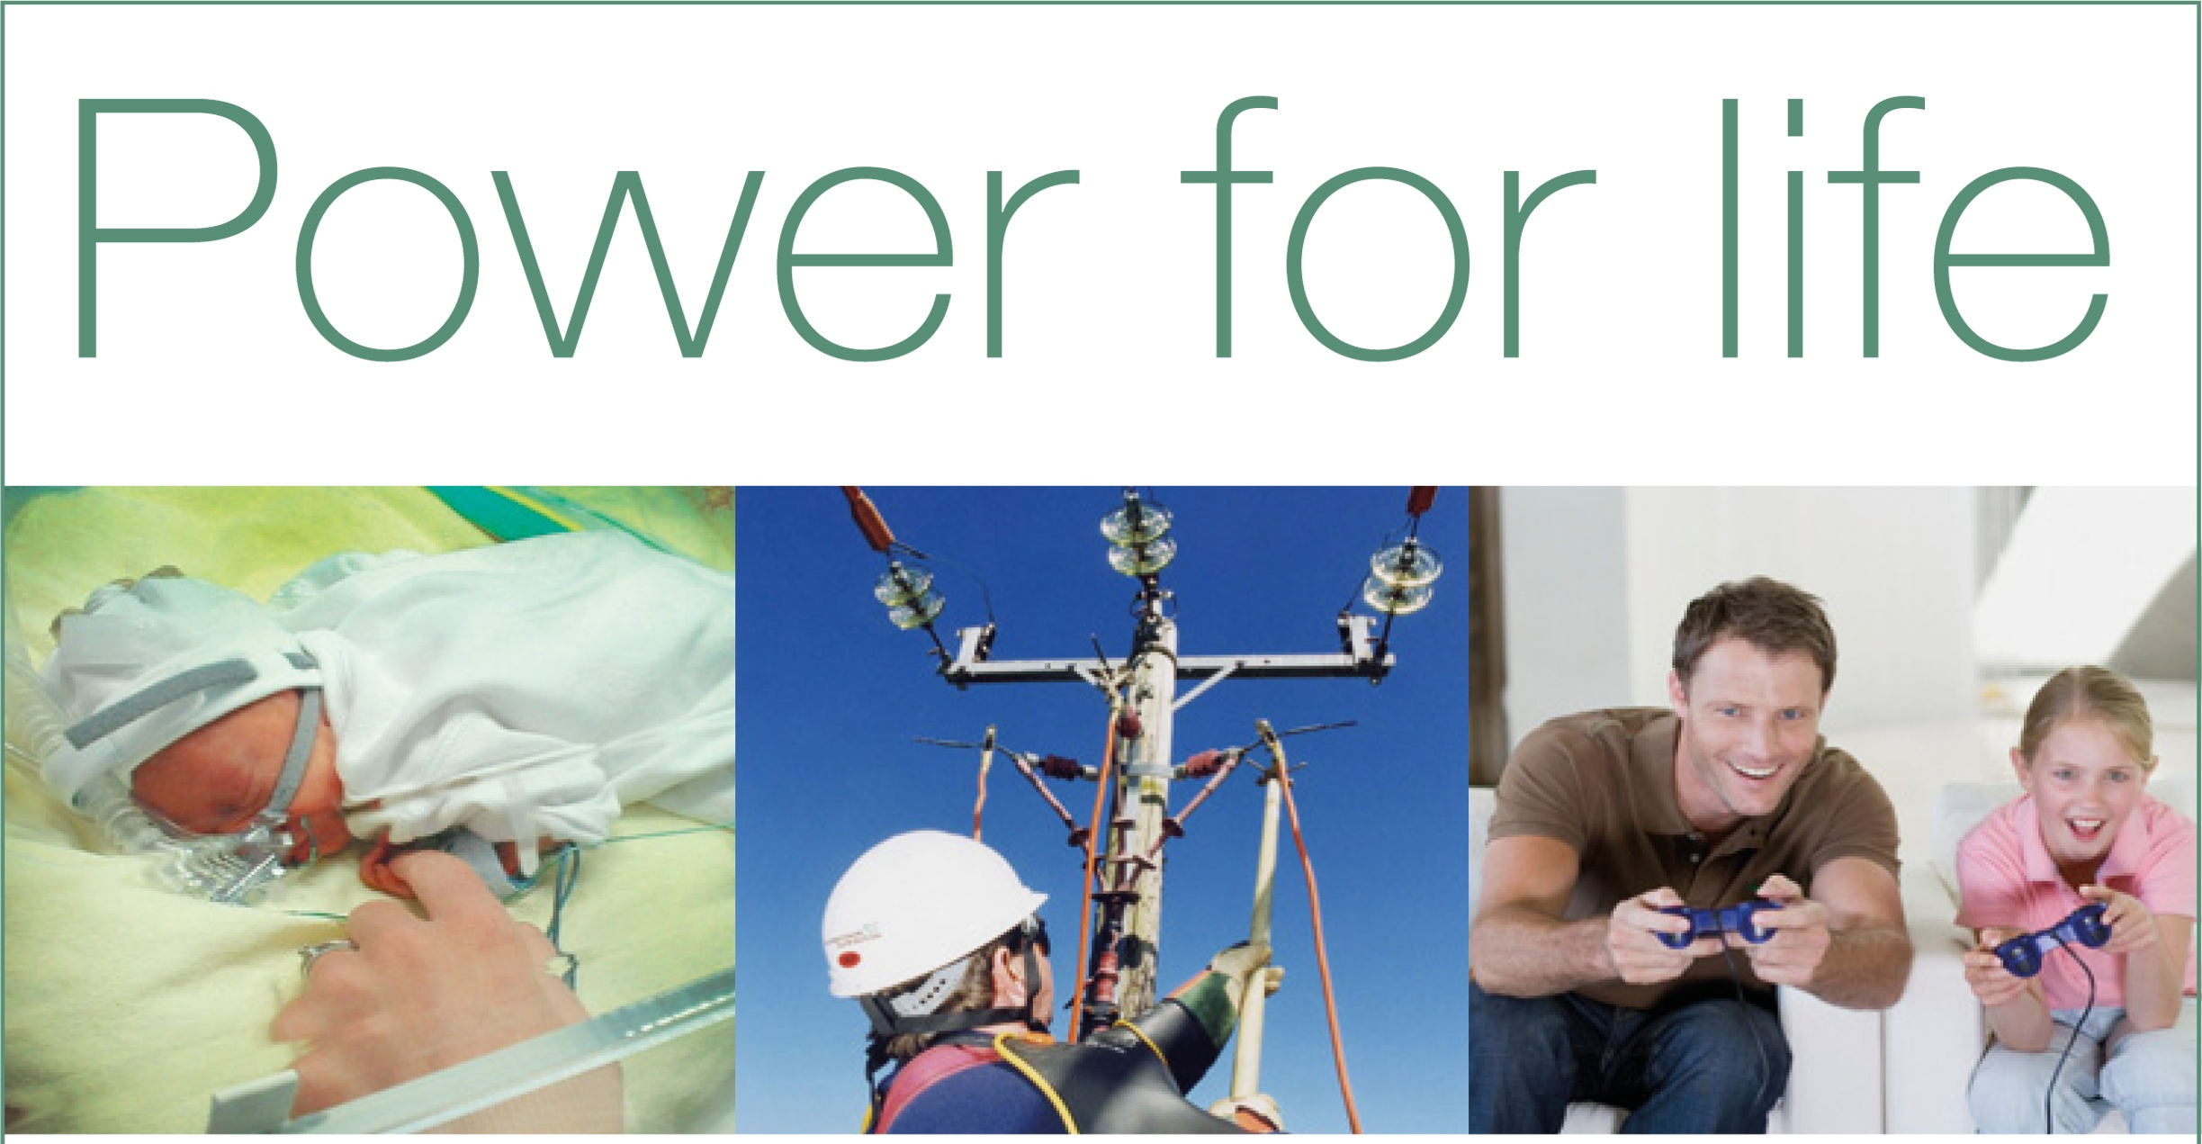
Delivering electricity to homes and businesses is about more than just cables and wires, poles and pylons. It’s about providing people with a service that they can depend upon to help them live their lives to the full.
At Western Power Distribution we are investing many millions of pounds long-term on our electricity network to ensure all our customers continue to receive the same world-class service.
We are proud to be leading the way in terms of customer service, network reliability, technical innovation and environmental care, but we are not complacent. This is why we will continue to set our own demanding performance targets and exceed those set by our industry regulator.
Our Target 60 initiative is a case in point, for when power interruptions occur its aim is to restore supplies within the first hour. This is a commitment our customers can depend upon.
To find out more about our plans for the future visit www.westernpower.co.uk or email info@westernpower.co.uk.
If you have a power cut – call 105 or 0800 6783 105

