Incorporating Sylw | No. 40

The COST of LIVING
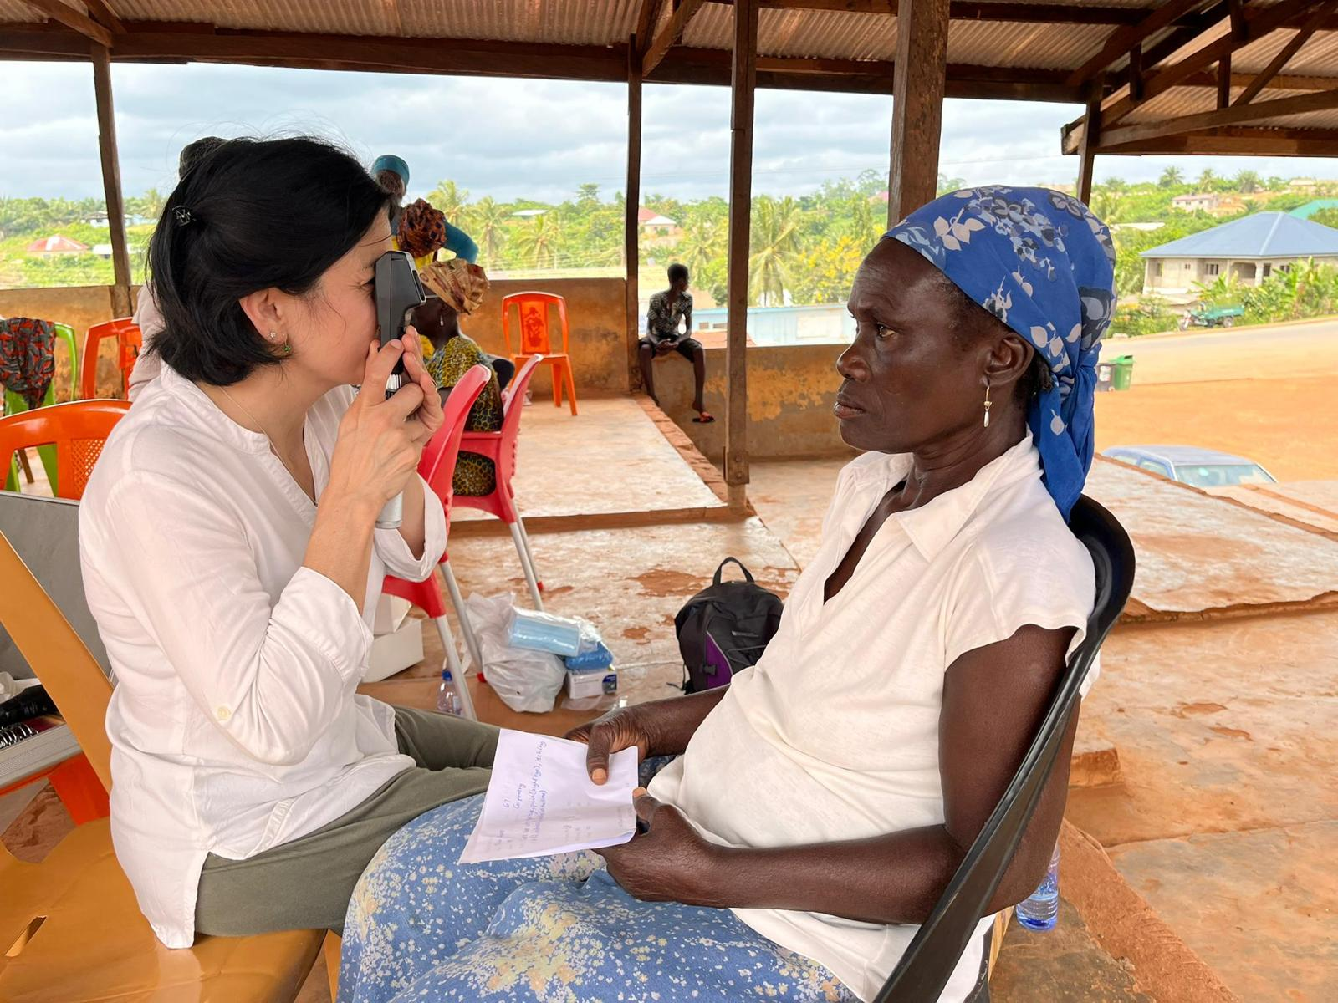

Plus: Cardiff optometry students supporting eye services in Africa.

IN THIS ISSUE
SYLVIA AND LAURA ON VOLUNTEERING IN AFRICA.

THE COST OF LIVING CRISIS AND DISABLED PEOPLE.

RECOGNISING A SCAM.

SUPPORT WITH THE COSTS OF LIVING.
COST OF LIVING SUPPORT SCHEME.
DISCRETIONARY HOUSING PAYMENT DIRECTORY.

UK GOVERNMENT ASSISTANCE WITH RISING ENERGY COSTS.

OTHER SUPPORT WITH HEATING COSTS.

FOOD AND FOOD BANKS.

TRAVEL CONCESSIONS.

OTHER CONCESSIONS.

BENEFITS AND DISABILITY BENEFITS.

OTHER SOURCES OF ADVICE AND SUPPORT.

SYLW BULLETIN.

SILVIA AND LAURA ON VOLUNTEERING IN AFRICA
Silvia and Laura are optometry students at Cardiff University. This summer they volunteered to work in Africa to support the programme of eye treatments there.

At the end of June, a group of 8 students from Cardiff University School of Optometry and Vision Sciences travelled to Malawi and another group travelled to Ghana. The aim of this trip to Africa was to participate in a student programme, volunteering as optometrists and helping as many people as possible to see better.

The students performed sight tests in the main hospitals and rural areas, giving as many refractive corrections (glasses) as possible, eye drops, and sponsored cataract surgeries when required.
Some of the most common eye conditions in Africa are glaucoma and river blindness (a tropical disease caused by parasites), especially in areas with difficulty in accessing fresh water; however, the major causes of blindness in Africa are simple eye conditions that are easily resolvable in the UK. The main one is cataract followed by visual impairment caused by refractive errors; this means that while in the UK we can easily access a sight test and glasses made on the same day at a reasonable affordable price, in many areas of Africa lots of people become visually impaired just because they cannot have an adequate pair of glasses.
This also applies to cataracts: in the UK most cataract surgeries are covered by the NHS and most people can happily have their vision restored with a fast procedure, while in Malawi and Ghana this procedure is not that simple: lack of transport, time and financial resources often prevent their access to such an easy surgery.

Before the departure the students collected secondhand and new spectacles, ophthalmic equipment, together with money to sponsor cataract surgeries, and eye drops.

By doing this perhaps we gave an acceptable level of vision and made a positive impact to some degree on the life quality of the local people, and at the same time learned a great deal from the experience and came back home with a different level of understanding and awareness. This experience will make us better people and give us ideas on how to contribute better once fully qualified as optometrists.

THE COST OF LIVING CRISIS AND DISABLED PEOPLE
A recent meeting between the Disability Forum and the Minister for Social Justice discussed the additional impacts the cost of living crisis has on disabled people. The Leonard Cheshire Foundation conducted an opinion poll of over 1,200 working-age disabled adults. It found that over a 12-month period:

- 41% had not been able to visit family and friends;
- 36% had been unable to leave their house, shop for food or clean their home;
- 28% had not been able to prepare a meal
- 24% had been unable to work.
- 25% had missed a meal because they could not afford it.
- 28% had not been able to afford to keep their home warm.
- 30% had asked for financial help from friends or family.

This edition of Roundup highlights sources of support and advice to help with financial pressures.

RECOGNISING A SCAM
A scam is a way of conning you out of your money by giving you the impression that you owe something to the scammer, or they are offering something for you. Scammers try find their way in through our weak spots when we are most vulnerable. With disabled people facing economic pressures with the rise in fuel and other costs, it is easy to be tempted by offers with financial incentives. Citizens’ Advice gives help with spotting scams. Here are some initial tips.

It might be a scam if:

- it seems too good to be true – for example, a holiday that’s much cheaper than you’d expect;
- someone you don’t know contacts you unexpectedly;
- you suspect you’re not dealing with a real company – for example, if there’s no postal address;
- you’ve been asked to transfer money quickly;
- you've been asked to pay in an unusual way – for example, by iTunes vouchers or through a transfer service like MoneyGram or Western Union;
- you’ve been asked to give away personal information like passwords or PINs;
- you haven't had written confirmation of what's been agreed.

[Source: Citizen’s Advice website]

To report a suspected scam contact
Action Fraud on 0300 123 2040.
For further advice contact
Citizens Advice Consumer Service on 0808 223 1133
or 0808 223 1144 for a Welsh speaking advisor.

And remember – if you are dealing with a genuine service you should never feel under pressure to complete a transaction if you want more time to consider it. Scammers will often show their impatience if you delay the process. If they’re getting rude or short with you, it’s quite likely they are trying to scam you.

Never carry out a transaction online if they have asked you to download an app or computer programme to complete the transaction – it is likely that they are trying to gain access to your computer that way. If they ask you to download anything during the sale or refund - don’t! You’d be best advised to hang up and speak to Action Fraud.

Email scams.

It’s very common to get emails suggesting you have had your access to a service limited or cancelled until you renew, or that offer you free or cheap products, holidays, and so on. They use psychological manipulation to draw you in. These are some things to guard against and look out for.

1) Visceral influence: Sounds unpleasant but this simply means the scam makes you feel a certain way: excited or scared, for example. Your mind wants to deal with these feelings immediately because they are deep-seated emotions. But the mind does not act rationally under these conditions. Sit back. Don’t act upon it until you’ve thought about it. Make yourself a coffee!

2) Urgency: Again, don’t act too fast. They will often put real or implied time limits on what they want you to do: ‘you have 24 hours to reply’; ‘only the first 100 people will get the free holiday’ and so on. Stop and think. Check who these people are. Don’t click on the links in the email, but research them independently of the email. If it’s a scam, there’ll almost certainly be information online about it (but see ‘Authority’ below). Or contact Action Fraud above if you are concerned and need someone independently to check for you.

3) Scarcity: Are they offering deals or incentives because you are a ‘valued customer’? Are you being told that there are only 100 people who will win the prize? If something is scarce, we instinctively want it and will act quickly to get it. We are also more likely to agree to things that we would normally be wary of (such as downloading software apps). Again – stop and think! Sit back and allow your brain to calm down a bit.

4) Authority: Emails can look very professional. They often use the logos of big companies such as Microsoft (they don’t care if they are breaking any laws, remember). They do this because we tend to respond positively to authority. Their language might be legal speak, making them sound authoritative. If it’s a scam, the chances are there’ll be mistakes in the writing: not just spelling mistakes, but factual errors as well. Sometimes they’ll have assumed something about you that you know isn’t true – for instance that you are an existing customer. Read the email carefully. Be sceptical! Sometimes the email address they use is fake. Try to check these details.

They might also try to increase their authority through testimonials. We tend to feel more confident in a service if there are genuine-seeming testimonials from happy customers. Some scammers use social media channels to create a group discussion along the lines of ‘Is this is a scam, it seems too good to be true?’ with replies like ‘I thought so at first, but I replied and they sent me a computer within a week. I’m so impressed!’ Again, look at our checklist above! If it seems too good to be true, it probably is a scam!

5) Charity and greed: We all know those emails that seem to come from people who have family members needing expensive life-saving operations and so on. The language is often couched in Christian terms to appeal to our sense of charity. Similarly, we get ones where they are offering to deposit money in your bank account because you are a benefactor in someone’s will. These are easy to spot and are almost certainly scams. They appeal to our desire to help people out or, alternatively, simply appeal to our greed. In the case of being donated money, a genuine offer will be easy to spot because there will be sufficient information relating the sender to yourself – the chances are you would know them personally.

SUPPORT WITH COSTS OF LIVING

Welsh Government information

The web page https://gov.wales/get-help-cost-living gives information on the following: Universal Credit (see below); New Style Employment and Support Allowance; New Style job Seeker’s Allowance; Personal Independence Payment (see below); Statutory Sick Pay; Pension Credit and more.

Cost of Living Support Scheme

The Cost of Living Support Scheme has two elements:
1) The main scheme is the £150 payment for council tax bands A-D and households benefitting from the Council Tax Reduction Scheme
2) The discretionary scheme is the funding that has been provided to Local Authorities which decide on targeted support. Not all LAs are doing the same thing.
The main scheme:
Under the main scheme households are limited to one payment of £150 – this was stated to ensure that duplicate payments weren't made, for example, a payment is made to a property in Band B, but they cannot receive another because they are also in receipt of Council Tax Reduction.
The discretionary scheme:
Each local authority can decide how best to target resources in their individual area. For example, Local Authorities can provide support dependent on need or they may choose to provide extra support to specific groups, such as families with children.

Someone can receive £150 under the main scheme and also apply for support to their local council for help under the discretionary scheme.

Each Local Authority manages and defines its own Discretionary scheme. However, the Government has set overarching eligibility criteria:

Discretionary Housing Payments provide financial support towards housing costs and are paid by an LA when they are satisfied that a claimant needs further financial assistance with housing costs and is in receipt of either:

- Housing Benefit (HB) or
- Universal Credit (UC) with housing costs towards rental liability

Owner-occupiers are not eligible to receive DHPs, with the exception of Shared Ownership properties which carry a rental liability.

In general, ‘housing costs’ usually refers to rental liability, as well as:
- rent in advance
- deposits
- other lump sum costs associated with a housing need such as removal costs

In most cases, a claimant will need to demonstrate that they are unable to meet housing costs from their available income or that they have a shortfall in meeting their housing costs.

Government Guidance
https://www.gov.uk/government/publications/discretionary-housing-payments-guidance-manual/discretionary-housing-payments-guidance-manual

Advice from Shelter Cymru
https://sheltercymru.org.uk/get-advice/paying-for-housing/housing-benefit-and-council-tax-reduction/discretionary-housing-payments/

Discretionary Housing Payment Directory
Contact your local authority to claim Discretionary Housing Payment. Website addresses are given only where the phone number is unknown.

Anglesey: Call the freephone number - 0800 859 5924 - which is free from landlines or call 033 0101 5000 which is charged at a local rate.

Blaenau Gwent: Telephone 01495 353398

Bridgend: https://www.bridgend.gov.uk/residents/benefits-and-support/discretionary-housing-payments/

Caerphilly: Tel: 01443 866567

Cardiff: https://www.cardiff.gov.uk/ENG/resident/Benefits-and-Grants/Housing-Benefit/Discretionary-Housing-Payments/Pages/default.aspx
Carmarthenshire: Tel: 01554 742100

Ceredigion: Tel: 01970 633252

Conwy: Tel: 01492 576491

Denbighshire: https://www.denbighshire.gov.uk/en/benefits-grants-and-money-advice/housing-benefits/discretionary-housing-payments.aspx

Flintshire: https://www.flintshire.gov.uk/en/Resident/Council-Tax-and-Benefits-and-Grants/Housing-Benefits.aspx

Gwynedd: Tel: 01286 682689

Merthyr Tydfil: Customer Care Tel: 01685 725000

Monmouthshire: Tel: 01633 644644

Neath Port Talbot: https://www.npt.gov.uk/5069

Newport: Tel: 01633 656 656

Pembrokeshire:
Telephone 01437 764551
From a mobile call 0345 601 5522

Powys: Tel: 01597 827462 (all areas)

RCT: Housing advice centre Tel: 01443 425005

Swansea: Advice line: 01792 635885

Torfaen: Customer Care Team Tel: 01495 766430

Vale of Glamorgan: Tel: 01446 709244

Wrexham: Switchboard: 01978 292000

UK GOVERNMENT ASSISTANCE WITH RISING ENERGY COSTS
The UK Government has announced the following measures to help with rising energy costs:

Money off energy bills

All electricity customers will get £400 off their energy bills between October 2022 and April 2023. This is a grant, not a loan – so you don't have to pay this money back through future bills.

If you're a pre-payment customer, you will receive a voucher or have the money applied as credit to your meter.

Payments are expected to be made across six months starting in October 2022, but the exact design of the scheme is not yet confirmed.

One-off payments

This year (2022-23), you may also be entitled to one or more lump-sum payments. These are:

- a £300 Pensioner Cost of Living Payment (PCLP)

This is for households that receive the Winter Fuel Payment. It will be paid as a top-up to your Winter Fuel Payment in November/December, which means you can receive it in addition to your usual Winter Fuel Payment (and Warm Home Discount, if you also qualify for this). To be eligible for the PCLP, a person will need to be over State Pension (SP) age between 19–25 September 2022. Provided they are over SP age at any point in this period, they will receive the PCLP. For example, if a person was born on 26 September 1956, they will not receive the payment, as they will become SP age outside of the specified eligibility window.

- a £650 Cost of Living Payment (CLP)

This is for households on means-tested benefits, such as Pension Credit and Universal Credit. You'll be paid in two instalments if eligible. Your eligibility for the first instalment will depend on your circumstances on 25 May 2022. The UK Government has announced that the first instalment will be £326 and should begin to be paid into people’s bank accounts from mid-July 2022. You should have received it by the beginning of August. The second instalment of £324 will be sent out in the Autumn.

If a person begins a claim for Pension Credit (PC) after 25 May 2022, and then later receives an award which is backdated to a date on or before 25 May 2022, they would be eligible to receive a CLP. The DWP have advised us that the last date to make a claim for PC to be eligible for a CLP will be 24 August 2022. It doesn’t matter which type of Pension Credit a person receives – both Guarantee Credit and Savings Credit will mean you're eligible for the CLP.

- a £150 Disability Cost of Living Payment

These payments are for those receiving disability benefits, such as Attendance Allowance. People will get this payment in September. To qualify, you must have been in receipt of a disability benefit on 25 May 2022 (or have made a claim for a disability benefit by 25 May 2022, which was later successful).

None of these one-off payments are taxable and they won't count towards the benefit cap or affect your benefit entitlement in regard to existing benefits which you qualify for.

[Source: Age UK website ageuk.org.uk]

OTHER SUPPORT WITH HEATING COSTS

Care and Repair ‘70+ Cymru’ project – Tackling fuel poverty

Care and Repair Cymru’s 70+ Cymru project aims to improve the warmth, comfort, and quality of life for older people in Wales at a time of rising fuel prices, by visiting homes and providing advice and support on home energy saving techniques and housing improvements.

Care & Repair have a team of 70+ Cymru Home Energy Officers working across Wales, who can visit you and work with you to find ways to keep your home safe and warm. They do this by:

- Assessing your home to make sure it is insulated and well-heated
- Offering you advice on ways to save energy
- Helping you to apply for benefits and grants that will help keep you warm
- Ensuring that your heating system and heating appliances are safe
- Helping to make improvements where there is damp and condensation
- Connecting you to other Care & Repair specialist services and support, which include support for people with sensory loss.

The 70+ Cymru service is available to anyone in Wales aged 60 or over who owns their own home or privately rents.

For more information telephone 0300 111 3333.

10 Energy-Saving Tips from Care & Repair

(Please note: the recommended brands are Care and Repair’s suggestions – not WCB’s).

1. Manual socket timers. These little timers turn off appliances at the plug, so you don’t have to remember to. You set the time controls to whatever suits you. Turning your TV off at the socket with one of these could save £30 per year.
Typical cost: £4.99
Brand we recommend: Defender – Solon Equipment

2. Energy-efficient bulbs. Switch to efficient light bulbs, and you could save from £3 to £6 per bulb per year. They are good for your pocket and good for the planet.
Typical cost: £5.99
Brand we recommend: Status International

3. Night lights. Do you leave on lights during the night for safety or reassurance? Well, these night lights are low energy - using them instead of leaving a main light on through the night will save you money and energy.
Typical cost: £4.99
Brand we recommend: Defender – Solon Equipment

4. Remote plug sockets. These are like manual socket timers, but remote controlled. A remote plug socket gives more flexibility than a timer, they’re particularly useful if you have difficulty bending down to use mains sockets. Bonus, they save energy just the same.
Typical cost: £5.99
Brand we recommend: Status International

5. Letter box brushes. Simple brushes inside letter boxes can stop draughts and increase warmth. Pro-tip: you may also be able to use similar brushes around attic hatches. Stopping draughts saves money.
Typical cost: £9.99
Brand we recommend: Stormguard

6. Insulation tape. This simple and versatile tape can be used externally in wet conditions and internally. It seals gaps around doors and windows, stopping draughts.
Typical cost: £9.99
Brand we recommend: Stormguard

7. Door draught excluders. Draught excluders come in many forms and can be the easiest way to stop your heat escaping. Stopping draughts could save you £25 per year.
Typical cost: £11
Brand we recommend: Tesa

8. Radiator foils. These are reflective panels that sit behind your radiator. The foils reflect heat from the radiator back into the room, reducing heat loss and keeping you warmer. What’s not to like about that?
Typical cost: £19.99 (3 sheets)
Brand we recommend: Radflex

9. Cold alarms. It’s better to keep your home at a steady temperature – if the temperature drops too low, your heating system may need to use lots of energy to bring the temperature up again. A cold alarm provides a series of visual and audible warnings when the temperature in your home drops.
Typical cost: £9.99
Brand we recommend: Gti

10. Chimney pillows. Chimneys suck warm air out of your house. A chimney pillow (sometimes called chimney balloon) stops the heat escaping– it’s like double glazing for your chimney.
Typical cost: £14.99
Brand we recommend: Stormguard

[Source: Care and Repair website.]

FOOD AND FOOD BANKS

Best before? Look, Smell, Taste!

An estimated 10% of food is wasted because people often don’t know what the Best Before date means. On food products, this date is just to advise you of when the food is at its best. It doesn’t mean the food has suddenly become inedible – it will often be perfectly good for some time.

An initiative by the people at ‘Too Good To Go’ is to reduce food waste by encouraging a sensible approach to checking stuff that’s past the Best Before date. Their advice is …

Look: Check the food for signs of visual decay.
Smell: Sniff the food to test whether it smells as it usually would.
Taste: Taste a small amount of the food to check whether it's turned unusually tangy or sour.

Here’s their explanation of the different product dates:

USE BY
This is found on food that goes off quickly - fish, meat products, and salads-to-go, for example. This food will be unsafe to consume after this date. Remember that you can extend the life of use by food by freezing - although you must freeze it before the Use By date passes.

BEST BEFORE
You’ll see this on packaged foods such as frozen, tinned, or dried items. It means that food may have lost some of its flavour or texture after this date. However, it doesn’t mean food will be unsafe to eat after this date. If the date has passed but the food still looks, smells, and tastes okay, you’re in the clear.

DISPLAY UNTIL or SELL BY
This is found on all kinds of products. This is not useful to the consumer – it is only there to help the staff in shops know how long products have been sitting on shelves. These labels aren’t required by law.

Too Good To Go

The Look, Smell, Taste initiative is delivered by Too Good To Go, whose mission is to reduce food waste globally. They work in conjunction with retailers to provide packages of food at a third of the retail price. Via an app you can find a local retailer who is involved in the scheme and order a food parcel. You collect it at the designated time. You don’t get to choose what goes in the parcel; that’s up to the retailer as it depends on what they have at the time. You can specify if you are vegan or vegetarian. (Our inspection of the app does not show any options for allergies and intolerances, however).

The app is available from https://toogoodtogo.co.uk/en-gb/consumer

Trussel Trust

There are over 1,200 food bank centres in the Trussell Trust network. The services provided by food banks may vary from area to area as they react to the needs of their community to provide help and support to local people in crisis.

Food donations
Non-perishable, in-date food is donated by the public at a range of places, such as schools, churches, and businesses, as well as supermarket collection points. It is then sorted into emergency food parcels to be given to people in crisis.

Food vouchers
Care professionals such as health visitors, staff at schools and social workers identify people in crisis and issue them with a food bank voucher. This means people can receive a food bank parcel of three days’ nutritionally balanced, non-perishable food from their local food bank.

You can locate a food bank via the Trussel Trust website: https://www.trusselltrust.org/get-help/find-a-foodbank/

Telephone: 01722 580 180

TRAVEL CONCESSIONS

Rail Travel

Information is correct at the time of writing but is liable to change.

Disabled Person’s Railcard

If you are vision impaired, and can produce evidence of this (for example, a Certificate of Visual Impairment), you can apply for a Disabled Person’s Railcard, which allows you to get 1/3rd off most rail fares throughout Great Britain. There is a charge of £20 for a one-year card, or you can get a three-year card for £54. You can find out more and apply online here: https://www.disabledpersons-railcard.co.uk/ .

You can also download an application form here:
https://www.disabledpersons-railcard.co.uk/help/application-forms/

You will then need to complete and return this application, along with the required proof of disability and payment to:

National Railcards
PO Box 10776, Ashby-de-la-Zouch
LE65 9FA

Concessionary discounts

If you are blind or partially sighted and don’t have a Disabled Persons Railcard and are traveling with a companion, the following concessionary discounts apply for both you and your companion. You cannot receive this discount if you are travelling on your own. The discount applies to adult fares only. In order to receive the discount, you will be required to present evidence of your vision impairment, such as your Certificate of Visual Impairment. The tickets can only be purchase from a staffed National Rail station ticket office and on the train.

- First or Standard Class anytime single or return tickets – 34% discount
- First or Standard Class anytime day single – 34% discount
- First or Standard Class anytime day return – 50% discount

Season tickets

If you are blind or vision impaired you can also purchase a Season ticket, enabling you and a companion to travel on National Rail services only at no extra cost. The tickets can be bought from staffed National Rail station ticket offices.

Assisted Travel

If you require assistance on your train journey, you can book this service via the following methods:

Transport for Wales Passenger Assist team:
Phone: 03330 050 501
Text relay service: 18001 03330 050 501

National Rail:
Phone: 03457 48 49 50 or 0800 022 3720
Text Direct: 0345 60 50 600 (for people who are hard of hearing or deaf)

Bus Travel

Disabled Bus Pass

If you are eligible for a Disabled Bus Pass, you can travel for free on most bus services in Wales and the boarders and get discounted or free travel on many rail services. For further information contact Transport for Wales on 03333 211 202.

You can apply for your Disabled Bus Pass via the Transport for Wales website at www.tfw.wales and some local authority hubs. Contact your local authority for further information. If you require a paper application form, please call 0300 303 4240.

Companion Cards

If you require assistance from another person when travelling for some or all of your journeys, you can apply for a companion card that provides free travel for one person accompanying you.

If you require a companion card, you’ll need to contact your local council who will assess whether you meet the criteria and process your application.

[source: Transport for Wales website]

Taxi Schemes

Your local authority might offer a scheme to help with taxi costs if you have a disability. However, the schemes can vary.

Contact your local authority to find out whether they offer a taxi scheme and whether you would be eligible.

Patient Transport

Eligible patients can arrange free transport to non-emergency medical appointments at clinics, hospitals and day centres with the Welsh Ambulance Service.

To find out if you are eligible and to book your transport, please contact the Welsh Ambulance Service on 0300 123 2303.

OTHER CONCESSIONS

Blue Badge Scheme

People who have a signed Certificate of Visual Impairment or who receive certain disability benefits may be eligible for a Blue Badge, enabling certain parking concessions. Blue Badges are free in Wales and are issued by local authorities. The badge is usually valid for 3 years.
For more information, visit the Welsh Government website:
https://gov.wales/apply-or-renew-blue-badge

TV Licence Concession

If you are registered blind (severely sight impaired) and can provide the appropriate evidence, you are eligible to apply for a 50% concession. Your licence will also cover anyone who lives with you. If you are registered partially sighted (sight impaired) you are not eligible.

You can find out more on the TV Licensing website:
https://www.tvlicensing.co.uk/check-if-you-need-one/for-your-home/blindseverely-sight-impaired-aud5

Free over 75 TV Licences are only available to households that receive Pension Credit.

You can contact TV Licensing on 0300 790 6117.

Free Directory Enquiries from BT

If you can't read or hold the phone book due to visual impairment, illness or disability, you can apply for free 195 directory enquiries from BT, whether or not BT is your telephone company. Once signed up, you can ring 195 and request a number from the operator.

Call 0800 587 0195 to request an application form. Your form will need to be signed by a medical professional who knows you, such as your doctor or nurse.

Council Tax Reduction

If your property has been adapted in specific ways because you are substantially and permanently disabled, you’ll be eligible to get your Council Tax bill reduced by one valuation band. For example, if the property is valued in Band C, the bill will be charged in Band B.

To qualify for a reduction in your valuation band, the adaptation must be essential or of major importance to the disabled person's well-being. No reduction is available where adaptations have only been made outdoors.

For more information, see the Welsh Government website:
https://gov.wales/council-tax-discounts-and-reduction/disabled-people

Cinema Exhibitors’ Association Card

This is a national card which entitles a disabled person to one free ticket for a person accompanying him or her to the cinema. The card costs £6.00 and is valid for one year. You must be registered blind, or in receipt of certain benefits, and evidence of entitlement and a photograph must be provided. The application form can be downloaded from the website www.ceacard.co.uk .

Telephone 01244 526 016 or email info@ceacard.co.uk.

Hynt Card

Hynt is a national access scheme that works with theatres and arts centres in Wales to make sure there is a consistent offer available for visitors with an impairment or specific access requirement, and their carers or Personal Assistants. If you need support or assistance to attend a performance at a theatre or arts centre then you may be eligible to join Hynt.

Hynt cardholders are entitled to a ticket free-of-charge for a personal assistant or carer at all the theatres and arts centres participating in the scheme. Participating venues include theatres across Wales, such as Cardiff New Theatre, Aberystwyth Arts Centre, Venue Cymru and Theatr Colwyn.

For more information, visit the Hynt website, https://www.hynt.co.uk/en/ or contact the help desk on 01244 526001.

Other Concessions

Many theatres, leisure centres, tourist attractions and other providers of goods and services provide discounts to disabled people or a person who accompanies them. However they are not necessarily publicised, so it is always worth asking.

If you are aware of any other concessions which may be of interest to readers of Roundup, please let us know.

BENEFITS AND DISABILITY BENEFITS

Universal Credit.

Universal Credit is a payment to help with your living costs if you are on a low income, out of work or you cannot work. If you have a health condition or impairment, you may be entitled to an extra amount.

Universal Credit is replacing the following benefits:

- Housing Benefit
- income-related Employment and Support Allowance (ESA)
- income-based Jobseeker's Allowance (JSA)
- Child Tax Credit
- Working Tax Credit
- Income Support

Universal Credit Helpline: 0800 328 5644.
Welsh language: 0800 328 1744.

Pension Credit

Pension Credit gives you extra money to help with your living costs if you’re over State Pension age and on a low income. Pension Credit can also help with housing costs such as ground rent or service charges.

You might get extra help if you’re a carer, severely disabled, or responsible for a child or young person.

Pension Credit is separate from your State Pension. You can get Pension Credit even if you have other income, savings or own your own home.

You can apply by phone if you prefer. A friend or family member can call for you if you cannot use the phone.

Pension Credit claim line

Telephone: 0800 99 1234 (Croesawir galwadau yn Gymraeg / Calls are welcomed in Welsh)

Disability benefits
If you are a disabled person, you may be eligible for certain benefits. We’ve given information on these below.

If you require further information about benefits, please contact:

Citizen’s Advice Bureau on 0800 702 02020 to find out more or to make a claim.

Alternatively, contact Wales Council of the Blind on 02920 473 954 to find an organisation that can advise with benefits or help you to complete a claim form.

Disability Living Allowance (Children)

Disability Living Allowance is a tax-free benefit for children under the age of 16 who have care or mobility needs.

You can apply for DLA for a child if one of the following apply:

- They required more care, attention and supervision than a child of the same age who isn’t disabled.
- They have difficulty walking or getting around outdoors in unfamiliar places, compared to a child of the same age who isn’t disabled.

Personal Independence Payment (PIP)

PIP is money for people aged 16 or over and have not reached State Pension age who have extra care or mobility needs as a result of a disability. PIP is not means tested and can be claimed in addition to most other benefits.

PIP comprises two parts:

- Daily Living - if you need support with everyday tasks.
- Mobility – if you need help with getting around.

You can make a claim by calling free on 0800 917 2222. Calls are welcomed in Welsh.

Attendance Allowance

Attendance Allowance is a tax-free benefit for people who have reached State Pension age to help with extra costs if you have a disability severe enough that you need someone to help look after you.

The payment is not means tested and how much you can get will depend on the level of care that you need. The allowance does not cover mobility needs.

You do not have to have someone caring for you in order to claim for Attendance Allowance.

Carer’s Allowance

You can usually get Carer’s Allowance if all of the following apply:
- you're aged 16 or over
- you're not in full time education
- you spend at least 35 hours a week caring for a disabled person
- you don't earn more than £132 a week from employment or self-employment – after deductions such as income tax, National Insurance and half of your pension contributions
- you're not subject to immigration control that would stop you getting benefits
The person you're caring for must get one of the following benefits, called 'qualifying benefits':
- Attendance Allowance
- Constant Attendance Allowance
- the care component of Disability Living Allowance at the middle or highest rate
- the daily living component of Personal Independence Payment (either rate)
- Armed Forces Independence Payment

Employment and Support Allowance (ESA)

ESA can help with living costs if you have difficulty working because you are sick or disabled. You can also receive support to help you get back into work.

You cannot get Statutory Sick Pay and ESA at the same time but you can apply for ESA up to 3 months before your SSP ends.

People who are self-employed can also claim ESA.

To claim ESA you must:
- be aged 16 or over
- be under State Pension age
- live in England, Wales or Scotland

You can only do a limited amount of work while you get ESA.

Disability Premiums

Disability premiums are extra amounts of money that can be added to your:

- Income Support
- income-based Jobseeker’s Allowance (JSA)
- income-related Employment and Support Allowance (ESA)
- Housing Benefit

There are 3 types of disability premium for adults:
- disability premium
- enhanced disability premium
- severe disability premium

OTHER SOURCES OF ADVICE AND SUPPORT

Older People’s Commissioner for Wales

If you are over 60, living in Wales and are in need of help or support, the Older People’s Commissioner’s Advice and Assistance team may be able to help. This covers concerns that your rights may have been breached, or if you have been experiencing problems with services, such as health, social care, community services or housing.
You can also get in touch on behalf of an older person, such as a family member or friend if they are facing issues or difficulties.

To contact the team, please ring 03442 640 670 or email them at ask@olderpeople.wales

Care and Repair Cymru

A service for older people. A caseworker visit helps determine the client’s housing, personal and financial circumstances, before discussing solutions to housing problems and providing advice on welfare rights and funding available for home improvements.

Contact your local Care & Repair 0300 111 3333

Age Cymru Advice

Provides confidential, impartial and expert information and advice to older people, their families, friends, carers and professionals. This covers issues such as care and support, health and wellbeing and benefits.

Telephone 0300 303 44 98 to speak to someone directly, in English or Welsh, Calls charged at local rate, and the line is open between 9:00am and 4:00pm, Monday - Friday. You can also Email advice@agecymru.org.uk.

Turn2Us

Turn2us is a national charity providing practical help to people who are struggling financially. This includes benefits checks and grant searches.

Telephone helpline - 0808 802 2000, 9.00 am - 5.00 pm Mondays-Fridays. Much of the information is also available via the website, www.turn2us.org.uk.

Contact

UK charity for families with a disabled child. Helpline provides advice, information and support.

Helpline 0808 808 3555 or email helpline@contact.org.uk

Access to Work

Access to Work can help you get or stay in work if you have a physical or mental health condition or disability. It is to cover the additional costs of employment due to disability.

The support you get will depend on your needs. This may include a grant to help pay for practical support with your work, taxi fares to work or a support worker if you cannot use public transport for example.
To find out more contact Access to Work on 0800 1217479.

Money Saving Expert

If you have internet access, it is worth having a look at www.moneysavingexpert.com , and signing up to their weekly newsletter. The site contains information and tips on how to save money in a huge range of areas such as banking, insurance, utilities and travel, as well as information on benefits, and news of special deals from shops and service providers. It also covers topics such as the effect of changes announced in the Budget.

SYLW BULLETIN

News

Diary marker - Wales Eye Care Conference

The annual Wales Eyecare Conference is back! It will be held on Monday 7th November – contact WCB on 029 20 473954 or email owen@wcb-ccd.org.uk for more information.

Consultations and Surveys

England and Wales Blind Golf survey

England and Wales Blind Golf (EWBG) are currently undertaking a large scale survey to communicate with blind and partially sighted people in Wales. They aim to raise the profile of the charity, which supports blind and vision impaired people to take up or continue playing golf.

Currently, out of approximately 50 active members, there are only three Welsh members playing regularly within the EWBG events. They would therefore like to find out why the numbers taking part in regular golf are so low. With the help of several specialist organisations within Wales they are looking to communicate with potential future members to encourage participation in the wonderful sport of golf.

Often the two main issues preventing people playing golf after sight loss are finding a sighted volunteer guide in the locality to assist with travelling and playing golf, and financial reasons, including cost of equipment and playing at a golf course. In many instances, EWBG can help with some initial funding to help with set up costs, and they are working with Wales Golf Affiliated Clubs to find sighted guides together with reducing costs for people with sight loss.

EWBG are keen to understand the barriers preventing people with sight loss from playing golf by completing a short survey. All responses returned will be put into a draw for a £25 voucher for a local or national store of your choice.

To take part, please call Geoff Morris on 01594 845900 or email geoff.morris123@btinternet.com to request a call back. If your call is unanswered, please leave your name and contact number and Geoff will call you back within 48 hours.

Events

Vision Support Community Information Unit

Vision Support’s Community Information Unit covers the Wrexham, Flintshire, Denbighshire and Conwy areas (as well as Cheshire and Halton). Visit the unit if it is in your area to find out about services, technology and products that can help people with sight loss
The schedule for August is:

Monday 1st Asda, Llandudno 10.00am – 2.30pm
Tuesday 2nd Ysbyty Gwynedd, Bangor 10.30am – 2.30pm
Wednesday 3rd Chirk AAA car park 10.30am – 2.30pm
Thursday 4th Lard Yr Orsaf car park, Porthmadog 10.30am – 2.30pm
Friday 5th Lower High St car park, Prestatyn 10.00am – 2.30pm
Monday 8th Rhos on Sea by TIC 10.00am – 2.30pm
Wednesday 10th Tweedmill, Trefnant 10.00am – 2.30pm
Thursday 11th Morrisons, Holyhead 10.30am -2.30pm
Friday 12th Prestatyn Library 10.00am – 2.30pm
Monday 15th Morrisons, Rhyl 10.00am – 2.30pm
Tuesday 16th Bellis Bros, Holt 10.30am – 2.30pm
Monday 22nd Llandudno Prom 10.00am – 2.30pm
Wednesday 24th Morrisons, Caernarfon 10.30am – 2.30pm
Thursday 25th Cae Pwmp car park, Cemaes Bay 10.30am – 2.30pm
Sunday 28th Johnstown (Wrexham) Fun Day 12.00pm – 5.00pm
Wednesday 31st Asda, Queensferry 10.30am – 2.30pm

In case of last-minute changes, it is advisable to telephone 01244 381515 (Mon – Fri 10.00am – 4.00pm) to confirm details if you are planning to visit the unit.

LOOK Parent Support Group - August session

LOOK runs an online Parent Support Group for the families and carers of children and young people with sight loss.

The group meets fortnightly, on Tuesday evenings. The next session is on 30th August and the subject will be 'back to school'. Parents are also welcome to suggest topics for discussion at future sessions.

Visit their website at www.look-uk.org or call 07464 351 958 for further information.

Sight Life Photography Exhibition

An exhibition of photographs taken by blind and partially sighted members of Sight Life's photography group is being held in Cardiff.
The exhibition is at the Museum of Cardiff in the Old Library, and continues until 30th September. For more information, visit www.sightlife.wales or call 02920 398 900.

Guide Dogs Cymru Family Fun and Information Sessions

Guide Dogs Cymru are holding some events for families with a vision impaired child across Wales this August. They are an opportunity to meet the charity's specialist staff to discuss habilitation, explore independent living skills equipment, enjoy activities, and to meet other families.

The South Wales events are on Tuesday 9th August in Haverford West and Tuesday 16th August in Merthyr Tydfil. Contact katherine.reynolds@guidedogs.org.uk for more information.

The North Wales events are on Tuesday 23rd August in Holywell and Thursday 25th August at a venue to be confirmed. Contact Branwen.jones@guidedogs.org.uk for more information.

RNIB Cymru ‘Living Well with Sight Loss’ course

RNIB has scheduled a further free 'Living Well with Sight Loss' telephone course specifically for people in Wales. The course consists of four sessions, each lasting around 90 minutes and will provide participants with a good overview of what services and support are available. The course will cover a range of topics including getting out and about, daily living, welfare rights, eye care services, wellbeing and leisure.

The next course will run on Tuesday afternoons from 2 pm to 3.30 pm, starting on 16th August, with the last session on 6th September.
RNIB is also offering follow on ‘Focus On’ telephone groups which provide more detail on certain aspects of the Living Well with Sight Loss groups. These are:

- Focus on Technology
- Focus on Confident Living
- Focus on Health & Wellbeing
- Focus on Money Matters & Safe Spending
- Focus on Friends & Family

For more information on any of the courses, or to refer, please contact Keira Brooks by phone 07864 954150 or by email keira.brooks@rnib.org.uk.

Sight Cymru Independent Living Sight Expo

Sight Cymru is organising an Independent Living Sight Expo on Monday 19th September, from 10am – 3pm at Masonic Hall, Guildford Street, Cardiff, CF10 2HL. It is an opportunity to find out about the latest products aimed at promoting independent living, discover resources and information for people with sight loss and attend talks and workshops.

To book your place on this free event, contact Esther at Sight Cymru via email at esther.weller@sightcymru.org.uk or by phoning 01495 763650.

Regular Telephone Meetings

Vision Support (North East Wales): Nia on 07548 829635 or email Nia at ngreer@visionsupport.org.uk.

Sight Life (Cardiff): Val on 07707 295121 or email Valerie.baynton@sightlife.wales.

Sight Life (Swansea, Neath and Port Talbot): Anita on 01792 776 360 or email: anita.davies@sightlife.wales

Sight Life (Rhondda Cynon Taf): Carys on 07753 305631 or email carys.groves@sightlife.wales

RNIB Connect Groups: Eleanor Rothwell on 0770 282 1915, email eleanor.rothwell@rnib.org.uk

The Macular Society in Wales: Adele Francis on 07494 468 007, email adele.francis@macularsociety.org

Other Opportunities

'Tech for All' - Free devices for all children with sight loss from Guide Dogs

The Guide Dogs Tech for All initiative is the charity's commitment to make sure children with a vision impairment in the UK have access to an Apple iPad to use outside of school.

Guide Dogs know how important these devices are to a child’s development - both to support learning at home or just to have fun and explore the activities and interests they enjoy. That’s why they are providing free iPads to children and young people with a vision impairment, aged 3-18.

While technology in schools remains the responsibility of local authorities, it’s important for children with sight loss to also have their own device at home. With excellent assistive technology built-in as standard, such as screen magnification, voiceover and audio descriptions, an iPad can break down barriers and make many activities easier, like reading in larger fonts, magnifying photos and keeping in touch with friends.

With the help of these devices children can independently play their favourite games, read and watch stories and shows, and connect with family and friends in the format that works best for them. These simple things can provide a sense of normality and independence that makes a huge difference to a child’s confidence and wellbeing.

The Guide Dogs website also provides digital learning resources to make sure children can get the most out of their device. This includes guidance on setting up your iPad and its accessibility features, as well as advice on additional apps to help with vision impairments. The resources also include help on how to use iMovie, Garageband, Clips, and more, so that your child can make the most of everything on offer. These digital learning resources can be accessed, by anyone, not just recipients of our iPads.

The Guide Dogs charity has 2,500 iPads available in 2022 and these devices are completely free of charge. The only requirement is proof of vision impairment for your child (please see our terms and conditions for a list of suggested documents).

To find out more, visit www.guidedogs.org.uk or call 0118 983 5555.

British Blind Sport 'Have a Go' day in Swansea rescheduled

British Blind Sport’s 'Have a Go' days in Swansea, originally planned for Saturday 2nd July and included in the June edition of Sylw, has been rescheduled and will now be held on Saturday 27th August at Swansea University.

These multi-sport taster events have been held successfully across the country since 2016, supporting blind and partially sighted people of all ages and abilities to get active and try a wide range of sports. These include:

- Tennis – delivered by Tennis Wales
- Blind Baseball – Delivered by UK blind Baseball
- Goalball – delivered by South Wales goalball club
- Boccia – Boccia UK
- Archery – Neath Archery and BBS sports section
- Golf - Golf England and Wales

Sight Life in Swansea will have a stand at the event and Just Run will join them to demonstrate guide running.

These days are always very popular and receive great feedback. BBS encourages everyone, no matter their previous experience in sport, to come along.

For more information or to register your interest please call BBS’s Participation Officer on 07792 710570 or email sportdevelopment@britishblindsport.org.uk . The closing date for applications is 20th August.

Friends and Family Sighted Guiding Training from Guide Dogs

The Guide Dogs charity is offering sighted guiding training to the family and friends of a person with sight loss who want to help their loved ones get out and about and do the things they enjoy - from visiting garden centres to attending gigs.
Friends and family members can simply sign up for a live, one and a half hour, virtual training session where they will:

- Learn how to help your loved one get around the obstacles they come across every day, so that they can get out and about with confidence.
- Top tips for practical guiding, such as the correct grip to use, walking through narrow spaces and how to detect changes on the ground and at head level.
- Discuss some of the emotional consequences of sight loss.
- Get an introduction to issues around access rights for those with sight loss.
- Meet others with similar experiences, with the chance to share knowledge, offer support and even form friendships.

Bookings can be made here: https://www.guidedogs.org.uk/how-you-can-help/sighted-guiding-training/friends-and-family-sighted-guiding-training-enquiry/, or phone Guide Dogs on 0800 781 1444.

Casting call for inclusive fashion show - 'Unique Boutique'

Unique Boutique is a new series for Channel 4 made by BBC studios. In this programme, a team of fashion experts will design and create bespoke and beautiful outfits for individuals who - for whatever reason - find that clothes shopping is more difficult than it should be because the mainstream fashion does not cater for their needs.

If you struggle to buy stylish clothes to meet your needs, shape or size, if you feel let down by mainstream fashion or if the High Street shipping experience fills you with dread, the fashion experts from 'Unique Boutique' would like to hear from you and are waiting to design bold and beautiful outfits for you! As a Welsh production they would love to find some amazing Welsh talent for the show.

If you are interested, please send an email to unique@bbc.co.uk. The closing date is 20th August, although earlier responses would be appreciated.

About Wales Council of the Blind

"I have found all my contacts with WCB over the years to be so useful and professional." - Rehabilitation Officer for VI.

What does Wales Council of the Blind do?
- We work to assist the Welsh Government by participating in and facilitating consultation
- keep in touch with what is happening in every area in Wales and in the U.K.
- We highlight examples of good practice and distribute this to the eyecare sector through our SYLW newsletter, e-bulletins, quarterly 'Round-Up' Magazine, and our professional networks
- bring people together to exchange information and ideas
- identify gaps in provision
- encourage the development of new services where necessary
- support and assist other agencies to provide a good service
- represent v.i. within Wales and at an all-Wales level
- represent v.i. in Wales at a U.K. level
Wales Council of the Blind, Hastings House, off Fitzalan Road, Cardiff CF24 0BL.
Email: richard@wcb-ccd.org.uk. Tel: 029 20 473954
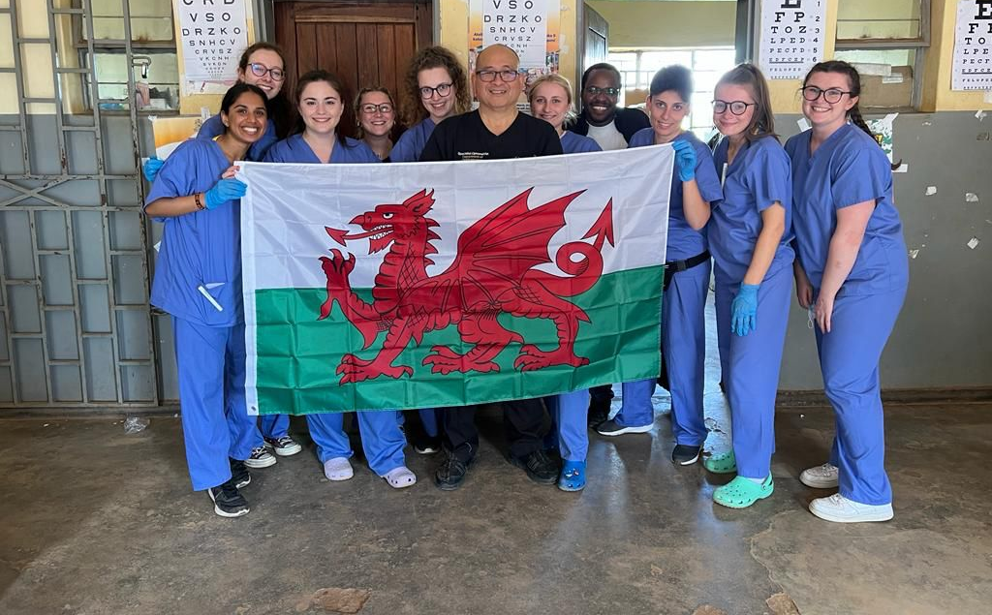
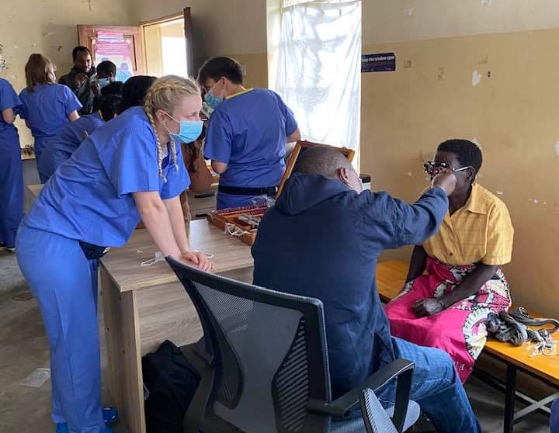
CARDIFF SCHOOL OF OPTOMETRY STUDENTS IN AFRICA

