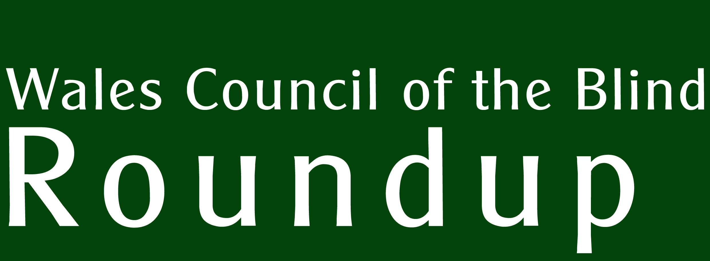  Incorporating Sylw | No. 39

FOCUS ON GLAUCOMA

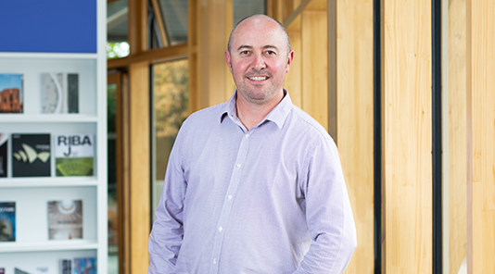

Inside: Anthony talks about his experience of being diagnosed with glaucoma.

The importance of eye drops for glaucoma

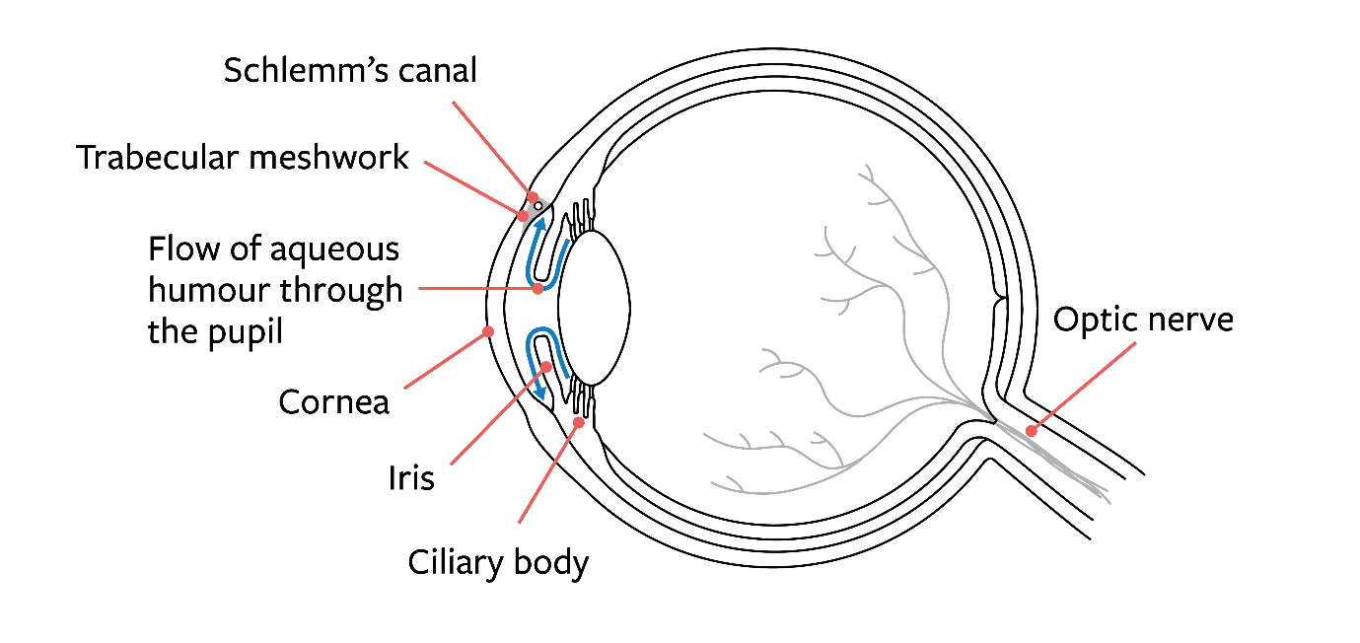

Diagram 1. Structure of the eye, showing the flow of aqueous humour.

What is glaucoma?
Glaucoma is the name given to a group of eye conditions in which nerve fibres in the optic nerve are damaged where they leave the eye. This results in parts of your vision being lost. Glaucoma commonly affects both eyes, although one may be more affected than the other. Most often, the off-centre (peripheral) vision is lost first.

Aqueous humour is the clear, watery fluid that fills the front portion of the eye. The aqueous humour bathes and nourishes the lens and maintains pressure within the eye. In glaucoma, aqueous humour builds up and increases pressure within your eye. This increased pressure can damage the optic nerve directly or restrict blood flow, damaging the optic nerve indirectly.

Loss of vision caused by glaucoma often goes unnoticed because the central vision, for reading and recognising faces, remains good. Also, one eye can make up for vision loss in the other eye, unless both of your eyes have lost vision in the same area. For this reason, a lot of damage has often been done before a person with glaucoma realises there is a problem with their sight. The loss of the peripheral vision can make people with glaucoma more likely to fall and may affect eligibility to drive. If left untreated, the damage continues (‘progresses’), usually slowly over a period of years, eventually affecting your central, detailed vision.

Although any vision which has been lost from glaucoma cannot be recovered, with early diagnosis, careful monitoring and regular use of the treatments, the vast majority of people with glaucoma retain useful sight for life. Glaucoma affects about two in 100 people over the age of 40 in the UK. However, glaucoma gets much more common as people get older, with about 1 in 10 people over 75 having glaucoma.

Why should I use eye drops for glaucoma?
Eye drops are currently the most common treatment for glaucoma. Other treatments such as laser are becoming increasingly common, but you will usually need to use drops as well. There are also surgical options.

Eye drops control the fluid inside your eye by reducing the amount being produced and/or increasing the amount being drained. This reduces pressure to stop further damage to the optic nerve and prevent more vision loss. In addition to regular eye tests and generally looking after yourself, using your glaucoma eye drops is vital and a really important thing to do to protect your eyesight.

The drops won’t restore or improve any vision you’ve already lost to glaucoma – but they should prevent further damage. Once you start using eye drops, it’s important to continue using them. Stopping them could further damage your eyes and you risk losing more of your sight. As glaucoma is often symptomless, the damage may not be obvious until your next appointment, so it’s important to use your eye drops as prescribed – and to keep using them until your eye specialist tells you otherwise.

What are the different types of eye drops for glaucoma?
There are several different types of eye drop for glaucoma. Your eye specialist might need to change your treatment until the right drop, or combination of drops, is found. Some drops are preservative-free as some preservatives may irritate your eyes, especially if you have moderate or severe dry eyes.

The different drops fall into five main categories, which work in slightly different ways:
- Alpha agonists - reduce production and improve flow of fluid.
- Beta blockers - reduce production of fluid.
- Carbonic anhydrase inhibitors - reduce production of fluid.
- Cholinergic inhibitors - improve flow of fluid.
- Prostaglandin analogues - improve outflow of fluid.

Why people stop putting in eye drops for their glaucoma
We now know how important it is to take glaucoma eye drops as prescribed.

So why would someone not take them? There are many reasons why some people stop taking their eye drops:

Physical:
- They cause side effects to the eyes such as itchy eyes, stinging of the eye and/or blurred vision.
- They can also cause other side effects such as fatigue, dizziness and a dry mouth.
- During Ramadan, people are concerned they are consuming food and/or drink as they can taste the eye drops at the back of their throat. However, eye drops are not considered food or drink, so they do not break the fast.

Practical:
- They struggle getting the drops in and have no-one to help them.
- They have run out of eye drops and cannot get another prescription for several days.
- They’ve never been shown how to put their drops in correctly.

Psychological:
- They feel that putting a colourless liquid in their eye will not help their vision.
- They think that they only needed to put drops in to lower their eye pressure and once it is lowered, they no longer need them.
- They do not see eye drops as important medication.
- They do not have any symptoms so do not feel they need medication.
- They have not been given any information about glaucoma and eye drops.
- They have poor memory and forget to take them.

Is there a correct way to put in your eye drops?
Putting in eye drops may sound easy, but many people often struggle with them. However, there are various techniques you can use to find the right angle, dispense the right amount and make sure the drop goes into your eye.

It’s really important to persevere with your eye drops. With practice, putting them in will become much easier. Glaucoma UK can help with resources such as online tutorials to show you how to put your eye drops in correctly, as well as leaflets, digital glaucoma support groups and a helpline you can contact for any advice.

Are there any aids to help me put in my eye drops?
There are a variety of aids available for eye drop bottles, single dose units and multi-dose preservative-free bottles. These aids help you squeeze the bottle, or hold the bottle in place over the eye, so the eye drop goes in.

For more information:
Watch our digital support groups about eye drops. All our previous groups are available to view on our website and you can register for future sessions at https://glaucoma.uk/care-support/support-groups/

Read our leaflets, which are free to download or order : https://glaucoma.uk/product-category/informational-materials/
Visit our website which has more information: https://glaucoma.uk

Being diagnosed with glaucoma can be a frightening experience. Giving a voice to those who are living with the disease by sharing their story often helps others who may be experiencing the same things.

Anthony’s story
Anthony, from Mid Glamorgan, was diagnosed with glaucoma at the age of 40 during a routine eye test. He later found out his grandfather had gone blind from the disease.

I am an architectural technologist, so my work involves a lot of computer work. The company I work for provides free eye tests, so in 2010 I decided to go along for one as I hadn’t had my eyes tested for a while.

During the test, the optician asked me whether there was any family history of glaucoma. I had a vague recollection that my grandfather had experienced eye problems but the details were sketchy, so she decided to take a scan of my eyes. When she showed me the images, there was clearly something very different with my left eye, so she referred me to a specialist.

I saw a consultant and he confirmed that I had glaucoma. He explained the diagnosis to me and handed me some leaflets and a prescription for eye drops, which I’ve used every day since.

At the time of diagnosis, I didn’t really know much about glaucoma or the consequences of having the disease. But after visiting the optician, then seeing the specialist and reading through the leaflets, reality soon hit home. I realised the significance, not least because of the job I do. I remember thinking ‘How can I do my job if I lose my eyesight?’.

Being told that this could potentially happen was initially a shock, but the early diagnosis along with the treatment and after-care I’ve received has certainly helped calm my concerns - although there is always something there in the back of my mind.

I wasn’t fully aware of any family history until after my diagnosis, when I discovered that my late grandfather had in fact lost his eyesight to glaucoma. I have two adult daughters and a teenage son. All three regularly visit the optician, who is aware that I have the disease. He now takes scans each time they visit to monitor for changes or any abnormalities.

In addition to taking eye drops every day, I go to my local opticians for an eye scan and field tests, which I take with me when I go to see my consultant twice a year.

My advice to anyone reading this is to visit your optician regularly and make them aware if you have any family history of glaucoma. The sooner you get a diagnosis, the sooner you can receive appropriate treatment. Don’t take your eyesight for granted!

For more information:
If you have any more questions about glaucoma, you can contact the Glaucoma UK helpline. Our helpline team can offer advice, guidance and information to support you at every stage of your glaucoma journey.

Call the team on 01233 64 81 70 Monday to Friday from 9.30am to 5.00pm, or email helpline@glaucoma.uk. Calls are charged at your standard network cost.
Join as a member or supporter, to find out more about our work and how we can help call our Supporter administrator, Natalie Smith, on 01233 64 81 71. Website: https://glaucoma.uk/get-involved/join-glaucoma-uk/become-a-supporter/

Sylw Bulletin

News

Macular Society resumes Winter Warmer calls
The Macular Society has resumed its Winter Warmer calls, which were introduced during last winter to entertain people with macular conditions and help them get through the long winter nights. Each hour-long call features light-hearted discussions and entertainment from people from many walks of life.

Calls are held on Wednesdays at 6 pm. The schedule is:
- 2 February Dave Andrews: Richard III
- 9 February Glenis Williams: Love in the Black Country
- 16 February Clare Murphy, professional storyteller
- 23 February Katriona Taylor, singer-songwriter with Stargardt disease

For more information and to book your place, call the Society’s regional services team on 01264 560 259 or email winterwarmers@macular society.org.

NHS Covid Pass
Currently an NHS Covid Pass is required to enter large indoor events, nightclubs, cinemas, theatres and concert halls in Wales. This is likely to change in the near future. In the meantime you can, if you are not able to apply online, request a paper certificate. This paper certificate has been designed for international travel but will be valid evidence for entering a domestic venue or event.

The paper NHS COVID certificate only provides evidence of full vaccination, so can only be issued if you have had a full course of the COVID-19 vaccine (you should wait 5 days after your final dose before requesting it) and you are aged 12 or over.

To request a COVID Pass, call 0300 303 5667.

For information on how to apply for a Covid Pass if you have online access, visit the NHS Wales website, https://gov.wales/get-your-nhs-covid-pass.

Accessible Covid vaccine information leaflets.

Information leaflets are now available online for the Oxford AstraZeneca and Pfizer vaccines. If you require the information in braille, large print or audio, please phone the accessibility line on 01372 371450. There may be an answerphone operating during periods of high demand. Please note this number is only for use for these coronavirus vaccine medicines.

To get any other medicine information in alternative formats, please call 0800 198 5000.

RNIB Connect Telephone Groups
RNIB Cymru may be starting the following new online/telephone groups, hopefully in the next few months. Please get in touch if you or anyone you know would be interested:

Newport Valleys social group: contact Anum.Munawar@rnib.org.uk or ring 07510 382714

Anglers group: Contact: Eleanor.Rothwell@rnib.org.uk or ring 077 0282 1915

Crafters social group (for people enjoying knitting, card making, crocheting etc) contact rachel.llewellyn@rnib.org.uk or ring 07510 382496

Also, the South Wales Welsh Speaker’s group would love to meet some new people – please contact Eleanor on the number above if you are a fluent speaker of South Walian Welsh and are blind or partially sighted.

Sight Cymru Resource Centre - appointment only
Sight Cymru's Resource Centre is running on an appointment only basis to ensure the safety of staff and visitors to keep everyone safe. You can book an appointment with the Resource Centre in Pontypool by ringing 01495 763650, and opening hours are Monday to Friday, 10 am to 4 pm.

Consultations
The University of South Wales, in partnership with Data Cymru, is conducting research on behalf of the Welsh Government to better understand the role and experiences of Personal Assistants (PAs) and their employers in Wales.

For the purpose of this research, anyone who is paid directly by the person they support, or immediate family of the person they support, is considered a Personal Assistant. If you are a PA, or you employ a PA using Direct Payments, then this is your chance to have your say.

The study team would like to invite PAs and their employers in Wales to take part in either a telephone or online interview. Please feel free to contact the researchers to ask any questions by contacting Sarah Wallace, Senior Research Fellow at the Welsh Institute for Health and Social Care, University of South Wales at email: sarah.wallace@southwales.ac.uk or by telephone on 01443 483 882.

Events

Bridgevis Coffee Mornings are back!
Bridgend and District Visual Impairment Society (Bridgevis) has resumed its face-to-face coffee mornings. Meetings will be held from 11.30 am to 1 pm on the first Friday of the month, starting on 4th February 2022. The venue is St John's Ambulance Training Centre, Minerva Street, Bridgend, CF31 1TD and there is free parking directly outside the building.

In line with Bridgevis' Covid Risk Assessment there will be:
- Hand sanitisation on entry
- Your name and phone number will be taken for Track and Trace purposes
- Wearing of face masks unless sitting down at the coffee tables (or if medically exempt)
- Two-metre social distancing of the chairs
- Disposable cups, cutlery and plates provided
- Single individual portions of coffee, tea, sugar, UHT milk, individually wrapped biscuits served by the server who has been double Covid vaccinated and wearing PPE
- Hand gel on the tables
- Whilst not mandatory, the Covid Risk Assessment advises that attendees are double Covid vaccinated or have a negative lateral flow test result.
- Good ventilation at the venue
- £1 coin donation for tea/coffee/biscuits to be placed into a container so no money handled, please bring exact change.

Bridgevis look forward to seeing you if you are able to attend.

‘Living Well with Sight Loss’ telephone course
RNIB’s ‘Living Well with Sight Loss’ telephone courses continue to run. The next course will run from Monday to Thursday afternoon, 1.30 pm – 3 pm, 14th, 15th, 16th and 17th February 2022.

RNIB is also offering follow on ‘Focus On’ telephone groups which provide more detail on certain aspects of the Living Well with Sight Loss groups.

For more information on any of the courses, please contact Keira Brooks by phone 07864 954150 or by email keira.brooks@rnib.org.uk. You can also make a booking by calling the RNIB Helpline, 0303 123 9999.

Vision Support Community Information Unit
Vision Support’s Community Information Unit covers the Wrexham, Flintshire, Denbighshire and Conwy areas (as well as Cheshire and Halton). Visit the unit if it is in your area to find out about services, technology and products that can help people with sight loss
The schedule for February 2022 is:

- Tuesday 1st Dolgellau Co-op 11 am – 2.30pm
- Wednesday 2nd Morrisons, Caernarfon 10.30am – 2.30pm
- Friday 4th Lower High Street Car Park, Prestatyn 10.00am – 2.30pm
- Wednesday 9th Bellis Brothers, Holt 10.30am – 2.30pm
- Thursday 10th Morrisons, Rhyl 10.00am – 2.30pm
- Friday 11th Porthmadog, lard Yr Orsaf Car Park 10.30am – 2.30pm
- Sunday 13th Morrisons, Holyhead 10.30am – 2.30pm
- Monday 14th Llandudno Prom by Cenotaph 10.00am – 2.30pm
- Tuesday 15th Tweedmill, Trefnant 10.00am – 2.30pm
- Monday 21st Rhos on Sea by TIC 10.00am – 2.30pm
- Thursday 24th Chirk Town Hall 10.30am – 2.30pm
- Monday 28th Flint Pavilion Car Park 10.30am – 2.30pm

In case of last-minute changes, it is advisable to telephone 01244 381515 (Mon – Fri 10.00am – 4.00pm) to confirm details if you are planning to visit the unit.

Glaucoma UK Digital Support Groups
Glaucoma UK is running digital support groups via Zoom – but if you don’t have internet access, you can still ring in and listen to the event. The following events is planned for December:

Monday 7th February, 2 pm to 3 pm, ‘Glaucoma self-care: how your pharmacy team can help you with your eye drops’. Representatives of the ophthalmic pharmacy team at Moorfields Eye Hospital, London will give advice and you will have an opportunity to ask them questions.

Tuesday 22nd February, 3 pm to 4 pm, ‘Everything you ever wanted to know about glaucoma’. Dr Hari Jayaram, Consultant Ophthalmologist at Moorfields Eye Hospital, will be the speaker. There will be an opportunity to ask questions at the end of the talk.

To listen to either of these sessions by phone, dial in at the start time by calling +44 208 080 6591 or +44 208 080 6592.

To access the event by phone, you will need a Webinar ID and Passcode. To get these details, please contact Glaucoma UK on 01233 64 81 64. Please note, if joining on the phone you will only be able to listen to the verbal presentation. You will not be able to ask questions or view the supporting presentation slides.
If you have internet access, you can find out more and book a place on the Glaucoma UK website, . https://glaucoma.uk/get-involved/glaucoma-uk-events/

If you need any further information, Glaucoma UK’s Helpline is 01233 64 81 70.

Regular Telephone Meetings
As reported in previous issues of this newsletter, vision impairment organisations continue to run regular telephone group meetings.

Contacts are as follows:

Vision Support (North East Wales): Nia on 07548 829635 or email Nia at ngreer@visionsupport.org.uk.

Macular Society North Wales groups: Marian Williams, Regional Manager for North Wales on 07768362609.

Macular Society South Wales groups: Adele Francis, Senior Regional Manager for Wales on 07494 468 007 or 01639 843236.

Sight Life (Cardiff): Val on 07707 295121 or email valerie.baynton@sightlife.wales

Sight Life (Swansea, Neath and Port Talbot): Anita on 01792 776 360 or email: anita.davies@sightlife.wales

Sight Life (Rhondda Cynon Taf): Carys on 07753 305631 or email carys.groves@sightlife.wales

RNIB Connect Groups: Eleanor Rothwell on 0770 282 1915, email eleanor.rothwell@rnib.org.uk

Other Resources

RNIB Tax Advice Team
Did you know that RNIB has a Tax Advice team that supports blind and partially sighted people with tax, tax credits and HM Revenue and Customs (HMRC) issues across the UK?

The team makes a difference to the lives of blind and partially sighted people by making tax and HMRC issues clearer. They can help people to claim extra tax allowances, such as Blind Person’s Allowance and Marriage Allowance, which can reduce your tax bill. RNIB's tax service is free, confidential and available to people with sight loss, regardless of their age or income. They also have a factsheet in different formats with information on tax allowances and useful contacts.

You can contact RNIB’s tax team by telephone via the RNIB Helpline 0303 123 9999, or by emailing tax@rnib.org.uk. You can also find out more about the service by visiting the RNIB website: www.rnib.org.uk.

Opportunities

Goalball Taster Session on Port Talbot
There’s an opportunity to try the paralympic sport goalball at a session on Saturday 19th February from 1.30 pm to 3.30 pm at Ysgol Bae Baglan, Seaway Parade, Port Talbot SA12 7BL, organised by South Wales Goalball.

Try paralympic sport boccia in Bridgend
Bridgend Inclusive Network Group (BING) is working alongside Bridgend County Borough Council well-being team to be able to offer free sessions for you or your group to have a go at the sport of boccia on Tuesday evenings at Brackla sports hall.

Boccia is a Paralympic sport and is similar to bowls. Players try to get their boccia balls closer to the jack ball than the other player or team. Players can roll, throw or kick the ball. Assistive equipment such as ramps and head attachments can also be used if players are unable to propel the ball sufficiently without them. Boccia is suitable for all ages and abilities.

The sessions will be from 5pm to 6pm. A representative will be available to help for your first session and then you will be able to continue additional sessions yourselves with the loan of Boccia sets. Sessions will be starting in February so please get in touch if you or your group would be interested in an initial trial. If you live outside of the Bridgend County area and can get to Bridgend centre support with transport can be arranged. If you live within the Bridgend county, arrangements can be made to pick you up or meet at a central location.

If you are interested, please contact Anita Davies, Locality Development Manager at Sight Life on 07824 541982 or email anita.davies@sightlife.wales.

Free audio bible player offer from Torch Trust
Torch Trust, the Christian sight loss charity, is offering a free audio Bible player to anyone who is losing their sight (or has recently done so) in the UK - the Megavoice Pathway. They come preloaded with David Suchet reading the New Testament and Psalms.

These audio Bibles are the size of a small remote control. They have few easy-to-use buttons to make it simple to start and stop, to move forward or backward between different sections. Some instructions are included to help you get started. They have an in-built speaker and some in-ear headphones have been included. Rechargeable batteries are already installed, and it comes with a charging cable for you to plug it in. Lastly there’s a lanyard included so you can put the player around your neck so it’s harder to lose.

To find out more about this offer and to apply, call Torch Trust on 01858 438260 and they will take all the necessary details and get one in the post to you. Opening hours are:

- Monday 9.30am to 4pm
- Tuesday and Wednesday 9am to 4pm
- Thursday 10am to 4pm
Numbers of the players are limited, so apply quickly if you are interested.

About Wales Council of the Blind

"I have found all my contacts with WCB over the years to be so useful and professional." - Rehabilitation Officer for VI.

Wales Council of the Blind is the umbrella agency representing vision impairment within Wales. WCB provides a platform for vision impaired people to raise their concerns and wishes.

Four Regional Steering Groups will be established across Wales, covering North, West, South East and South Central. Each group intends to offer a platform for local clubs, charities, statutory services and people with sight loss to get together and contribute to directing the work and resources of WCB. It's likely that priorities may vary from region to region, and we want that to be reflected in the work of WCB.

What does Wales Council of the Blind do?
- We work to assist the Welsh Government by participating in and facilitating consultation
- keep in touch with what is happening in every area in Wales and in the U.K.
- We highlight examples of good practice and distribute this to the eyecare sector through our SYLW newsletter, e-bulletins, quarterly 'Round-Up' Magazine, and our professional networks
- bring people together to exchange information and ideas
- identify gaps in provision
- encourage the development of new services where necessary
- support and assist other agencies to provide a good service
- represent v.i. within Wales and at an all-Wales level
- represent v.i. in Wales at a U.K. level
Wales Council of the Blind, Unit 2.2, Hastings House, off Fitzalan Road, Cardiff CF24 0BL.
Email: richard@wcb-ccd.org.uk. Tel: 029 20 473954

