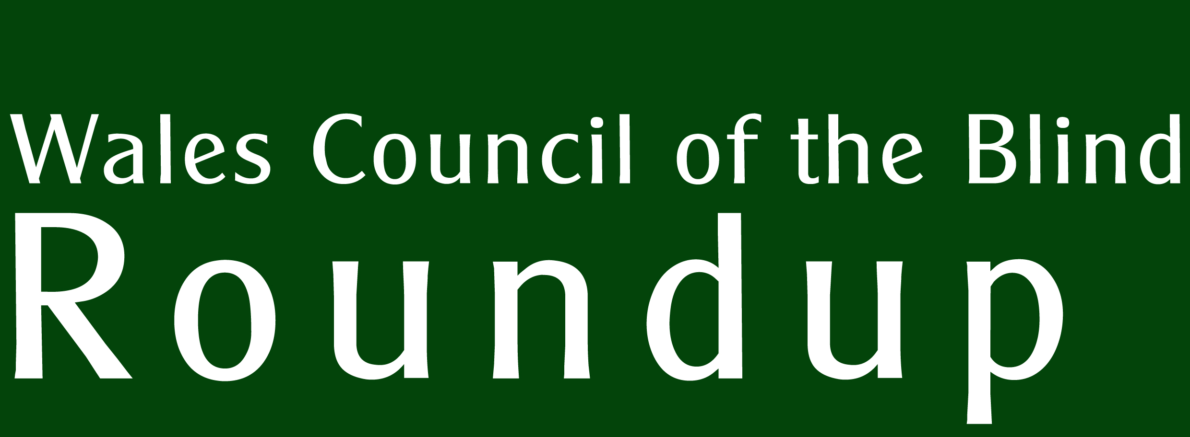 |  | Supported by  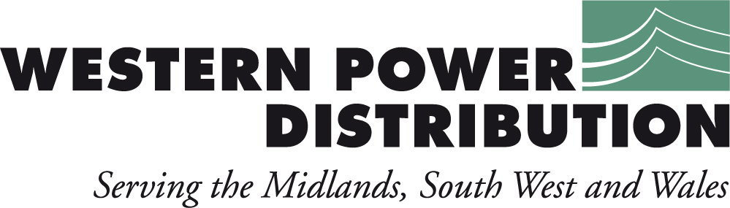  No. 27
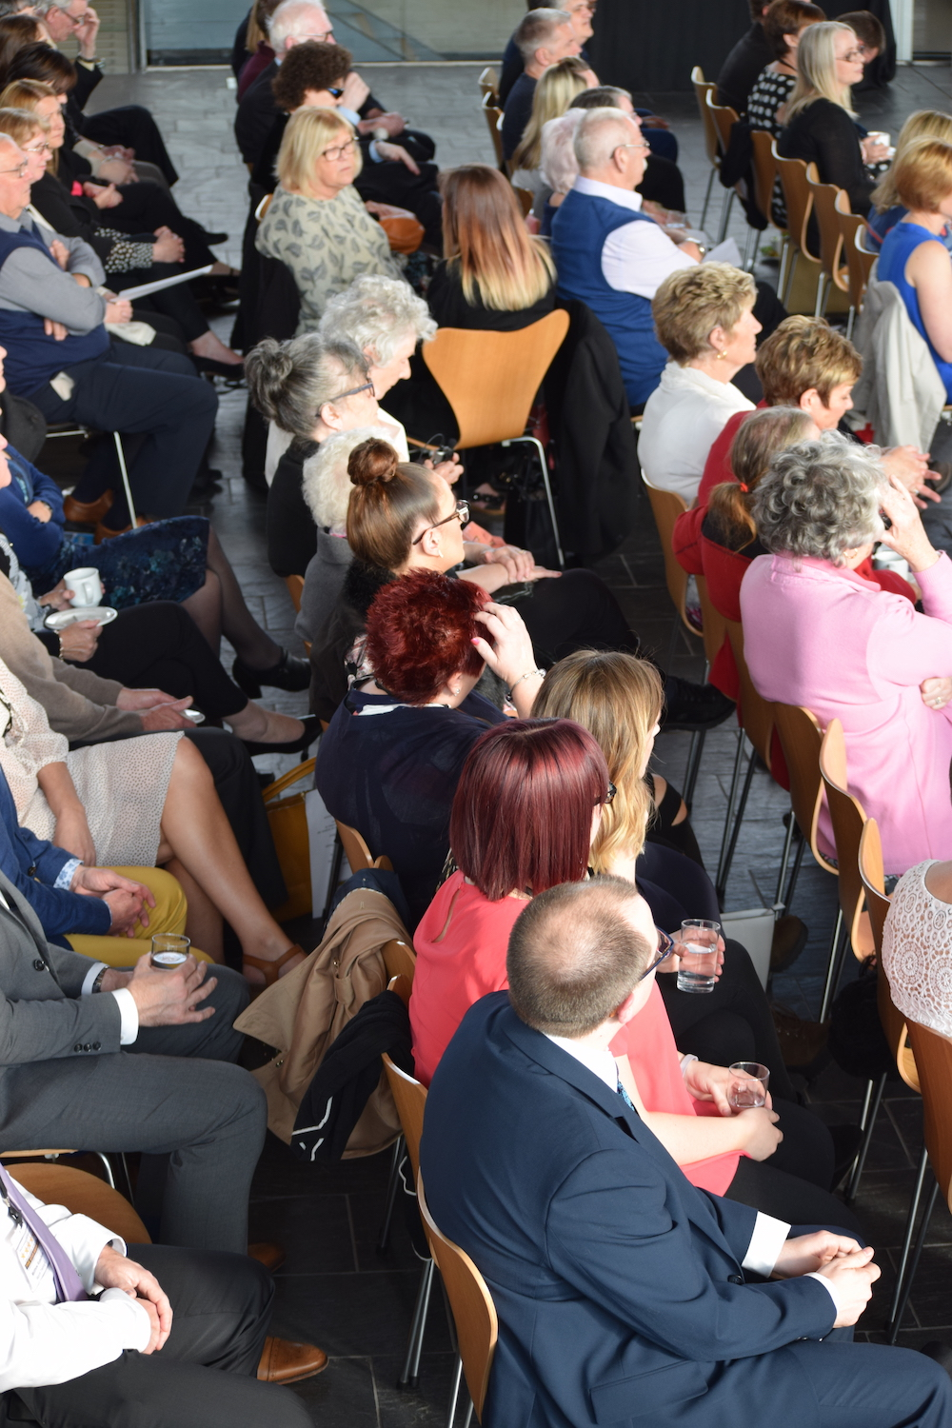 | Five Star Awards  Congratulations to Russell Ham (Low Vision Service at Specsavers Newport) and Eirian Davies (Prince Phillip Hospital) on winning Five Star Awards for their work with people with sight loss. The event was staged in May at the Senedd by Wales Council for Deaf People and Wales Council of the Blind.
In this issue:
Framework for Action on Independent Living
Supplement: Storm WCB


Delivering electricity to homes and businesses is about more than just cables and wires, poles and pylons. It’s about providing people with a service that they can depend upon to help them live their lives to the full.
At Western Power Distribution we are investing many millions of pounds long-term on our electricity network to ensure all our customers continue to receive the same world-class service.
We are proud to be leading the way in terms of customer service, network reliability, technical innovation and environmental care, but we are not complacent. This is why we will continue to set our own demanding performance targets and exceed those set by our industry regulator.
Our Target 60 initiative is a case in point, for when power interruptions occur its aim is to restore supplies within the first hour. This is a commitment our customers can depend upon.
To find out more about our plans for the future visit www.westernpower.co.uk or email info@westernpower.co.uk.
If you have a power cut – call our new emergency number 0800 6783 105
EDITORIAL
We like to bring you something new when we can. This time we introduce a regular column from John Sanders who writes on employment - the barriers, pitfalls and how to overcome them. John shall be writing on a series of topics and we would welcome your comments.

Direct Payments was intended as the theme for this edition, but we were disappointed at the absence of input from agencies that manage Direct Payments on behalf of individuals. We have therefore deferred the topic until the next edition in order to give a fuller picture.

Direct Payments are an ingredient in the cocktail of services that enable independence. The Framework for Action on Independent Living, Welsh Government's plan to address the barriers disabled people face, is being refreshed through consultation with disability organisations and disabled people. WCB conducted some research on behalf of the government to see how independent living for Wales' disabled people has changed in three years. Some of the findings are published here.

- Richard Bowers (richard@wcb-ccd.org.uk)
WCB Roundup is published quarterly by Wales Council of the Blind, 2nd Floor, Hallinans House, 22 Newport Road, Cardiff CF24 0DB. Tel: 029 20 473954.
Email: richard@wcb-ccd.org.uk.

Further copies, in audio CD or large print formats, are available. All editions are online at
http://www.wcb-ccd.org.uk/roundup.php
with audio at
https://soundcloud.com/wales-council-blind

Advertise in WCB Roundup
WCB Roundup is sent to more than 2500 people, in a variety of formats. We are a not-for-profit organisation that hopes to recoup its costs. We seek advertisers for our newsletter so that we can continue to produce this valued journal. Advertisers will reach a readership of individuals with sight loss, optometrists, ophthalmologists, rehabilitation officers, social workers, and organisations working for blind, partially sighted and disabled people.

Our rates are (per edition):
Full A4 page: £150 (black and white) £250 (colour)
1/2 A4 page: £100 (black and white)
Enclosures: single sheet A4 750 copies, supplied in a ready-to-go format: £200.
Larger enclosures (such as booklets): please ask for quote.

To advertise in many editions, please contact us for discounts. Contact Ann via ann@wcb-ccd.org.uk or
telephone 02920 473954.
Warm words on work

An inaccessible group interview activity based around small print brochures. Magnification software not set up for an interview - even though the applicant supplied it in advance. These are typical challenges faced by visually impaired (VI) people when job hunting.

At a recent Storm/WCB⁽¹⁾ meeting of young visually impaired people in Cardiff to discuss employment, one summed up the general sense of frustration: “A lot of what is being promised is not happening on the ground.”

Sadly, although Government says it wants more disabled people in work, the evidence and its actions tell a different story. RNIB’s Employment Status & Sight Loss report⁽²⁾ shows a fall in the proportion of registered blind and partially sighted people in work from one in three in 2005 to around one in four in 2015.

In terms of Government actions, it’s hard to see how replacing the Two Ticks system with Disability Confident ⁽³⁾ is good news for disabled job-seekers. Under the old Two Ticks scheme, if we met the minimum job requirements, it guaranteed us an interview with certain employers.

Disability Confident offers no such promise. Instead it is peppered with patronisingly bland statements such as: “Training in the workplace is a great way to learn skills and gain experience.” Hardly surprising then that Disability News Service last year described Disability Confident as “trivially easy to abuse.”

So, what should we do to maximise our chances when applying for jobs? Young people at the Cardiff event came up with several suggestions. Firstly, keep any mention of visual impairment to a minimum on application forms (unless the job is in the VI sector). If possible don’t refer to visual impairment at all and certainly don’t use medical terms like aniridia, cataracts or nystagmus. They will almost certainly result in an application being rejected out of hand.

But it’s probably wise to explain your visual impairment at interview. So, secondly, work out what you want to say about your sight, when you want to say it and how. Interviewers are unlikely to know anything about VI, but their ignorance is likely to fuel unjustified fears about employing a “blind” person.

Thirdly, be confident, encourage interviewers to ask you questions and above all reassure them you can do the job. This is one part of the interview where you definitely know more than they do. Be prepared to explain reasonable adjustments in the workplace and your rights under Access to Work⁽⁴⁾ too.

Finally, check out potential employers’ equality policies before interview. Most organisations (big and small) now have lovely warm words online about being equal opportunity employers. Don’t be afraid to quote those words back at them. We are their opportunity to live up to their claims. If we don’t challenge unfair practices, no-one else will do it for us.

John Sanders is an independent writer. The views in this column are his own. We would like to hear what you think. Please send your letters or emails richard@wcb-ccd.org.uk

1. http://www.stormwcb.org.uk
2. http://www.rnib.org.uk/knowledge-and-research-hub-research-reports/employment-research/employment-2017
3. https://www.gov.uk/government/collections/disability-confident-campaign
4. https://www.gov.uk/access-to-work/overview

Employment Tips
Daniel Williams from Visualise Training and Consultancy (www.visualisetrainingandconsultancy.com) has the following tips for a person with a visual impairment at interview:

- Prior to interview, disclose your visual impairment, empower your interviewer to meet your needs.
- Establish a friendly rapport, be first to present your hand to greet your interviewer.
- Knowledge is power, and it is important to self-advocate, to explain your requirements.
- If you use assistive technology, demonstrate it.

You may be the first interviewee that has disclosed a visual impairment. Be savvy! Sell your skills and your ability.

Daniel and John have differing advice on whether to disclose your vision impairment in advance. This may be a matter of judgement based, for example, on how large or well-resourced the company is. You would expect a large company to be better advised and equiped to make the adjustments necessary for a fair interview, while a small organisation might not use rigorous recruitment methods and might be ill-informed about disability equality regarding employment. We would be interested to hear the experiences of our readers on this topic.

Working with blind and partially sighted colleagues

RNIB has recently produced a guide for employers, managers and colleagues of employees with sight loss, which covers topics such as:

- What is vision impairment?
- How you can give practical support to vision impaired employees.
- Communication (verbal and written).
- Case studies.

We’ve put a link to the guide on our website, http://www.wcb-ccd.org.uk/single_post.php?var=2046.

WCB NEWS.
Your Voice: a Shared Vision.
West Wales Regional Forum

WCB held its West Wales Regional forum in Carmarthen where the group heard from Caroline Morgan from RNIB Cymru about their welfare benefits service 'RAISE'. Caroline reported that over 5000 individuals across the UK have been supported with their applications for disability benefits, bus passes, blue badges, tribunals and more. The project was funded by the Big Lottery and comes to an end in November 2017. Caroline was pleased to confirm that the service will continue after November.

Gail Bowen and Liz Johnson gave a talk to promote their work around accessing high street shops in Carmarthen. They were accompanied by a member of staff from the O2 store which is supporting their work. Gail and Liz brought along some cards and posters they had designed to inform retail assistants of the needs of people with sight loss when visiting their stores. The posters have been placed in the staff rooms of over 400 retail stores across Carmarthen. Further information can be found on their Facebook page 'accesscarmarthen'.

WCB gathered the group's views on the 'Framework for Action on Independent Living' document. (See elsewhere).

Next meeting: 29th September, Carmarthen Bowling Club.
South East Wales Regional Forum

WCB held its 4th South East Wales Regional forum in Newport.

The group heard from Nathan Foy of Guide Dogs about their work to inform Welsh Government of the transport issues that continue to inhibit people with sight loss from travelling independently. The group was asked to complete a questionnaire about their personal experiences of public transport during the year. The responses were collected and will form part of Guide Dogs' response to the Welsh Government's Framework for Action on Independent Living refresh.

Mike Rose gave a talk about Tai Calon Community Housing, covering Blaenau Gwent. Mike sits on the Tenant Forum and he was pleased to report on the support they offer tenants with disabilities to enable them to live independently. Their services include completing benefit claim forms, teaching cooking skills, work clubs and more. Further information can be found at http://www.taicalon.org or 0300 303 1717

Gavin Davies from Sight Cymru updated the group on their new project called 'ACE' - Access, Connect, Explore. The project will offer assistance to people wishing to access technology from products such as the Amazon Echo, Apple IPads, and much more. Sight Cymru has also completed a refurbishment of their resource centre enabling them to demonstrate aids and equipment that can be used around the home.

WCB invited the group's views on Welsh Government's 'Framework for Action on Independent Living' document. Most were unaware of the document but were able to contribute their views around the key priorities. Please see ‘What you told us’ below for more about this.

Date of the next event
The next meeting will take place on 28th September 2017, 11am - 2pm at Salvation Army, 1 Hill Street, Newport.

WCB Storm Event.

Please read the Storm WCB supplement for the latest reports and notices.

Outcomes and Accessibility Wales Eyecare Conference 2017.
Bookings are now open for the 10th Wales Eyecare Conference on Wednesday 20th September at the Cardiff School of Optometry and Vision Science. The event is free, and this year's theme is 'Outcomes and Accessibility’.

This year’s conference takes place during National Eye Health Week and delegates will hear about the themes and work taking place across Wales.

The programme includes:
- Opening address from Vaughan Gethin AM, Cabinet Secretary for Health, Well-being and Sport;
- Performances by UCAN Productions;
- Support and services for children with sight loss in Wales;
- Update on the All-Wales Standards for Accessible Information;
- Communication and Information for people with sensory loss;
- An update on the work from each of the Local Health Board areas;
- Outcomes from the Social Services and Wellbeing (Wales) Act and Population Needs Assessment.

We recommend you book your place early. Visit the Eyecare Conference website, http://www.wcb-ccd.org.uk/conference/conference.php. If you prefer to book over the phone, ring WCB on 029 2047 3954.
What you told us.
The consultation on the Framework for Action on Independent Living.

The Welsh Government’s Framework for Action on Independent Living was published in 2013. It includes a list of actions, many of which have been completed or need updating. A survey was conducted to ascertain that the Welsh Government's future plans will address the barriers to independent living that are the most important to disabled people.

Wales Council of the Blind took on the role of gathering the views of people with sight loss through a questionnaire and discussion groups.

It is not surprising that the concerns people have and the challenges they face often arise within a group of services that may or may not be the responsibility of one agency. Transport is an example of this where a cocktail of challenges emerges over a range of service providers, making it difficult to apply solutions across this range. In this regard, it follows that concerns with the benefits system or employment support are discussed, despite them being outside the remit of this consultation, because they're central to attaining a state of independent living. It would be inadequate not to take these issues into the discussion, since they interface with other aspects of provision that Welsh Government does have jurisdiction over. For example, accessible transport is necessary for disabled people to access employment. Therefore, some of the areas covered below are included to give a fuller picture.

This report sketches out the responses very generally. It mixes feedback from groups in West Wales and Gwent with written responses on the questionnaires.

Knowledge of the Framework.
The existence of the Framework itself was known only to a quarter of the 86 respondents to the questionnaire, but the issues it addressed were familiar, as can be seen in the following. The Framework was initially developed by a working group of disabled people and disabled people's organisations.

What's improved in the last 3 years?
“Wales is a good country for the elderly, sick and disabled to live in. The quality of life is high.”

Nevertheless, it is clear that people with sight loss continue to face barriers in a number of areas. Raising public awareness of hidden disabilities is suggested by many people to improve support for people who do not ‘look disabled’.

Social Care.
A number of people rely on family to care for them but if they were left alone would be completely reliant on social care. It is important that people are offered support to gain independence, even where support is provided by their family. The “what matters” conversation needs to address this.

There are still large numbers of people who are unaware of the services offered by a local authority. Better promotion of the work of the Rehabilitation Officer for Vision Impairment is needed as well as the option to receive Direct Payments.
WCB asked for people's experiences of Direct Payments. However, as most of the group was unaware of them, there were no examples or experiences to gather. Once an explanation of the service was given, there was some interest in finding out more.

Person-centred technology.
Perhaps the most noticeable sense of positive improvement was in the area of person-centred technology. This is, perhaps, not surprising given the ever-expanding range and quality of technology in general. However, there was concern over the prohibitive cost of such products:

“Whilst technology is very good it is so expensive and usually out of my price range.”

Problems with access to technology were mentioned:

“The technology has improved but I depend on family/friends to signpost it to me.”

On the other hand, the support from the Low Vision Service, which can be easily accessed at the local optometrist, is valued:
“The scheme for visual technology and magnification devices provided by the local optician is very good.”

"Technologies are empowering but not the answer for all."

Many were disappointed that local authorities, GPs and hospitals are not providing correspondence in accessible formats. Dentists, however, text details of appointments to patients, so questions were raised as to why other agencies can't do the same.

Accessible Housing.
There were reports that some Housing Associations are avoiding making adjustments to homes because they can't afford to pay for the work and sometimes opting for second-hand equipment. There were also reports of delays in processing funding through Care and Repair and instances of landlords reluctant to agree to adaptations.

A message of advice was shared with the group around support once discharged from hospital. People were advised to request an assessment from the Discharge Services team, which is linked with Social Services. They will look at the support needed once discharged and ensure it is in place prior to leaving hospital.

Transport.
There seems to be a downturn in perceived improvements to public transport. 18 respondents felt it had improved against 43 (half of the respondents) who thought it hadn't. The issue of accessible transport is very high on the agenda and dominated many of the discussions. This was the area that the largest number of respondents said they faced barriers with.

"Services need to be extended to better support people to get about in rural Wales and in evenings. Drivers need to have a better understanding of sight loss."

“Buses should not pull away before a blind person has found a seat. Bus drivers need to be trained to understand disability.”

“Buses not slowing down enough by bus stops to see where they are going.”

"The need for improved information such as timetables in accessible formats, lack of announcements continues to be a problem."

“Train timetables in Swansea are so high up we can’t see them.”

“No timetables to plan route/connections.”

“Train timetables are printed so small even my 20/20 vision friend has to strain her eyes to read them.”

“Isn’t easy to read bus stops. Electronic timetables don’t speak.”

“Train announcements while on a train, they could announce what station the train is at as I cannot see signs.”

“Departure boards and general signage on stations are inaccessible. They should be clear and backed up with clearly spoken versions.”

"The drivers of the x4 service are excellent, they help when you get on the bus and ask if you wish to be told when you’re stop is coming up. 95% of the drivers are helpful."

"I asked for the driver to tell me where the stop was. He said he would if he could remember. No audio announcement on bus. Very stressful journey wondering whether driver would remember and whether I would be able to get off at the right stop in time. Have talked to Guide Dogs and rehab officer and asked drivers whether AV can be turned on."

"Aiming to get last train home, I arrived at the station and there were no staff for assistance. I went to the designated platform only to find out my particular journey had changed platforms, therefore had an expensive taxi journey home. I complained to Arriva on their website about the issue. The situation is ongoing."

"I use the bus in Newport. But do not travel without company as it’s too difficult to get to the bus stop as it has changed location. Have to take a taxi or be with company. I like to have the same driver when booking a taxi who is very helpful."

"On the bus and pressed button to stop, driver did not stop so ended up staying on the bus and getting a taxi home. Asked the driver why he didn’t stop and was told that there was no stop when I pressed the bell. Was refunded my money back when I complained."

"Not experienced any negative issues. Very pleased with the service. Every 10 minutes from Newport to Blaenavon. Driver always waits until I sit down before he moves off."

Also, there is a safety issue with some platforms:

“There is a large gap between the train and platform. Does it need to be so wide?”

"Unable to catch a bus as can’t cross the road where I live. Newport coaches - not mobility friendly - step is too high to get onto the bus - no help with this. I take a taxi - small company - very good and helpful."

The Blue Badge Scheme is one which many disabled people greatly rely on to minimise the distance from vehicle to destination. This gets abused by non-disabled people when they park in designated spaces:

“[Councils] could, as is done in London, make revenue from the fines which are handed out. This would be useful to those of us who find so many of the disabled spaces used by able-bodied people who find these spaces useful.”

With regard to community transport there is clearly a lack of drivers, particularly in rural areas:

“Isolation – poor transport. Loss of independence. Country Car – once a week. Short of drivers.”

Shared spaces.
Uneven pavements, street furniture and poor markings are reported by many as hazardous to pedestrians.

“Pavements for walking and wheelchairs are poor.”

“Bins on pavements and low branches overhanging paths.”

“Blocked footpath adjacent to A40 at Neville Hall Hospital – many cars parked right across pavement.”

“The main problem in Welshpool is street furniture on pavements (Coffee shops). Notice boards placed in front of shops so that blind people do not know they are there. Mobility scooters cannot pass and they are often knocked flat. Risks to falls.”

“One very simple thing which would help me would be to differentiate between steps. Painting the edges with white paint or a contrast colour. Steps are potentially a massive risk to me.”

There is a need for more community-based services such as that provided by the Low Vision Service Wales. We received feedback that many hospitals are too centralised. The role of the third sector was recognised in providing support around person-centred technology.

Benefits – PIP
“PIP. I wanted to volunteer, but any thing positive you try and do goes against you, they think either you work or fester away in the corner.”
Employment.
Accessible information – a cross-cutting theme in the Framework – remains a barrier in the domain of employment. Advertisements, application forms, interview test pieces, are all subject to the requirement to be made accessible to people with print disabilities. The practice of creating an ‘even playing field’ in this regard remains unfulfilled.

"Applying for jobs is difficult due to accessibility. There is a lack of support during interviews such as accessible software to use the computer."

“Employment is still ‘unobtainable’ for most disabled people. Not all information and advice is sent in formats easily accessible to vision impaired people.”

There is also a concern that the 'Two Ticks' system of ensuring an interview for disabled applicants who meet the criteria for the post, is under threat (see John Sanders’ ‘Warm Words on Work’ earlier for his thoughts on this).
Where employment is attained, the support available from Access to Work and others does not seem to be foregrounded in the minds of employers and some employees. There is a clear need to raise awareness of Access to Work, Work Choice, etc., to people with sight loss and employers.

In this regard, Welsh Government could do more to raise concerns at a UK-level for benefits and employment.

DWP seen as a barrier:
“DWP refuse to give correspondence in large print. Therefore cannot respond to letters. They also refuse to email information.”

"I gave up my job because I lost my sight. I was unaware of Access to Work and I was not offered an Access to Work assessment."

Those who knew of the service shared their experiences. They reported that the Access to Work team are very difficult to contact. They seem to rely on individuals knowing what equipment or support they need and many assessments are carried out over the telephone rather than face-to-face resulting in some people being allocated unsuitable support.

There was a general feeling that information about the services that can support disabled people is difficult to find yet there is an expectation that people should know what they want.

Some believed that inequality exists in how equality legislation is enforced, particularly around disability. Although it is a Protected Characteristic of the Equality Act, some felt that disability issues lack support compared to other Protected Characteristics.

The full report will be submitted to Welsh Government and will inform the content of the refreshed Framework.
ACROSS THE SECTOR.

New Chief Optometric Adviser
David O’Sullivan has been appointed Chief Optometric Adviser to the Welsh Government. He will provide the Welsh Government with independent professional advice relating to optometric services and eye health matters in Wales. He will also lead the development of Welsh Government policy and legislation relating to the optometry profession and eye health.

Welsh Government Statistics
Welsh Government has published its Sensory Health: Eye Care and Hearing Statistics, 2016-17. The report aims to provide a summary of currently provided sensory care services in the context of poor eye health and hearing loss. It is available at www.gov.wales

Impact award winners
Congratulations to Sight Cymru, RNIB Cymru’s Transcriptions Team and LOOK-UK who have all received awards recently.

Sight Cymru were presented with a GSK Impact Award at a ceremony on 18th May. The awards, which are run by GSK in partnership with The King’s Fund, reward community-based health and wellbeing charities by providing them with mentoring and funding. Sight Cymru was one of nine organisations to be awarded £30,000 of unrestricted funding.

The name ‘IMPACT’ derives from the criteria that winners must have demonstrated in their application submissions: Innovation, Management, Partnership,
Achievement, Community Focus and Targeting Need.

RNIB Cymru's Transcriptions Team received a bronze award at the ‘New York World's Best Radio Programmes Awards’ for the Welsh language narration of David Walliams’ ‘Cyfrinach Nana Crwca’ (Gangsta Granny), narrated by actress Hanna Jarman. The recording is exclusively available to RNIB members and has been one of the charity’s most listened to Welsh language recordings of the past year.

Danielle and Jack from LOOK-UK have won 'Mentoring Pair of the Year (under 16)' in the Brightside Mentoring Awards. The Brightside Trust mentoring awards celebrate the inspiring stories of mentors and mentees nationwide. It works with over 9,000 mentees and 4,000 mentors across 60 projects, and has received 130 nominations for awards. LOOK-UK supports young people and families living with a vision impairment. Their mentoring scheme is still in its pilot year, so winning an award is an impressive achievement.

Bowls news
Between May 31st and June 11th, a multi-nations test series was held on the Gold Coast, Australia, as part of the qualification event for the Commonwealth Games 2018. We would like to congratulate Wales' mixed pair (vision impaired) of Julie Thomas (Director John Wilson) and Gilbert Miles (Director Byron John) in bringing home a bronze medal. To read more about their success or to find your nearest club visit www.welshvibowls.org.uk.
CONSULTATIONS
Welsh Government
Details of all consultations are at http://wales.gov.uk/consultations. Here’s a selection relevant to the disability sector:

- Phase 2 implementation of the Regulation and Inspection of Social Care (Wales) Act 2016 (closes 25th July)
- Draft supporting people programme guidance and outcomes framework (closes 4th August)
- Taxi and private hire vehicle licensing in Wales (closes 8th September)
- Services fit for the future (closes 29th September)

For preferred formats contact CustomerHelp@wales.gsi.gov.uk or call 029 2082 3683.

NICE Consultation on AMD
NICE, the National Institute for Health & Care Excellence, has published draft guidance on the diagnosis and management of age-related macular degeneration (AMD), and is asking for comments.

The full document is on the NICE website, www.nice.org.uk. Comments can only be submitted by 'registered organisations', so if you wish to comment, please send your response to RNIB. Contact them on 020 7391 2123 or email campaigns@rnib.org.uk. Closing date is 24th August.

OPPORTUNITIES

Workshop for vi musicians
Once again, the Royal Welsh College of Music and Drama (RWCMD) in Cardiff will be running a workshop for vision impaired musicians as part of its Summer School programme.

The event will be held from 1st to 3rd August and will include sessions on improvisation, music technology (with assistive software), and Braille music. It is open to people of all ages with a visual impairment who would like to develop their musical skills – previous musical experience is not required. The director is Jackie Clifton, founder of 'Musicians in Focus'.

The workshop is free, but there is a booking fee of £5. For more information and to book a place, visit the RWCMD website, www.rwcmd.ac.uk. For help with making an application, send an email to summerschools@rwcmd.ac.uk, or call 029 2039 1430.

Speed of Sight
The next 'Speed of Sight' driving event for disabled people in South Wales will be held on Monday 2nd October at Llandow Circuit, Cowbridge.

Speed of Sight offers disabled people (including those with sight loss) the opportunity to experience the thrill of driving in dual-controlled cars. Early booking is advised. To find out more and reserve a place, visit the Speed of Sight website, http://www.speedofsight.org and click on ‘Driving Days’, or telephone 0161 714 4567.

Accessible performances of ‘The Tempest’
Taking Flight Theatre, the company that brings accessible performances to venues across Wales each summer, will be touring Shakespeare’s ‘The Tempest’ during June and July. All performances have audio description and live integrated BSL interpretation, and touch tours and BSL introductions are available by arrangement.

The tour concludes in Kymin Park, Penarth on 30th July. Other venues include the National Botanic Garden, Beaumaris Castle, Denbigh Castle and Valle Crucis Abbey Llangollen.

For full details, visit the Taking Flight website, http://www.takingflighttheatre.co.uk/tour-dates-booking-2017/, telephone 07785 947823 or send an email to beth@takingflighttheatre.co.uk.

‘Early Years’ weekend
VICTA is running a weekend event for vision impaired infants (aged 0 to 4 years) and their families on 21st - 22nd October. This is the fourth time that the event has been held, and once again, the venue is New College Worcester.

There will be activities for the children, and workshops and information for parents. The cost is £10 per adult and £5 per child, which includes accommodation, meals and activities. For further information and to book a place, visit the VICTA website, http://www.victa.org.uk/early-years-weekend-2017/. Applications must be received by 15th August.

Nystagmus Network Open Day
The annual Nystagmus Network Open Day will be held on Saturday 30th September in Birmingham. The event brings together the entire nystagmus community, including parents (and grandparents) of children with the condition, the children and young people themselves, adults with congenital or acquired nystagmus, as well as education and eye health professionals. It's a day to learn, mix and ask questions, with an emphasis on sharing experience, finding friends and building lasting, supportive relationships. More information available via http://www.wcb-ccd.org.uk/single_post.php?var=2107
VI Tennis in Swansea
Vision Impaired Tennis Sessions are held at Swansea Tennis Centre every Thursday throughout the year, from 12 midday to 1pm. All ages and abilities are welcomed, and equipment can be supplied. There is a charge of £3 per session.

Sessions are held at Indoor Courts at Swansea Tennis Centre, Brunel Way, Landore, Swansea SA1 7DS (telephone 01792 650484).If you have any questions or would like more information please contact Shaun Donovan on 077543 24118, or just turn up on the day.

Access and Technology Grants for children and young people
Guide Dogs' Children and Young People's Services offer grants towards the purchase of assistive or adaptive technology and sensory toys for those aged 18 years and under with vision impairment.

The grants, which are dependent on available funding, can be made for items such as tablets, specialist software, magnifiers and braille devices. A minimum contribution of 10% must be made by the applicant. For more information and details of how to apply, visit the Guide Dogs website, https://www.guidedogs.org.uk

Telephone 0118 983 8329.
PUBLICATIONS AND RESOURCES

Welsh Pathway for Children & Young People
VISION 2020 UK, the umbrella organisation which leads collaboration in eye health and sight loss, has launched the 'All-Wales Integrated Pathway for Children and Young People (0 to 25 years) with Vision Impairment, and their Families'. The pathway, created in collaboration with the Children’s Vision Service Advisory Group for Wales, provides an agreed provision pathway from the point of diagnosis to adulthood.

The Pathway is underpinned by two basic principles: early/timely support and key working; and emotional support for children, young people and their families.

It follows 7 steps, starting with diagnosis of visual impairment, and incorporates the full range of support that is provided by Health, Education and Social Care professionals as well as the Voluntary Sector.

To find out more, and read the Pathway document, visit the Vision 2020 website, http://www.vision2020uk.org.uk/vision-2020-uk-launches-welsh-pathway-children-young-people/.

Tough Talks
'Tough talks: Talking to children about sight loss' is a new guide for parents which gives advice to parents and carers of children with vision impairment on ways to discuss this sensitive topic. The guide covers topics such as:
- When is the best time to discuss the child's vision impairment?
- Who is the best person to do it?
- What to say, and what not to say.
- Talking to siblings and other family members.
You can read the guide on RNIB’s website, www.rnib.org.uk/toughtalks, or order a printed copy by sending an email to cypf@rnib.org.uk.

New guide to falls prevention
The risk of falling increases with age, with one in three people over 65 having a fall every year. A new handbook on falls prevention is being given to patients on non-emergency transport in Wales, as part of an initiative by Public Health Wales, the Welsh Ambulance Service and the Chartered Society of Physiotherapy to tackle this problem.

The handbook, 'Get up and Go - a guide to staying steady' has lots of useful advice, including a checklist to help you identify whether you are at risk of a fall. Eye care is an important factor in falls prevention, and the guide recommends yearly eye examinations and good lighting in the home. You can find out more and download the guide on the Public Health Wales website, www.wales.nhs.uk, or send an email to hplibrary@wales.nhs.uk to request a printed copy.
Power for Life
Western Power Distribution (WPD) operates the electricity distribution network in the Midlands, South Wales and the South West. Put simply, our role is to ensure the power network of poles and pylons, cables, wires and substations – the infrastructure that we all rely upon to live our lives to the full – delivers electricity to our homes and businesses around the clock.

Power cut? Call our emergency number 0800 6783 105
Sometimes power cuts can happen for reasons beyond our control. During a power cut we are able to help.
We know it can be particularly worrying if you rely on electricity for medical equipment or if you are elderly, very ill or disabled. If you depend on electricity for a reason such as using a nebuliser, a kidney dialysis machine, an oxygen machine, a ventilator – or any other reason – you should register with us.
WPD provides a FREE Priority Service Register, which helps us to identify customers who may need a little extra help during a power cut.
If you join our FREE Priority Service Register we can:

- Give you a direct number to call in the event of a power cut so you can get straight through to us.
- Agree a password with you before we visit you, so you feel safe.
- Provide special help, if needed, through the RVS (Royal Voluntary Service) or British Red Cross.
- Ring and tell you about planned interruptions to your electricity supply.
- Keep you as informed as possible in the event of an unplanned power cut.

To join, call 0800 9177 953, or visit our website www.westernpower.co.uk
EVENTS
North Wales Mobile Information Unit
Mon 24th July | Hafan Gwydir Llanrwst | 10:00am – 3:00pm
Friday 28th | Rhyl Town Hall | 9:30am – 3:30pm
Mon 31st | Penrhos Polish Community | 10:30 – 2:30pm
Friday 4th August | Llangefni Town Hall car park | 10:30am – 3:00pm
Monday 7th | Parkway, Rhos on Sea | 9.30am – 3:30pm
Mon 14th | Tywyn Library | 10:30am – 1:00pm
Friday 18th | Co-op, Dolgellau | 11:00am – 2:30pm
Tues 29th | Gwrych Medical Abergele (AM)  Abergele Eye Clinic (PM) | 9.30am – 12:00pm  1:00pm – 3:30pm
Friday 1st  September | Tweedmill, Trefnant | 9:30am – 3:00pm
Monday 4th | Y Maes, Pwllheli | 10:30am – 2:30pm
Friday 8th | Morrisons, Holyhead | 10:30am – 3:00pm
Monday 11th | Llandudno North Shore by Cenotaph | 9:30am – 3:00pm
Friday 15th | Nant Y Mor, Prestatyn | 9.30am - 3.00pm
Friday 23rd | Prestatyn Library Denbs Talking Point | 9.30am – 3:30pm
Monday 18th | Y Maes, Caernarfon | 10.30am – 3:00pm
Friday 22nd | Ysbyty Gwynedd, Bangor | 10.00am – 3.00pm
Monday 25th | Tan Y Fron, Llandudno | 10.00am – 3.00pm
Friday 29th | Prestatyn Library | 9.30am – 3.30pm
Please check Vision Support’s website http://www.visionsupport.org.uk/ for further details and for later schedules. It is recommended that you ring 01745 338914 to confirm details before travelling.

RNIB’s Online Today
At various shows this summer Digital Skills Officers will be available to talk to people about the benefits of digital inclusion and demonstrate how to change settings on phones and tablets. People will also be able to make follow up appointments for 1:1 tuition at home and can also pick up information about how to get cheaper equipment, broadband and accessing specialist software such as Synaptic.

The schedule is:
- Saturday 29th & Sunday 30th July - The Big Cheese Festival, Caerphilly (find us at stall 36)
- Sunday 6th August, Gower Show, Reynoldston, Gower
- Wednesday 9th August, Vale Of Glamorgan Show, Fonmon Castle Park, near Rhoose
- Tuesday 15th and Wednesday 16th August, Anglesey Show, Gwalchmai
- Thursday 17th August, Denbigh & Flint Show, Denbigh Showground
- Tuesday 15th - Thursday 17th August, Pembrokeshire Show, Haverfordwest Showground
At each event, there will be free giveaways such as pens, phone bobbles and tablet stylus and this year, there will also be a free prize draw. The prize draw runs across all events with the winner picked at random at the end of August. The winner will receive an up-to-date tablet kindly donated by Happus.

National Museum tours
The next audio described tour for vision impaired people at the National Museum Cardiff will be at 2 pm on 10th August, when you can visit the Museum’s herbarium and handle original plant specimens. The event is free but booking is essential. You are welcome to bring your family or sighted companions with you, and guide dog puppy walkers are also welcome. A limited amount of guided assistance is available, but please let the museum know if you require this. For further information and to book a place, ring 029 2057 3240.

National Eye Health Week
This year's National Eye Health Week (NEHW) will take place from 18 to 24 September 2017, promoting the importance of eye health and the need for regular sight tests for all.


