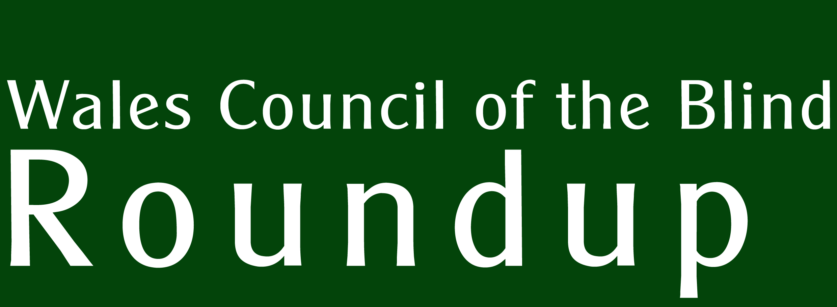 | Supported by  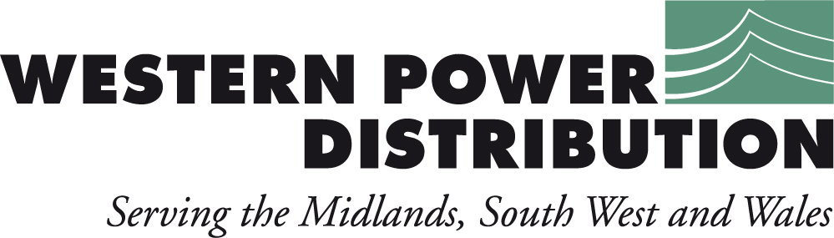  Winter 2015
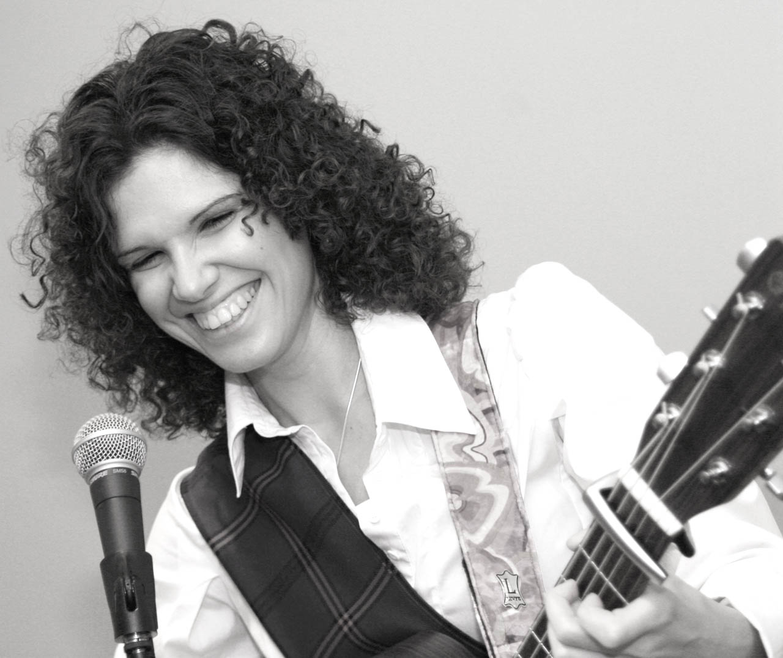
Photo Copyright Lorna McNiven
An interview with Elena Piras
WCB’s Three Year Plan.
WCB AGM – 2pm, 3rd March at WCB’s offices in Cardiff.

Delivering electricity to homes and businesses is about more than just cables and wires, poles and pylons. It’s about providing people with a service that they can depend upon to help them live their lives to the full.
At Western Power Distribution we are investing many millions of pounds long-term on our electricity network to ensure all our customers continue to receive the same world class service.
We are proud to be leading the way in terms of customer service, network reliability, technical innovation and environmental care, but we are not complacent. This is why we will continue to set our own demanding performance targets and exceed those set by our industry regulator.
Our Target 60 initiative is a case in point, for when power interruptions occur its aim is to restore supplies within the first hour. This is a commitment our customers can depend upon.
To find out more about our plans for the future visit www.westernpower.co.uk or email info@westernpower.co.uk.
If you have a power cut – call our new emergency number 0800 6783 105
An interview with Elena Piras

Elena Piras is a folk singer and guitarist whose personal journey is a testament to self-determination and passion. She was born and raised in Sardinia where her musical talents flowered in the church, despite some resistance from her banker father who saw no financial future in music. She was born blind and learned to read Braille when she was six. She attended a mainstream school (Italy had no specialist schools at that time) but her particular school had a teacher of Braille. In middle school she received support for a few hours a week during lectures.

“I first started singing and playing in church when I was seven years old. At the age of eleven I wanted to learn to play the guitar. I found someone who could teach me the basics, then a lot of it was self-taught. At the age of fourteen I joined a professional choir that did operas. We also did jazz with big orchestras and recorded an album. With this professional choir we would have to rehearse three or four times a week and my dad would take me there and back.”

During a car journey with her father she was struck by the beauty of the Sardinian folk music playing on the car radio and discovered a passion for indigenous folk music that led to her explore the music of other nations.

“I’m not a man, so I’m not allowed to sing the Sardinian cantu a tenore but I’ve always said to myself that I need to do something about this music because I think women should sing it too. It’s a work in progress for me. I’ve done Bulgarian music, which is very guttural very much like the tenores.”

At eighteen Elena upped sticks and headed for the UK where, having little English, took a taxi from Heathrow to Hereford.
“I represented Sardinia with my music and an organization called the Apostolic Movement for the Blind, which worked to integrate blind and disabled people into society. When I was eighteen I just disappeared to England, disappointing everybody!

“I always wanted to come to Britain to learn English. I was studying it at school but my spoken English was next to zero. I got this magazine on a tape one day, and it had an article about the Royal National College for the Blind in Hereford. I was in my last year at school on an experimental course of about twenty subjects. It was ridiculously hard, and we had to write a thesis at the end to present to the external commission and discuss it with them during the oral exam. I was doing a thesis about tectonic plates and I was given an article in English to put in. We had to find someone to translate it so we would know what it meant.”

Elena found a translator in the city and worked with her on the translation. She was asked what she wanted to do when she finished school so she mentioned the Hereford College. Elena had never been selected to go to a place near Pisa to get independent living training – not even white cane training - so she was desperate. She needed help. Her translator suggested a personal contact she had, so Elena wrote to the RNIB who passed the letter on to the RNC.

“It was so weird. I couldn’t have planned it in a million years. So I did have time at RNC on my own money, which I had saved up for a long time. I managed to raise some more funds for another half term. Then they offered me a scholarship for a year.” She learned English, which was her initial goal.

Since leaving, Elena moved to Lerwick in the Shetlands where she absorbed the folk music and language of the region. Being an outgrowth of the oral tradition, folk music, Elena asserts, is best understood musically if the language is understood. So she has taken it upon herself to learn the languages of the cultures she explores.

Her studies of the Celtic folk traditions are currently with Wales, where she intends to learn Welsh and identify its authentic folk music. Authenticity is a key aspect of her quest. She spent time in the Shetland Islands to research the fiddle music there and to get closer to the sea. The islanders don’t speak Gaelic; there is a Viking tradition that has led to Norse being the predominant influence within the Shetland dialect. “Scotland is trying to promote the Gaelic language and is producing signs in both English and Gaelic but the Shetlanders fought very strongly against this because they don’t speak it there.”

Elena’s formidable ear for languages (she speaks Italian, Sardinian, English, French, Spanish, Gaelic and, soon, Welsh) has resulted in her voice has being described as a blueprint for how Gaelic should be sung.

“For me it’s about giving my own interpretation by being very authentic and respecting that authenticity and making sure that I don’t get anything thrown at me onstage because I’ve pronounced a word wrong!!

“I am looking for proper Welsh singing that doesn’t sound operatic. I think I’ve found something but I need to make the connections with the right people. I’m still looking for the authentic sound that somebody would make that’s not been worked at. When I hear these people singing I hear … well, a farmer wouldn’t sing that song like that. I think it’s important to learn the language and to hear the cadence of a word, not just where the music is, because people can hear it. You need to know what that word sounds like in real life and where it stands in a sentence. Folk music is almost like speaking the song. You’re not just looking at the phrasing of the music – you’re looking at how people would say it and then you’ve got to put that point across.

“I think, in this country, because of the way the government has done things, we have tended to franchise a lot and there is a danger of that happening to music, and that must not happen. You could think of Italy and France being very conservative as countries because in every single little village they’ve got their own traditional way of doing things. That’s important because people need their own identity kept. You don’t want to lose that. And that is nothing to do with being conservative – it’s about keeping the community and the tradition alive as the heritage and future of that country.

“I’ve always been a musician since I was very young but I didn’t really do it as a profession until the penny dropped that life is too short – you’ve got to take the chance when you’ve got it. I took a course at Stow College in Glasgow, which was the only college (without going to the Conservatoire) that did traditional Scottish music. I said to the tutor that I want to be ready to start as a musician when I’m finished. So I worked really hard in those two years to achieve this. I set up my own website, my own business cards and it took another couple of years for me to register as a self-employed musician because there was further work to do: learning the Gaelic language, making contacts and finding where to go and sing. I was learning to play the violin as well. There was so much going on.

“As soon as I finished my course I recorded my album so I had something to give people.”

What support did Elena receive to set up as a musician?
“Nothing at all. I’ve had no money to set myself up. I had nobody to talk to. I even struggled to find out what the bridge was between Income Support and Working Tax Credit.

“I had no money at all. My bills were really high living in Scotland – I was paying initially for wood and peat to light my fire. When I went to live in the Shetlands the district heating bill was one of the highest on the island because I was right on the shore. But my motivation was really strong – I wanted to do what I wanted to do and I was determined that that was going to happen.”

Like many musicians, Elena is self-employed. To support her in this, she had approached Access to Work for financial assistance to buy aids and equipment so that she can carry out the normal functions of maintaining a business with greater ease. Unfortunately, her level of income from her work is too low which pushes her under the eligibility threshold for support! This is a frustrating state of affairs for someone who is building a legitimate business and simply needs a little extra help in managing things like correspondence, bookings, financial management and so on.

“I applied for Access to Work and the application was really straightforward and I had to tell them what my job entailed. They agreed my initial support of twenty hours a week in December but I couldn’t find anybody until February. They said that after six months I would have a review. Basically, they wanted to know how much I earned – I’d doubled my earnings since last year – and they said I’m not entitled to Access to Work.” Elena felt she was not being trusted by AtW enough to continue building her business.

To help a little with reducing costs, she is registered for VAT so that she can claim back some of the cost of purchasing items for the business. But on balance, she takes a philosophical view of the support she may or may not be entitled to.

“I’m a great believer in not making a huge issue of things, you know, because I don’t believe in using my disability to get things. For me it’s just a matter of fact. I’ll be the first one that says I need help with this and that and I’ll be very specific. It’s about people recognizing that the music is beyond my disability.”

Accessibility is related to Elena’s wish to make folk music available to more musicians. Her own experience of accessing music through recordings and braille scores has inspired her project to disseminate folk music. Many folk musicians do not read printed music, so she would like to evolve a systematic way of sharing traditional songs through a combination of recordings and other media.

But what about physical access? Music venues can present challenges to disabled people.

“I normally carry black and white tape around with me that I can stick on steps and things, but it’s not always possible. It’s about having the humbleness to ask people where the toilet is, for example, and once I’m shown, normally I just remember it. It doesn’t have to be a big faff. I’ve never found anyone that’s kind of gone ‘Oh, my goodness, she’s blind. What are we going to do?’

“Most of my friends forget that I’m blind. People say ‘how does a blind person look?’ How do I know? I’ve never seen one! Do we have a special way?”

Elena sang some songs for us in this interview. They can be heard at https://soundcloud.com/wales-council-blind

More information about Elena and samples of her music can be found at
https://soundcloud.com/elen-piras-music and
https://www.youtube.com/user/elenapiras

WCB Three year plan

Statement from the Chair

We are delighted to have received confirmation that our application for funding under the Sustainable Social Services Third Sector Grant scheme was successful. This scheme effectively replaces our core funding which was formerly issued under the Section 64 scheme. WCB had been in receipt of this fund for over 20 years and it is been a testament to the good work of the organisation that it retained this funding stream throughout its existence. The new scheme, having shifted the emphasis from core funding to project funding, placed a new challenge in WCB’s way. Owen Williams and his team worked hard to identify ways that WCB can deliver against Welsh Government’s new agenda. WCB, as the independent umbrella organisation, shall thereby continue to enable and empower people with sight loss across Wales by working with its members.

Wales Council of the Blind has been awarded an indicative grant, over the next three years of £430,291. The grant will enable WCB to work even more closely with its members, with a quarter of the grant being used in new partnership agreements. In line with our change of name being from ‘for’ to ‘of’ the Blind, we are keen to ensure that this is a transparent project that seeks the views of people with sight loss and we will work with other national, regional and local societies to ensure this.

We have an exciting and challenging time ahead of us and with your support we will make it a success.

Brian Mawby, Chair, Wales Council of the Blind.

Introduction.

The new Social Services and Wellbeing (Wales) Act 2014 places a new emphasis on person-centred services, amongst other things, where the voice of service users must be listened to.

The Act has a number of key themes: focus on people; wellbeing; prevention and early intervention; partnership; accessibility; and new service models.

WCB’s role will be to monitor changes in services through the regional groups where blind and partially sighted people are in control. As the umbrella organisation in Wales we recognise the good work carried out by third sector organisations on the ground. However, with the Act placing more pressure on societies and groups to do more with less money and with demands from funding bodies to be more accountable, WCB sees its role as supporting third sector providers in this challenging environment. The start of the grant coincides with the implementation of the Act so there is a need to hit the ground running. We want to support the sector to achieve this on limited resources.

There is a move towards generic disability providers of services, that is to say non-specialist, pan-disability service providers. WCB shall work to ensure people with sight loss are properly represented within the shaping of these services and have a voice.

WCB will work with its partners to establish or maintain a series of regional groups of people with sight loss as well as regional groups of professionals and, where appropriate, bring these groups together. We will continue to provide secretariat for the Wales Vision Forum and ensure that our work is transparent and that our members are fully informed of our activities. In addition to continuing to work with our members, we are excited to be setting up new working relationships with North Wales’ societies, UCAN Productions (to gain the voice of young adults) and Welsh Rehab Officers’ Forum to establish specific training modules for the profession. We are also pleased to continue to work with Sight Cymru to develop a BME forum.

We will also have a fund to work more closely with local societies to develop their reach and services.

We would welcome involvement from blind and partially sighted people, third sector organisations in Wales and sight loss professionals and look forward to working with you all on the following plan.

The Plan 2016-19

WCB's Wales-wide work plan, based on the principle of partnership working, has five areas of work aimed at reducing the impact on Social Services.

We won't be providing services on the ground, other than referring people to organisations that support people with sight loss. We are in the unique position of being able to refer people impartially.

Our work-streams will address five outcomes:

That people with sight loss benefit from improved support from local societies and groups. We will foster the ‘full engagement of the Third Sector in the provision of community-based support services’.

That people with sight loss influence design and delivery to achieve citizen-centred services. We want the voices of vision-impaired people to be at the heart of service planning and delivery. For example, we want service users to provide the evidence needed to ensure that services do not create systems that unfairly screen out individuals at first point of contact.

That people with sight loss and social care professionals are fully informed of the wider range of services/support available through an integrated information service. Perspectif, WCB’s online database, collates all information necessary for people with sight loss within one portal. Its usefulness must be promoted to organisations, professionals and individuals and expanded to incorporate sensory loss services generally.

That the expertise in social services is used more efficiently and effectively. We believe rehabilitation is the core service that enables people with sight loss to achieve independence. We will work with WROF, Vision Impairment (VI) Professional Network (Health and Social Care professionals, Third Sector representatives), and a new ‘Making a Difference’ Advisory Board to raise the quality of the profession to a standard that vision impaired people expect.

That services are better coordinated and monitored. The sector offers a spectrum of services that often reduce the impact on social services by improving wellbeing and independence through training, support and social engagement. Services are generally monitored by providers in consultation with beneficiaries. We will work with providers to share best practice.

In order to achieve these outcomes, WCB will be initiating a series of activities over the three-year period 2016-19.

WCB News

WCB’s AGM
Wales Council of the Blind shall hold its Annual General Meeting at its offices in Hallinan’s House, Newport Road, Cardiff at 2pm on Thursday, 3rd March, 2016.

Your Voice : A Shared Vision

West Wales Regional Group
The last meeting was reported on in the previous Roundup. The next meeting shall take place on 14th March. Venue to be confirmed.

Gwent Regional Group
The Low Vision, Health and Social Care services were the topics of discussion at the December event. We asked people to let us know about their experiences of using these services.

Low Vision Service

The group felt that the Low Vision Aids assessment is an outstanding service being provided locally within their community. The portable optical magnifiers and the electronic magnifiers provided have proved invaluable, enabling people with sight loss to live independently. One person stated “the service has changed my life”. Some felt that the service needed further promotion through the eye clinics and local authorities.
Health Service

Conversations around health services raised uncertainty of the eligibility criteria for hospital transport to and from medical appointments following incidents of people with sight loss being refused a service. People reported hospital staff being unaware of their sight condition, which led to them wondering whether it was recorded on their medical notes. It was also clear that patients were still receiving inaccessible medical appointment cards. Some group members would like to see raised awareness of sensory loss from front line staff.

Social Care

There is no system of follow up when sight is deteriorating so the onus is on the individual to call the local authority contact centre for continuing help. Not all clients are aware of this. There is a worry that telephone assessments may be carried out by people who don’t understand sight loss. This is a particular concern when there is a high turnover of staff. Also, if clients are unaware of what is on offer, they don’t know what to ask for when calling the contact centre. There were also reports of a long wait to see a Rehabilitation Officer, but those who have been seen, were complimentary of the service they received. There were some instances of clients on a social services waiting list calling to seek progress only to be informed that their case had been closed. People also expressed in interest in receiving an information pack at the point of registration from their local authority detailing services available to them. The discussion highlighted that Direct Payments was not being fully promoted by some local authorities.

If you would like to report your experiences relating to any of the topics mentioned, we would like to hear from you.

Across the Sector

Inherited Eye Disease Patient Day

Cardiff School of Optometry and Vision Sciences, in conjunction with the Genetic Alliance UK and Wales Gene Park, hosted its second event to give information on the support available to people with sight loss – specifically those with inherited eye diseases such as retinitis pigmentosa and glaucoma.

Maggie Woodhouse gave a very clear explanation of special methods used to test visual acuity and visual field in children. Children find it challenging to be examined in the way adults are: they are less able to report symptoms, read letter charts, keep still and look steadily towards a light. Adults are more able to deal with the uncomfortable frames for testing out lenses. Children find it boring to do the long visual field tests that involve identifying tiny spots of light being flashed into view. And the chin rest is intrusive. Maggie explained that different methods can be deployed with small children such as simple retinoscopy to determine whether the patient is short or far sighted and simple pictorial methods to establish where a child is looking. Optical Coherence Tomography is revolutionizing investigations of the eye by providing the digital scanning equivalent of taking a thin slice of the eye for examination under a microscope. Again, the process is trying for children but hand-held devices are being developed that may be more suitable. Maggie’s final message was that designers must design instruments for the most challenging patients such as children with additional needs. If they work for them they will work for everyone.

Nicola Crews from RNIB spoke of the pathway from diagnosis to confidence and autonomy for children via health, social services and third sector support. She adds that the reduction in the number of Qualified Teachers of Vision Impaired children (QTVIs) has resulted in a game of musical chairs, where the few QTVIs move from post to post, leaving gaps in provision in their wake.

Alastair Kent from Genetic Alliance UK introduced the strategic context for the Rare Disease Plan.

Helen Gummet-Preece gave an outline of Access to Work support to help people retain employment and explained how the Equalities Act requires employers to make reasonable adjustments to enable disabled people to carry out their work functions.

Rebecca John explained how the Low Vision Service Wales provides individuals with low vision aids through a network of 200 optometrists spread throughout Wales. This service is for anyone who has difficulty performing daily tasks due to their vision, despite wearing their best glasses or contact lenses.

Andrea Edwards gave an explanation of ‘genetic counselling’ where information is gathered such as a patient’s family history, discussing choices with patients such as whether or not to test for genetic defects and how and who in the family to tell, such a teenage child.

Marcella Votruba talked about setting priorities for research in the field of eye disease. Discoveries do not come when they are needed – you have to wait for them, and they never come in an A to Z order. She tells us of there never being enough money and that UK funders have their own priorities. Only 2% of all medical research funding is directed at sight loss and eye disease.

Julian Jackson talked of the 150 projects in the UK Fight For Sight supports and Emma Hughes, Wales’ Development Officer from Genetic Alliance UK, told us about the patient support group, the Facebook page and website aimed at helping people with genetic eye conditions.

A discussion with three individuals who have various experiences of genetic conditions gave a human perspective to a sometimes dry subject. Emily spoke of having to overcome the first hurdle of asking for support, but when she did she found it easier to handle her sight loss. John added that being confident about the condition is important. ‘Take ownership of it – don’t fight it – find out about it. People are more supportive then.’

Contacts:

Cardiff School of Optometry and Vision Sciences
Marcela Votruba, Head of School
Maindy Road, Cathays, Cardiff, CF24 4HQ.
Votrubam@cardiff.ac.uk

Fight For Sight UK
Julian Jackson, Senior Advisor
Julian@fightforsight.org.uk
http://www.fightforsight.org.uk

Nystagmus Network
029 2045 4242
info@nystagmusnet.org
www.nystagmusnet.org

RNIB Cymru
Helen Gummett-Preece, Employment Advisor
029 20 828522
helen.gummett-preece@rnib.org.uk
www.rnib.org.uk

Access to Work
0345 268 8489

Genetic Alliance UK
Emma Hughes (Rare Genetic Eye Disease Support Group)
029 20 748154
emma@geneticalliance.org.uk

Low Vision Service Wales
Search the site for your local accredited optometrist
http://www.eyecare.wales.nhs.uk/low-vision-service-wales

All Wales Medical Genetics Service (Genetic Counselling)
Andrea Edwards, Clinical Director and Lead Genetic Counsellor
029 20 743922
Andrea.Edwards@wales.nhs.uk

RP Fighting Blindness
Helpline 0845 123 2354
www.rpfightingblindness.org.uk

Esme’s Umbrella
For everyone working for the greater awareness of Charles Bonnet Syndrome
Helpline 0345 051 3925
esmesumbrella@gmail.com
twitter @esmesumbrella

Depression and Vision Impairment study

The Guide Dogs / Cardiff School of Optometry research findings on depression have been in the news.

"The Depression in Visual Impairment Trial (DEPVIT) found that 43% of people who lose their sight go on to battle depression, however NHS low vision services focus only on the physical need, and psychological screening or therapy is not yet an integral part of rehabilitation.

"The study also found that of those who screened positive for depressive symptoms almost three-quarters (74.8%) were not receiving any treatment for their depression."

Read about this research at School of Optometry website http://www.cardiff.ac.uk/news/view/191612-sight-loss-patients-with-depression-routinely-overlooked
Esme’s Umbrella

Judith Potts, the founder of a new organisation to raise awareness of Charles Bonnet syndrome, tells us about ‘Esme’s Umbrella’.

On 16th November last year, I launched Esme’s Umbrella – the first Awareness Campaign for Charles Bonnet Syndrome (CBS) - at The House of Commons. Hosted by Dr Sarah Wollaston (Chair of the Health Select Committee), the event was a huge success and the support offered from all sides of the eye health world has been marvellous.

My mother – Esme - suffered from CBS and, at the time, there was very little help available – indeed, the situation has not improved very much now. The terrifying hallucinations became a daily occurrence and remained with her for the rest of her life. Like so many people, she said nothing until she could bear it no longer. The word ‘dementia’ hung in the air but, of course, CBS has nothing whatsoever to do with mental illness. It is a condition not widely known by health care professionals in general but, obviously, the correct diagnosis is crucial.

The Syndrome affects some people – but not everyone – whose sight is diminished (through all sorts of causes) producing hallucinations which can range from disconcerting to frightening. As the eyesight deteriorates, the parts of the brain associated with vision begin to create their own images, having been starved of stimulus from the optic nerve. These images/visions/hallucinations can seriously impact on the quality of daily life.

At the moment there is very little in the way of medication which can help – and what there is often causes side-effects – so the best we can do is to reassure the sufferer that it is a normal part of losing sight.

I hope to be able to turn the Awareness Campaign into a fund-raising charity so that our Medical Adviser, Dr Dominic ffytche (the only person in the UK who understands and researches CBS) can expand his work towards new knowledge and treatments. In the meantime, I am determined to take the Campaign into GPs’ surgeries and out into the wider community. I want to ensure that ophthalmologists warn their patients with low vision that CBS might develop; that GPs, optometrists, specialist doctors and nurses (like those working with diabetics, who could develop CBS) are aware of the condition and can point sufferers towards Esme’s Umbrella; and sufferers (or their families) can find help through support groups around the country. At the moment there is only one – run by the Royal Society for the Blind in Sheffield – but we need many more to give comfort and camaraderie to sufferers, their families and friends.

We have a website www.charlesbonnetsyndrome.uk, an email address esmesumbrella@gmail.com and a Helpline 0345 051 3925 given to us by The Help and Information Service as part of their 24/7 365 call centre.

Our website carries a printable information sheet to take to the GP; the updated results of Dr ffytche’s work, which has already begun to change and develop the understanding of CBS; along with other information about the condition, plus coping strategies for those who find the hallucinations disturbing. I hope that sufferers and their families will add their own experiences.

There is currently no cure for CBS but the work of Esme’s Umbrella will promote discussion, engagement and awareness, to enable sufferers to manage their condition, find coping strategies and – most of all – reassurance.

Under the clinical guidance of Dr Dominic ffytche, the Help and Information Service will work to implement a large-scale consumer-based campaign, to show the differences between dementia and CBS. Michael Davidson, non-executive director of TH&IS said: “It behoves us all in life to offer help where it is practical and possible to give it. We are proud to be playing our part”.

I wanted to name the Awareness Campaign in memory of my Mother, Esme, because it is only fitting that she – who suffered most terribly from the condition – should be the one to carry the umbrella which will shelter all those for whom CBS is a factor in their lives – from sufferers to researchers and health care professionals – promoting awareness, understanding and research.

Dr Dominic ffytche wrote an article about CBS for the Winter 2011/2012 edition of Roundup. You can still read it on our website:
http://www.wcb-ccd.org.uk/downloads/roundup08_supplement.pdf.

Cross Party Group on Vision – Key Achievements of the Fourth Assembly

Sandy Mewies summed up the Assembly’s achievements within areas of everyday life affecting people with loss of sight. During her tenure as chair of the group, which brings together sight loss charities and individuals with Assembly Members from each of the political parties, the sector has been able to engage with the Minister for Education regarding the diminishing numbers of Qualified Teachers of VI children and liaised with Welsh Government over the implementation of the Eye Health Care Delivery Plan for Wales and the newly implemented Welsh Eye Care Services. Guidance on the delivery of the Active Travel Act now includes a statement that ‘Local authorities should seek to establish a dialogue with organisations representing people with protected characteristics, as part of developing a clear understanding of local needs, circumstances and opportunities.’
Sandy went on to state that she hopes the group will continue and that organisations must engage with Assembly Members to make sure links are made with appropriate people in Welsh Government.
Sight loss organisations Guide Dogs, RNIB Cymru, Sense Cymru and Wales Council of the Blind were present to pitch their ‘key asks’ to AMs. Jonathan Mudd from Guide Dogs reminded the AMs that pedestrians are at risk because the vehicle is dominating the built environment but his ‘holy grail ask’ is for education, social services and health to talk to each other in a more strategic way.
Political hustings at RNIB Cymru.
The Fifth National Assembly is on the horizon with the elections taking place on May 5th. RNIB, to coincide with its manifesto launch, hosted a debate between candidates from each of six political parties to try to identify what is being promised to people with sight loss in Wales in the coming Assembly.
In the debate were Mark Isherwood (Welsh Conservatives), Neil McEvoy (Plaid Cymru), Caroline Jones (UKIP), Eluned Parrott (Welsh Lib Dem), Amilia Womack (Green Party) and Jeremy Miles (Welsh Labour and Co-Operative).
RNIB’s manifesto calls for action on three priority areas: health and care services; education support from QTVIs; and Independent Living. These offered a structure to the debate.
The subject of ‘intelligent targets’ for treatment within ophthalmology departments was put to the candidates. It seemed like a new concept to some, but there seemed to be unanimous agreement that delays and cancellations within the current system were unacceptable. McEvoy was concerned that decision-making was not being made by doctors, resulting in service planning that does not prioritise the patient. Parrott emphasised that the diagnosis-to-first-treatment time is not the full picture and that health boards are skewing resources to meet false targets. Isherwood suggested that there’s a risk of intelligent targets being used in reverse by enabling people to manipulate the system to jump the queue. Miles suggested that there is an over-reliance on hospital settings and we should work smarter by using facilities closer to home, such as treatments for AMD happening in the high street optometrist.
Asked about the decreasing percentage of blind and partially-sighted graduates obtaining employment, Parrott insisted that it is not unreasonable for employers to make adjustments to enable a disabled person to work but with Wales having a large percentage of small businesses, employers are reluctant to take a risk. Employers, she said, must be encouraged to make positive choices. Isherwood remarked that many of the jobs in the statistics are part time, so the picture is even bleaker. Also, his own daughter only started to get interviews for jobs after she stopped ticking the box saying she was a disabled person. Miles pointed out that the employment rates for blind and partially sighted people with a degree is roughly equal to those for sighted people without qualifications and he added that aggressive social security changes are not supporting people back to work.
There was universal support for audio-description being available on all buses in Wales. Parrott said there is a problem where the service is deregulated: more operators, often with old vehicles, make upgrading a longer process. Womack reminded us that some drivers have been known to switch off the announcements because they find them irritating. But, she says, the facility benefits all passengers so there is no excuse for not implementing it universally.
The issue of accessible education in both English and Welsh was raised. Parrott told us that Dragon Dictate, a popular access tool, was not available for use in the Welsh language and that support in general was not always available when you need it, such as in evening classes. McEvoy was dismayed at Cardiff Council paying £230k salaries in an environment where cuts are being made to education budgets.
So, that’s just a snapshot of the discussions. In the coming elections there will no doubt be opportunities to challenge your local candidates on party manifesto promises to see if and how they will improve matters in the devolved political areas for disabled people.
Wikipedia on the National Assembly elections: https://en.wikipedia.org/wiki/
National_Assembly_for_Wales_election,_2016
www.welshlabour.org.uk
www.welshconservatives.com
www.partyof.wales
www.ukip.org
www.greenparty.org.uk
www.welshlibdems.wales
RNIB Cymru’s manifesto is available at
http://www.wcb-ccd.org.uk/single_post.php?var=1632

'Bionic eye' restores some sight to woman from Cardiff

Rhian Lewis from Cardiff, who has had retinitis pigmentosa (RP) for most of her life, is the first patient in Britain to have a cutting-edge "bionic eye" implanted. The operation took place at the John Radcliffe Hospital in Oxford, and and the results have been very encouraging. Ms Lewis developed RP in her childhood, and has had very little sight for the past 16 years. Following the operation, she has had some restoration of sight, and both she, and the surgical team, are delighted with her progress. If the rest of the trial is successful, it's possible that the implant could be made available on the NHS. It may also be possible to apply the technology to other eye diseases, such as age-related macular degeneration. The story has featured on several BBC programmes, including BBC2's 'Trust me, I'm a doctor'.

Pavement parking review

Pavement parking is a problem which affects most vision impaired people - and other vulnerable pedestrians. Now the UK Government has announced that it will be conducting a policy review into the issue, considering how a law could be put into practice. This follows campaigning by Guide Dogs, and a debate on a private members bill.

Although the private members bill was defeated, the level of support for Guide Dogs' campaign has persuaded the Government to pursue the issue.

‘It Makes Sense’ – Sensory Loss Awareness Month

In December 2013 the Welsh Government’s Health Minister, Mark Drakeford, launched the All Wales Standards for Accessible Communication and Information for People with Sensory Loss, making Wales the first country in the UK to set out clearly how the NHS should make information and communication accessible to patients who are deaf, hard of hearing, blind, partially sighted or have dual sensory loss. Two years on, in December 2015, a national launch of ‘It Makes Sense - Sensory Loss Awareness Month’ took place, led by the Deputy Health Minister, Vaughan Gething. It is hoped that this will become an annual event.

Activities took place across Health Boards and NHS Trusts during December to raise awareness of the communication and information needs of people with sensory loss amongst the NHS Wales workforce and also to remind patients of their rights to accessible communication and information when they need healthcare. As part of the event, a new e-learning programme (developed in collaboration with RNIB and Action on Hearing Loss) is being made available to NHS staff to promote accessible healthcare for people with sensory loss by providing practical information and suggestions to assist communication within a healthcare setting.

People with sensory loss are reminded that a brief guide ‘Sensory loss: know your healthcare rights’ is available from the Sense website. Go to https://www.sense.org.uk/ and search for the guide’s title.

RNIB’s Talking Books now free

Talking Books, a service which provides 4,000 audio books every single day to people with sight loss, will now be entirely free for all blind and partially sighted people. RNIB (Royal National Institute of Blind People), which runs the service, made the announcement to mark the 80th anniversary of Talking Books.

The RNIB library is the largest of its kind in Europe with 23,000 books. Readers can access the audio books on CD or USB or as a digital download, so that they can listen to them how they choose, whether at home or ‘on-the-go’. In Wales, RNIB Cymru also produces Welsh and English language books from their Cardiff studios. There are 6,034 Talking Books customers in Wales – adults and children - and the charity now hopes that many more will now be able to enjoy them. To find out more about the RNIB Library or to sign up for Talking Books, call the RNIB Helpline on 0303 123 9999 or visit www.rnib.org.uk.

New Macular Support Group in Lampeter

The Macular Society has launched a new support group in Lampeter. It meets at St Thomas Church, St Thomas Street, Lampeter, Ceredigion SA48 7DQ on the second Wednesday of the month from 2 to 4 pm. The meetings are open to anyone affected by central vision loss, and carers are also welcome. For further information please contact Diana on 01570 640 034.

PIP: aids & appliances descriptors

The Department for Work & Pensions is carrying out a consultation on changes to the Personal Independence Payment (PIP), and RNIB is concerned that vision impaired people could lose around £200 per month if the proposals are implemented. They are asking people to contact their MP if they share these concerns.

To find out more about the proposals, and the issues which RNIB has raised, visit the ‘Campaigns’ section of the RNIB website http://www.rnib.org.uk/campaigning and follow the links to ‘Protect PIP’.
Have Your Say!

Welsh Government Consultations

Details of all WG consultations can be found on their website, http://wales.gov.uk/consultations. The following may be of particular interest:

- Draft Local Government (Wales) Bill and Explanatory Memorandum (closes 15 February).
- UK policy framework for health and social care research (closes 24 March)

If you would like a consultation document in a different format, email the document title and the preferred format to CustomerHelp@wales.gsi.gov.uk or call 029 2082 3683.

Give your views on Social Care Wales
The Care Council for Wales, which has a leading role in making sure the workforce delivering social services in Wales is working to a high standard, is to become a new body, 'Social Care Wales', that will lead a transformation of social care services. They are asking people who have a link with social care, for example as a professional, service user or carer, to help shape the new organisation by completing a survey.
You can find out more and complete the survey on the Care Council's website: http://www.ccwales.org.uk/news/2016/01/08/tell-us-what-you-think-social-care-wales-should-be-like/.
Welsh Ambulance Service wants your comments

The Welsh Ambulance Service want your comments to ensure they are providing the best possible service for you.
Visit their website to complete the online form at http://www.ambulance.wales.nhs.uk/Default.aspx?pageId=66&lan=en. Alternatively, email ppi.team@wales.nhs.uk or telephone 01792 311773.

If your feedback is about a particular service they provide, please mention it, for example, emergency 999 response, or transport to appointments, or contacting NHS Direct Wales.

This is not appropriate if you would like to raise a concern/complaint about the service. For further information please visit their Putting Things Right section at http://www.ambulance.wales.nhs.uk/Default.aspx?pageId=20&lan=en
Publications & resources
How can care homes support people with sight loss?
It is thought that one in two people living in the 18,000 care homes in the UK has a degree of sight loss that affects their daily life (around 200,000 people). Now the Thomas Pocklington Trust has produced a discussion paper which considers how care home staff can best support these people.

The report suggests discussion points for care home owners and managers, and areas for further research. To read the report, visit the Pocklington website, http://www.pocklington-trust.org.uk, and look under ‘Research reports’ for ‘Research Discussion Paper No. 14: Models of change for care homes’.

[Editor’s note: Wales Council of the Blind formulated the National Minimum Standards for Care Homes for Older People – Supplementary Guidance - visual impairment, adopted by the CSSIW]

Online Swimming course
British Blind Sport has launched a free, online resource to show anyone who is delivering swimming activities (such as coaches, teachers, parents and carers) how they can include people with a vision impairment more effectively, giving support, ideas and guidance. The course consists of five modules, including Understanding Visual Impairment and Accessible Swimming. To find out more and access the course, visit the BBS website, http://www.britishblindsport.org.uk
Power for Life

Western Power Distribution (WPD) operates the electricity distribution network in the Midlands, South Wales and the South West. Put simply, our role is to ensure the power network of poles and pylons, cables, wires and substations – the infrastructure that we all rely upon to live our lives to the full – delivers electricity to our homes and businesses around the clock.

Power cut? Call our emergency number 0800 6783 105
Sometimes power cuts can happen for reasons beyond our control. During a power cut we are able to help.
We know it can be particularly worrying if you rely on electricity for medical equipment or if you are elderly, very ill or disabled. If you depend on electricity for a reason such as using a nebuliser, a kidney dialysis machine, an oxygen machine, a ventilator – or any other reason – you should register with us.
WPD provides a FREE Priority Service Register, which helps us to identify customers who may need a little extra help during a power cut.
If you join our FREE Priority Service Register we can:

- Give you a direct number to call in the event of a power cut so you can get straight through to us.
- Agree a password with you before we visit you, so you feel safe.
- Provide special help, if needed, through the RVS (Royal Voluntary Service) or British Red Cross.
- Ring and tell you about planned interruptions to your electricity supply.
- Keep you as informed as possible in the event of an unplanned power cut.

To join, call 0800 9177 953, or visit our website www.westernpower.co.uk
Events
Video maker shares her story at open day

The producer of two nystagmus videos will be the keynote speaker at the Nystagmus Network Open Day on Saturday 7 May at the Hilton Hotel, Reading. Kristina Venning will talk about making NN’s ‘The way we see it’ and ‘Professional perspectives’ videos. Kristina will also share stories with delegates about her media career and what it’s like starting out as a mum when you have nystagmus and albinism.

The Open Day at Reading is NN’s annual gathering for people who have the eye condition nystagmus, families of children born with it and eye health professionals. The aim of the day is for people affected by nystagmus to meet others like themselves, share experiences of what it's like to have nystagmus and learn from the experts. Sessions for the day will cover new parents, education, benefit advice and research updates.

Richard Wilson, Chairman, Nystagmus Network, said: “Our Open Day is a fun way to meet other families and people with nystagmus. The emphasis is very much about interaction - everyone is encouraged to take part whether they have a lifetime’s experience to share or are just starting their journey. The relaxed atmosphere of the day helps people realise they are not alone and that there are others just like them.”

Kristina Venning said ”I’m really looking forward to this opportunity to talk to everybody, tell them about my work, how I overcome the challenges that nystagmus brings and share some stories about starting a family when you have nystagmus.”

Places at the Nystagmus Network Open Day can be booked online via https://www.eventbrite.co.uk/e/nystagmus-network-reading-open-day-2016-tickets-20965963762?aff=efbevent Tickets including lunch cost £30 for NN members and £50 for non-members.

Children under the age of 8 go for free and for those between 8 and 16 there is a charge of £10. There will once again be a crèche for children under the age of 8 which will be on a first come first served basis.

For more information please contact us on
tel: 0845 634 2630, or email: info@nystagmusnet.org

Kristina Venning produced two short videos for NN in 2015. They give an overview of what it’s like to have nystagmus and an update on the latest in research and treatment for this eye condition which affects 1 in 1,000 people. The videos can be viewed at www.youtube.com/user/NystagmusNet/

North Wales Mobile Information Unit

The schedule for the North Wales Mobile Information Unit for February and March 2016 is:

February

- Monday 8th Rhyl rear Town Hall 9.30 am - 3 pm
- Monday 22nd Dolgellau Marian Car Park 11.30 am -2.30 pm
- Friday 26th LLangefni Town Hall Car Park 10.30am–3 pm
- Monday 29th Llys Erw Ruthin 9.30 am – 12 pm and Trem Y Foel Ruthin 1 pm to 3.30 pm

March

- Friday 4th Llandudno North Shore by Cenotaph 9.30 am – 3.30 pm
- Monday 7th Blaenau Ffestiniog Diffwys Sq 10.30am–3 pm
- Friday 11th Holyhead Lower Hill Car Park 10.30am–3 pm
- Monday 14th Barmouth Main Car Park 11 am – 2.30 pm
- Friday 18th Rhos on Sea Prom by TIC 9.30 am – 3.30 pm

Please check Vision Support’s website http://www.visionsupport.org.uk/ for further details.

It is recommended that you ring 01745 338914 to confirm details before travelling.

RNIB’s Online Today events
Online Today, RNIB’s lottery funded technology project, is coming to libraries across Wales this winter. The team can give help with Smartphones, Tablets, Laptop and E-readers of all descriptions. The events are by appointment only. Please bring along any equipment you want help with, or if you want a demonstration of what equipment is currently available then let them know and the team will try to ensure that they have it with them on the day. Dates and venues are as follows:
Booking is essential. To book your place call 029 2082 8519.

- Neath - February 9th 10am-12pm, Neath Library, Victoria Garden, Neath SA11 3BA
- Mumbles - February 10th, 10am-12pm, Oystermouth Library, Dunns Lane, Mumbles, Swansea, SA3 4AA
- Port Talbot - February 11th, 10am-12pm, Port Talbot Library, 1st Floor, Aberafan Shopping Centre, Port Talbot SA13 1PB
- Pontarddulais - February 16th 10am-12pm, Pontarddulais Library, St Michael's Avenue, Pontarddulais, SA4 8TE
- Welshpool - February 23rd 10.30am-2pm, Welshpool Library, Brook Street, Welshpool, Powys SY21 7PH
- Llandrindod Wells - February 24th 10am-2pm, The Gwalia, Ithon Road, Llandrindod Wells, Powys LD1 6AA
- Machynlleth - March 15th 10.30am-1pm, Machynlleth Library, Maengwyn Street, Machynlleth, Powys SY20 8DY
- Newtown - March 16th 10am-2pm, Newtown Library, Park Lane, Newtown, Powys SY16 1EJ
- Lampeter - April 13th 2pm-4pm, St Thomas Church, St Thomas Street, Lampeter SA48 7DQ.

Professional Development Day at RNC

The Royal National College for the Blind (RNC) in Hereford is running an event for professionals working with young people aged 12 to 25 with vision impairment on 25th February.

Attendees will be able to find out about RNC's individually tailored academic and vocational programmes, the specialist support available (e.g. daily living skills, mobility) and how it helps vi young people move into further or higher education, employment or self-employment.

For more information and to book a place, visit the RNC website, http://www.rnc.ac.uk/events/pdd2016, or telephone 01432 376 621.

Specialist Workers Meeting

Sight Cymru's Specialist Workers Meeting will be held on Friday 4th March at the Masonic Lodge, Masonic Hall in Cardiff. There will be talks on new treatments for dry macular degeneration, prosthetic eyes and changes to diabetic retinopathy screening, as well as networking opportunities.

This free event starts at 12.00 pm and includes lunch. If you would like to attend, please contact Lissa Gomer at Sight Cymru on 01495 763650 or by email at lissa.gomer@sightcymru.org.uk.

Help with applying to university

VICTA is organising a free residential course for young people with a vision impairment aged 16 and over who are applying for a university place commencing in autumn 2017. The 'Applying to University' course will be held at New College Worcester on 23rd - 24th March 2016.

Topics to be covered include how to choose a course and a university, writing a personal statement, student finance, and sources of support. There is also a session for parents wanting to find out more about the application process. To find out more, visit the New College website, http://www.ncw.co.uk/ and look under ‘Events’ or telephone 01905 763933.

Glaucoma Support Group meetings

The International Glaucoma Association (IGA) is organising a support group meeting at the University Hospital of Wales in Cardiff on 22nd April from 2 pm to 4 pm. For more information, ring Eryl Williamson on 07856 68 79 31.

Details of all IGA’s support group meetings are on their website, www.glaucoma-association.com – click the ‘support groups’ option on the right hand side of the screen.
Minority Ethnic Communities Health Fair

This year's Minority Ethnic Communities Health Fair is at City Hall, Cardiff on Tuesday 15 March.

What's on? Health checks; experts on a variety of health issues; health-related displays and stalls; InterActive Schools Zone; language support provided.

To find out more, call (01495) 763650 or email bablin.molik@sightcymru.org.uk If you would like a stand / stall at the event, please complete the booking form that's on C3SC’s website http://www.c3sc.org.uk/networks/networks-doc-lib/cardiff-health-social-care-network/events

New College Worcester

New College Worcester, the national residential school and college for young people aged 11 to 19 who are blind or vision impaired, runs a range of events for education professionals as part of their Outreach Programme. Events planned for the next few months include preparing students for exams; Outreach Open Day; open day for professionals. There is also a Parent Information Day on Wednesday 16th March, which is aimed at parents who are in the very early stages of exploring education options.

For more information on all of these events, and to make a booking, visit the ‘Events’ section of the NCW website, http://www.newcollegeworcester.co.uk/events, or telephone the College on 01905 763933.

Sharing ideas and planning together
Social Services and Well-being (Wales) Act Information Event.
Wednesday, 10th February 2016 10.30am-3pm at the Bethlehem Church Life Centre, Cefn Cribwr, CF32 0AA.
Bridgend Coalition of Disabled People, in partnership with Wales Council of the Blind and Disability Wales, invites disabled people and representatives of disability organisations to attend a free information day.
Help us think about:
- What is the Social Services and Well-being (Wales) Act and how will it affect me?
- How does it differ from previous legislation and will it uphold and deliver on my rights?
- How can we empower ourselves to inspire change in public services to increase independent living for disabled people?
- How can disabled people work together with public services to achieve our goals?
This is a free event with lunch provided. Contact Cathy Rogers (Mon-Wed) on 07814 209472 or email: bridgendcoalitionDP@gmail.com for further information or to book your place.

Advertise in WCB Roundup
WCB Roundup is sent to more than 1200 people, in a variety of formats, the download version is available from our website and an audio version is on www.soundcloud.com/wales-council-blind. We are a not-for-profit organisation that hopes to recoup its costs. We seek advertisers for our newsletter so that we can continue to produce this valued journal. Advertisers will reach a readership of individuals with sight loss, optometrists, ophthalmologists, rehabilitation officers, social workers, and organisations working for blind, partially sighted and disabled people.

Our rates are (per edition):
Full A4 page: £150 (black and white) £250 (colour)
1/2 A4 page: £100 (black and white)
Enclosures: single sheet A4 750 copies, supplied in a ready-to-go format: £200.
Larger enclosures (such as booklets): please ask for quote.

To advertise in many editions, please contact us for discounts. Contact Ann via ann@wcb-ccd.org.uk or telephone 02920 473954.

WCB Roundup is published quarterly by Wales Council of the Blind, 2nd Floor, Hallinans House, 22 Newport Road, Cardiff CF24 0DB. Tel: 029 20 473954. Email: richard@wcb-ccd.org.uk.

Further copies, in audio CD or large print formats, are available. All editions are online at
http://www.wcb-ccd.org.uk/roundup.php

The focus for the next edition of Roundup will be sources of funding for groups and individuals.
Award for VI bowls manager

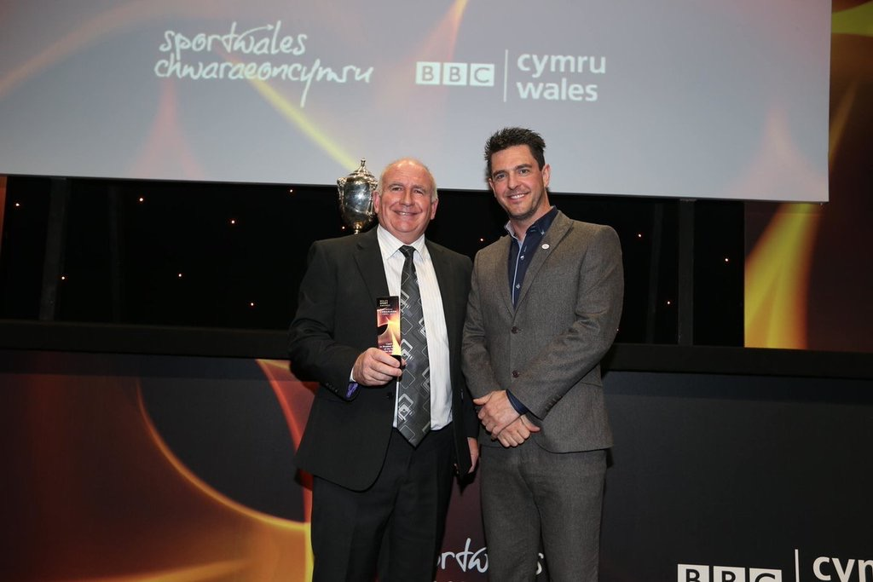

Many congratulations to John Wilson, Team Manager of the Welsh Association for Vision Impaired Bowlers (WAVIB), who has been named 'Coach of the Year to Disabled People' in the Wales Sport Awards. These annual awards are organised by Sport Wales and BBC Wales to showcase the very best of elite and grassroots sport in Wales.

The website of the Welsh Association of Visually Impaired Bowlers is http://www.welshvibowls.org.uk/


