
Spring 2015 Special Edition:
Cardiff Institute for the Blind
150th Anniversary

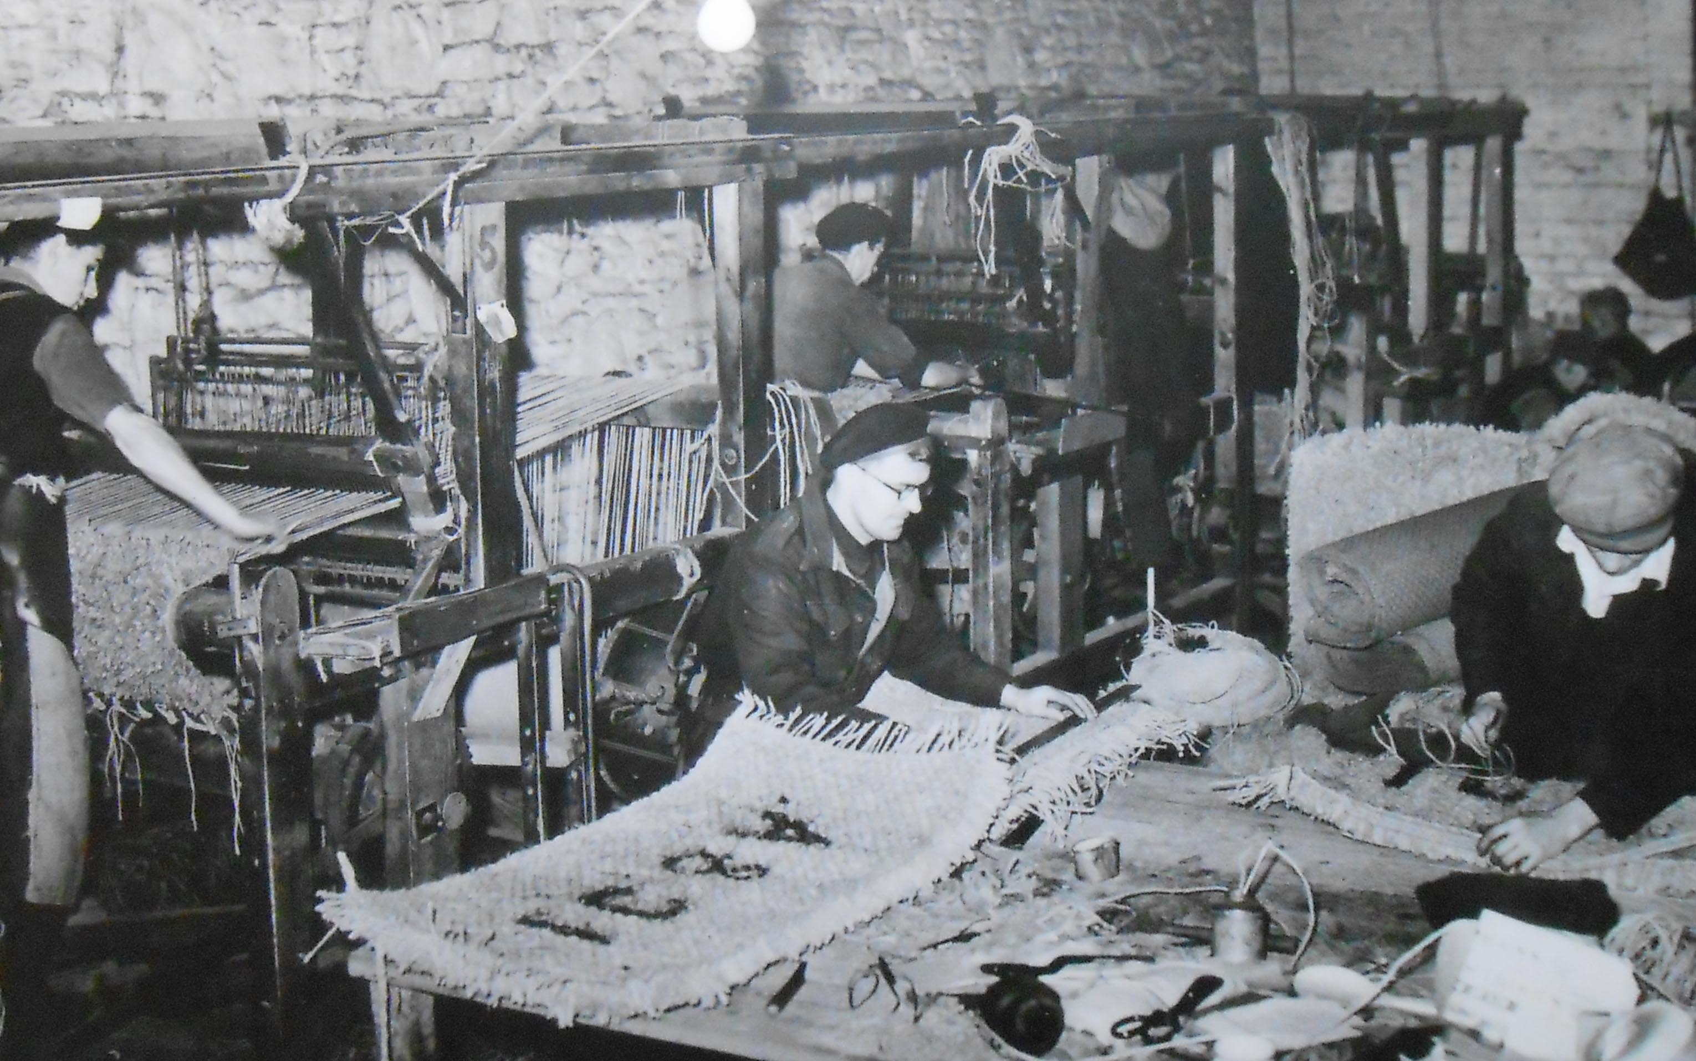

Supported by


Delivering electricity to homes and businesses is about more than just cables and wires, poles and pylons. It’s about providing people with a service that they can depend upon to help them live their lives to the full.
At Western Power Distribution we are investing many millions of pounds long-term on our electricity network to ensure all our customers continue to receive the same world class service.
We are proud to be leading the way in terms of customer service, network reliability, technical innovation and environmental care, but we are not complacent. This is why we will continue to set our own demanding performance targets and exceed those set by our industry regulator.
Our Target 60 initiative is a case in point, for when power interruptions occur its aim is to restore supplies within the first hour. This is a commitment our customers can depend upon.
To find out more about our plans for the future visit www.westernpower.co.uk or email info@westernpower.co.uk.
If you have a power cut – call our new emergency number 0800 6783 105

Cardiff Institute for the Blind

We are devoting this issue to Cardiff Institute for the Blind (CIB), which celebrates its 150th anniversary this year.

Introduction

Kieran Harris, CIB’s Director of Operations, introduces this special edition, and tells us about CIB’s history.

Cardiff Institute for the Blind (some people call us CIB for short) provides local services and lifelong support, so that blind and partially sighted people in South Wales can enjoy fulfilled lives.

We were set up in 1865, making us one of the oldest charities in Wales. We are also very honoured to have rugby legend Gareth Edwards CBE as our President.

We aim to support blind and partially sighted people locally to:

- Maintain or improve their physical and emotional wellbeing by providing advice, support and signposting to help people exercise, eat healthily, manage medication, increase confidence and self-esteem, give them a sense of security and future, and reduce incidents of falls and accidents.

- Enjoy independent and fulfilled lives by helping people to be part of a community, to take part in social and leisure activities, leave the house more, to be able and willing to shop alone, to visit friends, be digitally included, have more income and be able to manage money, to volunteer or work, and to take part in lifelong learning.

We are part of the RNIB Group of charities and work closely with RNIB Cymru to make every day better for people affected by sight loss. To make it easier for people who live outside Cardiff and the Vale to know who to contact, our staff work under the RNIB Cymru name in Swansea, Rhondda Cynon Taf, Merthyr Tydfil and Neath Port Talbot. All our staff work closely with RNIB Cymru, local authorities and other public and third sector organisations to try and ensure blind and partially sighted people get the support they need.

If you would like to talk to us directly, please call:

- 029 2039 8900 if you live in Cardiff or the Vale of Glamorgan
- 01792 776 360 if you live in Swansea or Neath Port Talbot
- 01443 401411 if you live in Rhondda Cynon Taf or Merthyr Tydfil

Or you can email us at cibpostmaster@cibi.co.uk, letting us know what information and advice you would like and how you would like us to contact you.

You can also visit us at Jones Court, Womanby Street, Cardiff CF10 1BR, where we have a products shop, IT training suite and an Activity Room. It is also where many of our clubs are based. You can also find many members of the Cardiff and Vale team here, who can provide information, advice and an ear to listen.

CIB’s History

Our heritage dates back to 1865 when The Cardiff Institute for the Blind was founded by Frances Batty Shand, the daughter of a Jamaican plantation owner, who had moved to Cardiff with her brother on the death of her father. Miss Shand was concerned with the "ragged" children she saw in Cardiff and toured the city offering help and support. Miss Shand first opened a small workshop in the Canton area of Cardiff employing four blind men making baskets for the coal ships sailing from Cardiff. Within a year larger premises were purchased at Byron Street in the Roath area and ten men were employed. In 1868 a third move was made to Longcross Street off Newport Road and a fourth move to the iconic Shand House. In 1877 Miss Shand retired and little is known of her until her death in 1885 in Switzerland.

The Longcross Street premises continued to prosper and by 1900, there were one hundred blind men and women employed at the Institute in the manufacture of baskets, mats, brushes, ships fenders and sewing. In 1941 Longcross Street was destroyed during a German air raid on Cardiff, but within weeks all employees were back at work, housed in small workshops scattered around the Roath area of Cardiff. The Institute was given a plot of land in Newport Road in 1949 and work on the new premises commenced in 1951, which were opened in 1953. The work of the Institute at this time was still concentrated on the employment of blind and disabled people and seventy employees were engaged in 1965 on the manufacture of traditional products traditionally associated with blind workshops.

Gradually as attitudes changed towards integrating disabled people into work, rather than segregated ‘sheltered employment’, more opportunities arose for blind and partially sighted people in open employment particularly with the rapid growth in technology. The role of blind workshops gradually decreased and they were shut down in 2006.

Cardiff Institute for the Blind then began to concentrate its role on the provision of direct services for visually impaired people in the counties of Cardiff and the Vale of Glamorgan and set benchmarks which societies have followed throughout the UK. In 2009, the biggest expansion in our long history took place when we became part of RNIB Group, with the remit to spread our service and support model across South Wales. This led to an office opening in Pontypridd to manage services in Rhondda Cynon Taf and Merthyr Tydfil and an office in Swansea Vale to manage services in Swansea and Neath Port Talbot.

In 2013, we began partnership work in North Wales as part of a three-year Big Lottery Fund project with Vision Support, North Wales Society for the Blind and RNIB Cymru.

In November 2013, we moved to our current premises at Jones Court on Womanby Street, which we share with RNIB Cymru.

A personal view – Michelle Jones

To get a personal view about how CIB has changed over the years, WCB went to speak to their longest serving member of staff, Centre Manager Michelle Jones, who has worked for the organisation for 29 years.

When Michelle joined as an office junior in 1986, the organisation was based in Shand House, Newport Road. The main service provided to people with vision impairment was an annual day trip to Weston-Super-Mare (when a fleet of six coaches was used to transport vi people from Cardiff and the Vale) and a £10 gift at Christmas. They also provided a very limited range daily living aids. One of Michelle’s jobs was to write out the Christmas cheques – a very time consuming task! There were a few flats for vi people on the top floor, although little support was provided to residents. The building housed a sheltered workshop with around 40 disabled employees, a few of which were vi, producing ships fenders for the Royal Navy, and bumper pads for breweries. This was the main source of income for CIB. CIB also gained an income by delivering beds for the Department of Health and Social Security (DHSS). Michelle felt that, at that time, vi people were ‘almost an inconvenience’, and that people’s attitude was one of ‘feeling sorry for them’.

Michelle’s role in those early days also involved helping out whenever extra staff cover was required – in the kitchen or the retail shop (which sold baskets as well as sandwiches, newspapers and confectionary). Although originally joining the organisation as a ‘stop gap’, her responsibilities gradually increased. As Quality Manager, she was part of the team responsible for obtaining ISO 9001 accreditation for the workshop activities. It wasn’t until 1989 that the first computer was installed: until then all administration and finance was handled manually. Michelle helped to set up the information required to computerise the office.

During the 1990s, the focus of the organisation began to change: contracts with the Royal Navy were lost, and the flats were closed, with the space used to provide accommodation to other organisations (including WCB) and gain income. CIB started to put people with sight loss at the heart of what they were doing, and Michelle cites the setting up of a Welfare Committee and the appointment of Carys Henry as Welfare Officer as a turning point in this change. Representatives from CIB’s clubs and groups started to become involved in decision making, and new services were provided. These included the first hospital support service in Wales at the Heath Hospital, a mobile resource centre, known as the ‘Shand Van’, and the creation of a ‘contact line’ ring around service in which vi volunteers made regular phone calls to service users to ensure that all was well.

One of the highlights of Michelle’s career came in 1991 when HRH Princess Diana opened a new Resource Centre in Shand House, where vi people could try out the increasing range of products available to help them. The visit involved a lot of preparation, with security officers making checks of the building before she arrived. Michelle demonstrated a talking cassette player to the Princess, whom she describes as ‘lovely – very friendly and natural’. The event was given extensive coverage in the press, and the South Wales Echo featured the story under the headline ‘Michelle’s big day’, with a photo of her in conversation with Diana.

2004 saw Michelle taking on additional responsibilities – as Fundraising Manager. This proved to be a very varied job, covering management of collection boxes, organising events such as quizzes and golf days, attending dinners and receiving cheques. She says ‘Having Gareth Edwards CBE as our president raised our profile and he attended many events during this period and helped organise our annual ‘Gareth Edwards Rugby 7s event’. Alongside this work Michelle continued to be involved in CIB’s Thursday Club, and organising home visits.

In 2009, CIB signed a partnership agreement with RNIB Group. Michelle became Head of Services for 2 years, managing the huge range of services which CIB now provides to people with sight loss. This was followed by a period as Corporate Services Officer, responsible for issues such as Human Relations and Health and Safety.

With the move of CIB from Shand House to the new building in Jones Court shared with RNIB Cymru, Michelle was appointed to her current role as Centre Manager, responsible for running CIB’s services and resource centre within Jones Court. She describes one of her challenges as supporting all the volunteers that want to work with CIB. Around 180 people, many of whom are blind or partially sighted, are involved in roles such as supporting the groups and clubs, helping with administration, computer training, telephone befriending, ‘finding your feet’ (confidence building sessions) and transcall (volunteer driver service). Disclosure and barring checks (previously known as Criminal Records Bureau checks) must be carried out before volunteers can start to work. Volunteers play a vital role – Michelle says that ‘we couldn’t continue to provide our services without them’.

We closed by asking Michelle about any low points and high points in her long career with CIB. One low point was when the workshop had to be closed, with some workers having to be made redundant. Michelle also says that she was very sad to leave Shand House – the building had so many good memories for her. Despite this, the move to the bright new accommodation in Jones Court has been a highlight, and of course, the visit from Princess Diana was a day which she will never forget. Michelle says that there is a ‘family feeling’ about working with her colleagues at CIB, and another very happy memory concerns the celebrations for CIB’s 140th anniversary in 2005. There was a sponsored walk involving staff and many members, accompanied by a Samba band, and culminating in a party – no doubt the events to mark this year’s 150th anniversary will provide more high points!

CIB Volunteers

As Michelle Jones points out in her interview, volunteers are vital to the work of the organisation – and many of them are vision impaired themselves. Here we find out about two of them.

Carol Cook

Carol is not only an active member volunteer of many of CIB’s clubs but also an invaluable admin volunteer who helps in the office 4 days per week.

'Before I came involved with the Blind Institute I was a very quiet introverted individual with no confidence. I was also very wary with people around me. When I was diagnosed with an eye condition, I was told about the Institute for the Blind and someone came to visit me. Following up on this, I joined the art club where I began to make new friends, enjoy myself and have freedom and gain confidence. I then went on to join many other clubs such as, the lunch club, gardening club, Penarth Insight Club poetry and computer group. I have recently been made chair person of the Thursday Club at which I am representing the members. From being a very quiet person, I now have a lot of friends who have helped and advised me in many ways. My life is totally different and without the Blind Institute I would be stuck in a room on my own'.

Peter Scanlan - in his own words

'I was forced to retire from my work as a Bespoke Tailor because of my failing eyesight. I have Glaucoma and was registered blind ten years ago. A social worker who visited me at the time asked had I considered learning to read braille. I thought I would give it a try and joined a grade one beginners’ class at the Cardiff Institute for the Blind (CIB). It was the best thing I could have done, because it opened a window of other opportunities for me. I soon became aware of what CIB is and does for the blind community. For me personally the CIB has enhanced my life as a blind person. I had never touched a keyboard before and I didn't know the first thing about computers. I joined a beginners’ class at CIB and under the patient tuition of the staff I learned to touch type and to use a computer. I became involved in many other clubs including poetry, singing and rambling.

‘All the staff who work at CIB are an amazing group of people who go far above and beyond the call of duty and are able to help and empathise with the problems of people with sight loss. You quickly realize that working at the CIB is more than just a job to them. Through losing my sight I have got to know some very special people; the staff at CIB make it a special place. The blind community of Cardiff and surrounding areas are very fortunate to have such a unique institution. It is a GEM, it is a life line and a safety net which enables blind people to go on living a full and happy life. The special people who work at CIB have made a tremendous difference to the quality of my life and will go on making a difference to countless other blind people in the future’.

150 years and counting: CIB services today

More information can be found at http://www.cibi.org.uk/.

Shand Pioneers
An adventurous group with members ranging from 16-60. Here’s your chance to go ten pin bowling, white water rafting, quad biking, horse riding and take part in other social activities. The end of the summer season of activities is topped off with a lively barbecue for all. Last THURSDAY of the month - approx 6.30pm to 9.30pm at the CIB and other venues. Also Saturday outings & adventures.
Cardiff Institute for the Blind, Jones Court, Womanby Street, Cardiff CF10 1BR. Contact Marie on tel. 029 20 398 900.

Cardiff (Heath) Eye Clinic Liaison Officer (ECLO)
ECLO based at National Hospital of Wales, Cardiff CF14 4XW. Provides emotional support, often at a time of great need. They also signpost patients on to the many different services to help maintain their independence. The role of ECLO has developed over the past fourteen years in the UK, and helps to bridge the gap between health and social care services for blind and partially sighted people.

Cardiff Resource Centre
Resource centre run by Cardiff Institute for the Blind. It contains the latest aids, gadgets and information for vi people, and all the equipment is sold at concessionary prices. Staff and volunteers are always on hand to advise and assist, but you are also welcome just to browse around. Transport can be arranged if required.
Cardiff Institute for the Blind, Jones Court, Womanby Street, Cardiff CF10 1BR. Tel. 029 20 398 900
Email: cibpostmaster@cibi.co.uk

Discussion Group
Held every Tuesday 11.15am to 1.30pm at CIB. Join this group of visually impaired people of Cardiff and the Vale, for talk and support. Be involved in lively discussions about a wide variety of topics (excluding religion and politics). The group also occasionally enjoys a trip out for lunch.
Cardiff Institute for the Blind, Jones Court, Womanby Street, Cardiff CF10 1BR. Tel. 029 20 398 900

Dual Sensory Support Group (in partnership with Deafblind UK).
The club meets at CIB on the 3rd Friday of every month from 10.30am - 12.30pm. Anyone with a sight and hearing impairment are welcome. Volunteers will be on hand to assist if need be.
Cardiff Institute for the Blind, Jones Court, Womanby Street, Cardiff CF10 1BR.
deafblindcymru@deafblind.org.uk

Gardening Club
Meetings are held each Friday morning between 10.30 – 1.00, primarily at an adapted plot at Rhydypenau Allotments on Lake Road North during the summer months and elsewhere at other times.
Tel. 02920 398 900

Poetry Club
First Wednesday of March, June, Sept & Dec 2.00pm to 3.30pm at CIB. If you like to write poetry or listen to your favourite poems read to you. come along and join this fun and entertaining group. Tea and Coffee provided.
Cardiff Institute for the Blind, Jones Court, Womanby Street, Cardiff CF10 1BR. Tel. 029 20 398 900
cibpostmaster@cibi.co.uk

Ramblers
The group meets monthly, and joins with Cardiff Ramblers for walks through interesting parts of South Wales.
Tel. 029 20 398 900

Singing Group
1st & 3rd TUESDAY of the month - 10.30am to 12.30pm at CIB. Run by volunteers, attendees can sing to some musical favourites old and new.
Cardiff Institute for the Blind, Jones Court, Womanby Street, Cardiff CF10 1BR
Tel. 029 20398 900

Women’s Hour
Last Tuesday of the month - 10.30am–12.30pm. A group of like-minded women who enjoy days out shopping, lunching and the odd glass of wine! Recent trips have included a day to Ebbw Vale Festival Site shopping centre and lunch at The Farmers Wife at St Brides Major. The group is also occasionally joined by guest speakers.
cibpostmaster@cibi.co.uk
Tel. 029 20 398 900

Computer training
Fully trained volunteers provide training in basic computer skills, touch typing, use of email and the internet, on a one-to-one basis.
Cardiff Institute for the Blind, Jones Court, Womanby Street, Cardiff CF10 1BR.
cibpostmaster@cibi.co.uk
Tel. 029 20 398 900

Macular Group – Cardiff (with Macular Society)
Support group for people with macular disease. Meets at CIB monthly on the last Friday of the month. 10.30am - 12.30pm.
http://www.macularsociety.org/How-we-help/Local-support-groups/local-group-pages/cardiff
Cardiff Institute for the Blind, Jones Court, Womanby Street, Cardiff CF10 1BR. Tel. 029 20 398 900

Thursday Luncheon Club
A mature group of around 40 visually impaired people. Members are brought in by V.E.S.T community transport including those in residential care. The group enjoys morning coffee or tea, lunch, bingo, raffles and quizzes and are well supported by an enthusiastic group of volunteers. Meets every THURSDAY - 10.30am to 2.30pm at St Andrews Church Hall, Wellfield Road, Cardiff, CF24 3PB. Tel. 029 20 398 900

Transcall
A door-to-door volunteer transport service organised by CIB. It can be used for social activities, hospital appointments and meetings, but not for work purposes. Two working day's notice is requested. There is a charge of £2.25 for every single journey up to 5 miles, and 45p per mile thereafter.
Tel. 029 20 398 900

Barry Blind Club
Held every TUESDAY from 2.00pm – 4.00pm at Salem Baptist Church, Beryl Road, Barry, Vale of Glamorgan CF62 8DN. Run by visually impaired for visually impaired with the help of volunteers from the Vale. Members can get involved in various social activities including bingo, days out and regular guest speakers. Speakers vary from welfare rights groups, local history experts and local musicians.
Tel. 029 20 398 900

Cowbridge Insight Club
The Club's purpose is to help people through the trauma of sight loss by means of mutual support, & by encouraging them to retain or re-gain confidence and independence. Meetings provide each individual with the opportunity to talk with others who have faced a similar situation. The club is run BY visually impaired FOR visually impaired people. It also has a social element. The members decide their own programme of activities, including outings, guest speakers & demonstrations. Meetings held in the Cowbridge Leisure Centre, the Broad Shoard, Cowbridge CF71 7DA, every other Wednesday from 10.30am – 12.30pm, but check website for latest info.
Tel. 029 20 398 900

Penarth Blind Club
The club meets every Monday from 2.00pm – 4.00pm at St Joseph R.C. Church Hall, Penarth, CF64 2RL, for quizzes, bingo, and to listen to a variety of entertaining speakers and occasional poetry readings. The group also enjoys various social activities including days out in the summer.
Tel. 029 20 485 414

Clubs and Groups in Swansea and Neath Port Talbot

Tel: Anita Davies, Locality Development Manager, on 07824 541 982 or email anita@cibi.co.uk

Information Surgeries, Clubs and Groups in Merthyr and Rhondda-Cynon-Taf

Tel: Kristian Borough, Locality Manager, on 01443 401 411or email kristian@cibi.co.uk
Power for Life

Western Power Distribution (WPD) operates the electricity distribution network in the Midlands, South Wales and the South West. Put simply, our role is to ensure the power network of poles and pylons, cables, wires and substations – the infrastructure that we all rely upon to live our lives to the full – delivers electricity to our homes and businesses around the clock.

Power cut? Call our emergency number 0800 6783 105
Sometimes power cuts can happen for reasons beyond our control. During a power cut we are able to help.
We know it can be particularly worrying if you rely on electricity for medical equipment or if you are elderly, very ill or disabled. If you depend on electricity for a reason such as using a nebuliser, a kidney dialysis machine, an oxygen machine, a ventilator – or any other reason – you should register with us.
WPD provides a FREE Priority Service Register, which helps us to identify customers who may need a little extra help during a power cut.
If you join our FREE Priority Service Register we can:

- Give you a direct number to call in the event of a power cut so you can get straight through to us.
- Agree a password with you before we visit you, so you feel safe.
- Provide special help, if needed, through the RVS (Royal Voluntary Service) or British Red Cross.
- Ring and tell you about planned interruptions to your electricity supply.
- Keep you as informed as possible in the event of an unplanned power cut.

To join, call 0800 9177 953, or visit our website www.westernpower.co.uk
Wales Council of the Blind News

Ceredigion ICT Project comes to an end.

Jill Cassidy, our ICT Development Officer for Ceredigion has left WCB after nearly 5 years with us. The project was supported by the Ceredigion Association for the Blind and has proved to be a great success. During this time, Jill provided specialist advice and support to over 100 people with sight loss living in Ceredigion. The project helped blind and partially sighted people to use technology most appropriate to their needs. Many people benefited from repeat visits to assist them with technology and training.

The loan of equipment from suppliers was invaluable in helping people determine what equipment and technology would help them. Software was trialled, CCTVs, readers, Kindles, iPads were loaned and evaluated.

People with sight loss living in Ceredigion will continue to be supported through the RNIB 'Online Today!' project.

We would like to thank Jill profusely for her good work and wish her well in the future.

VI Sector News

Accessible debit card launched

The Royal Bank of Scotland and NatWest have developed an accessible debit card for people with a vision impairment. The cards, which feature tactile markings and a notch to show what direction to insert them in to an ATM, are the first banking products accredited by RNIB.

The reverse of the card has also been adapted with the needs of partially sighted customers in mind. The telephone numbers have been placed on the front and the font has been increased by more than 50% to make it easier to read. The new cards can be ordered in all RBS and NatWest branches, online or through telephone banking and will be issued within 48 hours at no cost.

Welfare Rights Service for people with sensory loss

Lesley Griffiths AM, Minister for Communities and Tackling Poverty, has launched a new welfare rights service for people with sensory loss. RNIB Cymru will deliver the service in partnership with Action on Hearing Loss Cymru, Sense Cymru and Deafblind Cymru.

Sight Cymru shall continue to deliver services in Caerphilly, Torfaen and Newport.

Individuals can access this service directly or be referred by a professional or organisation. Referrals can be taken via email, telephone, fax, SMS, Text phone, Skype and Facetime services.

Welsh NHS still not meeting needs of people with sensory impairment

It is now over one year since the Welsh Government launched the ‘All Wales standards for communication and information for people with sensory loss’, and a group of organisations for people with sight and hearing loss commissioned a survey to find out what difference the standards had made. The survey shows that, although there has been some progress, it has been very much slower than expected.

A report by Action on Hearing Loss Cymru, RNIB Cymru and Sense Cymru, based on the input of 120 people with sensory loss spread across the seven Welsh Health Boards, has the following key findings:

- 91% of patients with sensory loss are not aware of any improvements in the way healthcare services communicate and share information with them.
- Only around 1 in 5 patients are asked about their communication and/or information needs by healthcare services across both primary and secondary care settings.
- 58% of respondents said that they did not know how to report a concern or complaint.

The report identifies seven actions which need to be taken as soon as possible to ensure that the communication standards are fully implemented, and that people with sensory loss are made aware of their rights.

If you visit the Sense website (http://www.sense.org.uk/content/slow-progress-making-healthcare-accessible-wales), you can send a message to your Local Health Board asking them to implement the standards immediately.

RNIB Cymru Employment Service

RNIB Cymru has an Employment Service that covers the whole of Wales and gives everyone the chance to have an equal service.

Our specialist employment service provides support to blind and partially sighted people across Wales. We can assist you in finding work as well as support if you have experienced deterioration in your vision and are worried about losing your job.

The support we can offer over the phone includes;

- Job searching
- Help with application forms
- Advice on CV design and content
- Advice about interview techniques
- Advice on how to disclose your eye condition to a potential employer
- Support to help retain your current job
- Signposting to other agencies and RNIB services e.g. welfare rights and digital inclusion.
- Advice on the Equality Act including reasonable adjustments
- Support with Access to Work.

If you would like any support please contact Helen Gummett-Preece on 02920 828522 or send an email to EmploymentRNIBCymru@rnib.org.uk for more information.

RNIB Campaign for accessible voting

In the previous edition of Roundup, which looked at political engagement, RNIB’s Campaigns Team wrote about their work to improve access to voting for people with a vision impairment.

Their website now includes a form which you can use to tell your MP and prospective Parliamentary candidates about problems which you have experienced when trying to vote. They will be encouraged to raise any issues with local councils so that problems can be addressed before the UK General Election on 7th May.

If you have experienced problems in voting previously, please give details by going to RNIB’s website, www.rnib.org.uk, and looking in the ‘Campaigns’ section. If you have any problems, contact campaign@rnib.org.uk.

Report shows how children with sight loss face bullying

Research by Blind Children UK has revealed that children with sight loss are encountering an alarming level of prejudice amongst both their peers and, perhaps more disturbingly, adults too. The report 'Parents and the playground: a study of attitudes towards children and young people with sight loss' claims that 43% of children with a vision impairment have been bullied at school and that nearly half of parents admit they wouldn’t invite a child who is blind or partially sighted to a play date or party.

You can find out more and read the full report on the Blind Children UK website, www.blindchildrenuk.org.

If your child is encountering bullying or negative behaviour, Blind Children UK can help. Their Education Support Team
can be contacted at 0800 781 1444.
Have Your Say!

Welsh Government Consultations

Details of all WG consultations can be found on their website, http://wales.gov.uk/consultations. The following may be of particular interest to people with a vision impairment:

- Implementation of the Social Services and Well-being (Wales) Act 2014 - Consultation on the code of practice in relation to measuring the performance of social services (closes 24 April)
- Devolution, Democracy and Delivery White Paper - Reforming Local Government: Power to Local People (closes 28 April)

Versions of these documents in alternative formats are available by ringing 0300 060 3300 (English) or 0300 060 4400 (Welsh).

Events

Minority Ethnic Health Fair

This year's Minority Ethnic Communities Health Fair will take place at Cardiff City Stadium on 25th March. Hear experts talk on a variety of health issues; visit health-related displays and stalls; collect a free fruit and vegetable bag. Language support is provided. There will also be FREE stadium tours.

For more information call 029 2002 6157 or email info@mentorring.org.uk.

AFBP Mobile Information Centre

Action for Blind People (AFBP)’s Mobile Information Centre is scheduled to visit South West Wales. Their friendly and knowledgeable team will be on hand to demonstrate equipment and products, and to offer free and impartial advice on sight loss. Details are:

- Tuesday, 14th April 2015, 10am - 3pm. Situated at Llys y Brenin Square (near the Museum), Aberystwyth SY23 2AP.
- Wednesday, 15th April 2015. 10am - 3pm. Situated at Castle Square, Haverfordwest SA61 2AA.
- Thursday, 16th April 2015, 10am - 3pm. Situated at the Guildhall Square, Carmarthen SA31 1PN

Wales & West Vision Conference

Sight Cymru has announced the 7th annual Wales & West Conference on Thursday 25th June 2015 at the School of Optometry and Vision Sciences, Cardiff University. This one-day conference is aimed at anyone involved with sight loss or supporting people with sight loss, across the public, voluntary and private sector.

The conference will bring professionals together from all sectors who are working with blind and partially sighted people, with a focus this year on those whose sight has been affected through stroke. There will also be information about innovative and leading edge research which has been taking place in the UK. This is an opportunity for professionals from different organisations to meet and share ideas and discuss the future and the way forward.

There is a cost of £70 per delegate or £60 per delegate if two or more from the same organisation attends. For bookings and more information please contact Emma Richards on 01495 793650 or email emma.richards@sightcymru.org.uk.
North Wales Mobile Information Unit

The schedule for Vision Support’s mobile unit in April and May is:

April
- Tuesday 7th Benllech Main Car Park, 10.00am to 3.30pm
- Friday 10th Blaenau Ffestiniog Diffwys Sq, 10.30am to 3.00pm
- Monday 13th Abergele Eye Clinic, 1.30pm to 4.00pm
- Friday 13th Criccieth Car Park 10.30am to 12.00pm and Pwllheli Car Park 1.30pm to 3.00pm
- Monday 20th Gwrych Medical Centre, Abergele, 9.00am to 4.00 pm
- Friday 24th, Tweedmill, Trefnant, 9.30 am to 3.30 pm
- Monday 27th Menai Bridge Car Park, 10.00am to 12.30pm and Beaumaris Car Park, 1.30pm to 3.30pm

May
- Friday 1st Caernarfon, Y Maes, 10.00am to 3.30pm
- Tuesday 5th Rhos on Sea Promenade, by TIC, 9.30 am to 3.30 pm
- Friday 8th Barmouth – Main Car Park, 11.00am to 2.30pm
- Monday 11th Ysbyty Dolgellau (eye clinic), 11.00am to 2.30pm
- Monday 18th Abergele Eye Clinic, 9.00am to 4.00pm
- Friday 22nd Bethesda Medical Centre, 10.00am to 3.30pm
- Tuesday 26th Morrisons, Holyhead, 10.30am to 3.00pm
- Friday 29th Rhosneigr Car Park, 10.30am to 3.00pm

Please ring 01745 338914 to confirm details before travelling.

Pembrokeshire Council event for VI People

Pembrokeshire County Council Sensory team will be holding an event for people with sight loss on 9th April at Haverfordwest Rugby Club, Pembroke Road, Haverfordwest from 10am - 3pm.

There will be a wide range of exhibitors including Dolphin, Calibre, Blind Veterans, Action on Hearing Loss, Age Cymru, Department of Work and Pensions, PAVS, RNIB, Guide Dogs, Sense and Wales Council of the Blind.

There will be an opportunity to explore the latest products and technologies for blind and partially sighted people. Visitors will also be able to find out what services are available for people with sight loss in Pembrokeshire.

Ceredigion County Council Focus Day

Ceredigion County Council in association with Dolphin Computer Access, Optelec, Calibre and the British Wireless for the Blind Fund will be holding a Focus Day for people with sight loss.

The event will take place on Friday, 10th April 2015 from 10am - 2.30pm at the Ceredigion Independent Living Centre, Unit 1, Aeron Valley Enterprise Park, Felinfach, Lampeter SA48 8AG.

Visitors can explore the latest products and technologies for blind and partially sighted people.

Wales Vision Strategy Conference

The Wales Vision Strategy Conference will be held on 17th June.
Workshop for VI Musicians

Once again, the Royal Welsh College of Music and Drama (RWCMD) in Cardiff will be running a workshop for vision impaired musicians as part of its Summer School programme. Working in groups, students will take part in sessions on improvisation, music technology (with assistive software), and Braille music. The course director is Jackie Clifton, who was awarded an MBE for her work for equal access and opportunities for visually impaired musicians.

The course is open to people of all ages, and previous musical experience is not essential. It is free of charge, but there is a £5 registration fee. The course will be held from 4th to 6th August, but the closing date for bookings is 15th May. For more information and an application form, visit the RWCMD website (http://www.rwcmd.ac.uk/other/short_courses.aspx), or contact Jackie Clifton on 029 2023 1113 or send an email to jackie.clifton@rwcmd.ac.uk.

Family Day at New College Worcester

On Monday 4th May, there will be a free Family Day at New College Worcester. The event is a fun and exciting day for any family who has a child with a vision impairment with a range of activities for all ages on offer, including pony rides, archery and go karts. Parents, grandparents, brothers and sisters are all welcome, and there will be a chance to find out what the College can offer to students. To find out more and book a place, visit the College’s website, www.newcollegeworcester.co.uk, or telephone 01905 763933.
Reminders

Details about the following events were given in the previous edition of Roundup:

- ‘Preparing to apply to university’ course at New College Worcester on 25th-26th March
- Specialist Workers meeting in Cardiff on 27th March
- ‘Have a go’ weekend at Royal National College in Hereford on 28th-29th March
- Glaucoma Support Group meeting at Abergele Hospital on 20th April
- Outreach Open Day at New College Worcester on 22nd April

Useful Publications

Guide to choosing cookers, ovens, hobs and microwaves

Rica, the UK consumer research charity providing practical information for disabled and older consumers, has produced a new guide to choosing cookers, ovens, hobs and microwaves if you are blind or partially sighted. Based on the real-life experiences and comments of vision impaired people, the guide highlights the pros and cons of different types of appliances and controls, and is packed with practical advice and tips. It will take you step by step through the decisions you need to make to find the best cooking appliance for your needs.

The guide, which was produced in association with the Thomas Pocklington Trust, can be accessed on the Rica website, www.rica.org.uk, or telephone 020 7427 2460 for a print version. For a copy on audio cd or in braille: phone Thomas Pocklington Trust on 020 8090 9268 or email research@pocklington-trust.org.uk.

‘Enjoy Life’ – Information from Sense

Many older people experience sight and hearing problems. Sense, the organisation for people with dual sensory loss, has produced a booklet titled 'Enjoy Life' for the friends and family of older people, giving them information to help them understand what their friend or relative is going through, and advice on how they can provide help and support.

When a friend or family member starts to have problems with their hearing and their vision they might start to withdraw from social situations, avoid family gatherings or activities they have enjoyed in the past and you might find that when you are with them, that having an easy conversation or doing activities together is difficult. It can be hard to know where to turn to for advice and support, and what you can do to help them continue to make the most out of life.

The booklet is based on consultations with older people, their families and professionals, and a separate version has been produced for South Asian communities. Topics covered include access to information, getting around and maintaining home independence.

You can find out more and read 'Enjoy Life' on the Sense website, www.sense.org.uk or telephone Sense on 0300 330 9250.

Managing payments when you can't get to the bank

The Payments Council has produced a new guide that explains the options available to people who are unable to get to the bank due to illness, accident or disability, but need to make payments safely. It takes you through the various options which are available, depending on whether you need to make a one-off payment, obtain cash, make regular payments, or want someone else to manage your accounts securely. You can find out more and download the 'Managing Payments’ guide from the website www.payyourway.org.uk (look under ‘Guides’, then choose ‘Managing Payments’)

People with a vision impairment may also be interested in the Payments Council's guide to Chip and Signature cards, which you can also find in the ‘Guides’ section of the website.

To get the information in an alternative format, please telephone 020 3217 8259, or email press@paymentscouncil.org.uk.

The views expressed in this newsletter are not necessarily those of WCB and, as much of the material is submitted by third parties, we cannot be held responsible for the accuracy of the information therein. We reserve the right to edit for publication.

The focus for the next edition of Roundup will be UCAN Productions which is celebrating its 10th anniversary in 2015.

Advertise in WCB Roundup.

WCB Roundup is sent to more than 1200 people, in a variety of formats, and the download version is publicised via our website and Twitter. We are a not-for-profit organisation that hopes to recoup its costs. We seek advertisers for our newsletter so that we can continue to produce this valued journal. Our rates are as follows (per edition):

Full A4 page: £150 (black and white) £250 (colour)
1/2 A4 page: £100 (black and white)
1/3 A4 page: £50 (black and white)

Enclosures: single sheet A4, supplied in a ready-to-go format: £125. For larger enclosures (such as booklets): please ask for quote.

To advertise in many editions, please contact us for discounts.
If you are interested, please contact Ann via ann@wcb-ccd.org.uk or telephone 02920 473954 to find out more.

Roundup is published quarterly by Wales Council of the Blind. It is available in large print and audio CD format. Further copies can be requested from Richard Bowers (Wales Council of the Blind), 2nd Floor, Hallinans House, 22 Newport Road, Cardiff, CF24 0DB. Telephone 029 2047 3954.


The old Cardiff Institute for the Blind premises.
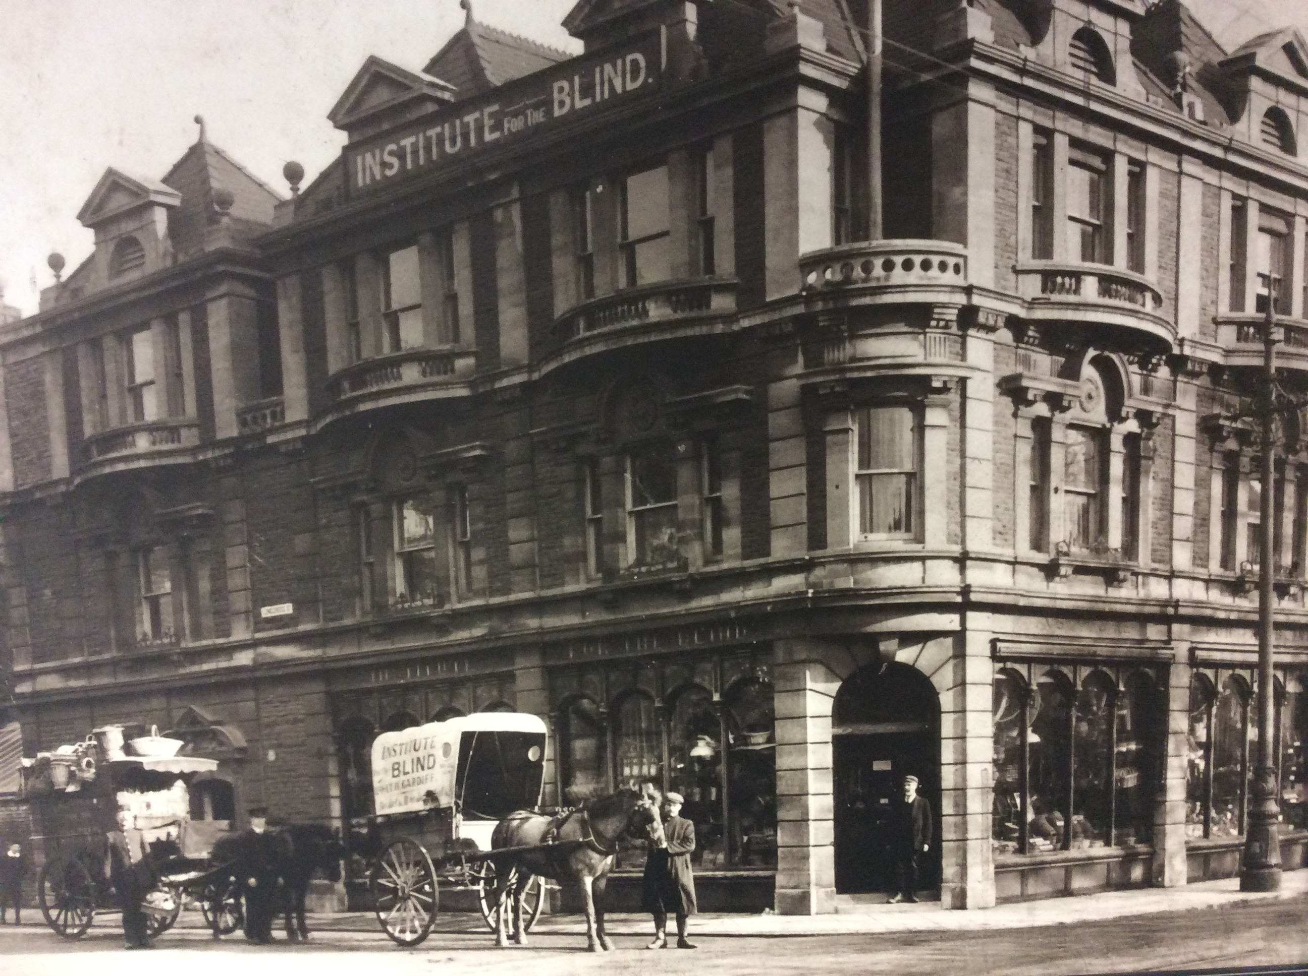

Basket weaving at CIB.



