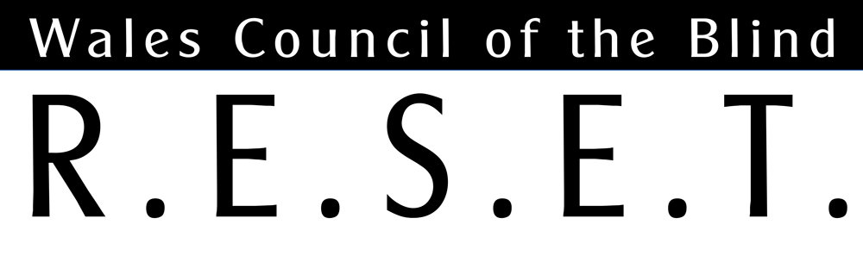

Conversations that Count
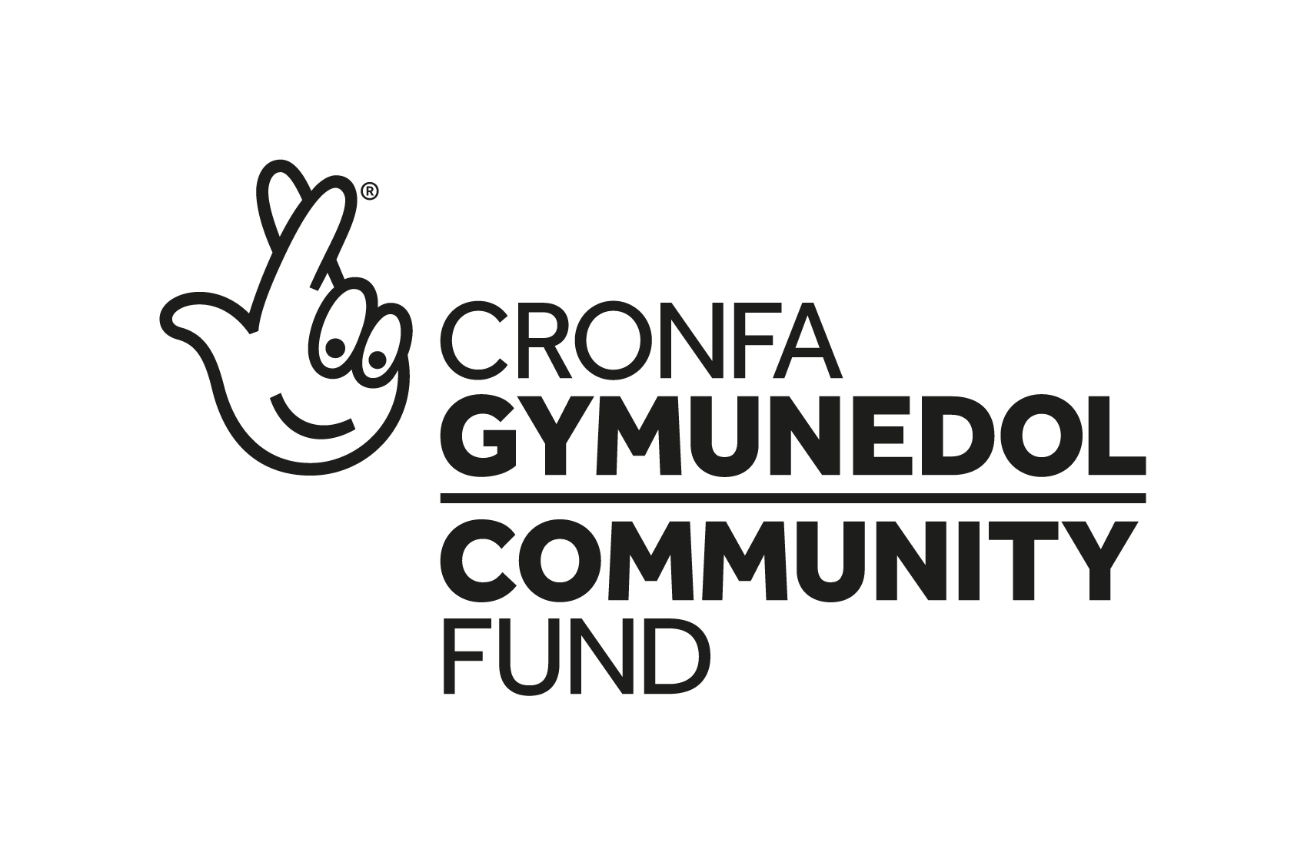
RESET is published by Wales Council of the Blind, Hastings House, off Fitzalan Road, Cardiff CF24 0BL.
Tel: 029 20 473954.
Email: richard@wcb-ccd.org.uk.
Further copies, in audio CD or large print formats, are available. All editions are online at http://www.wcb-ccd.org.uk/coronavirus.php

About this issue

Last year WCB put Frame Collective in touch with blind and partially-sighted people who would wish to contribute something to their publication “Conversations That Count” – a look at what people from three communities had to say about their experiences of the pandemic. We reproduce their conversations with people with sight loss here.

Conversations That Count

Conversations That Count is a narrative research project that explored three different communities’ experiences of Covid-19—communities whose voices are often less heard and whose experiences are often under-represented in mainstream narratives. We spoke with young people with complex lives or additional needs, refugees and asylum seekers and people with sight loss. This narrative tells the stories of people with sight loss.

The conversations took place over autumn and winter 2020 and the narratives, vignettes and illustrations were published in March 2021. The project was developed by Frame Collective CIC and made possible by Emerging Futures funding from The National Lottery Community Fund.

Interviews: Rosa Robinson and Michèle Aitchison.
Words: Rosa Robinson.

About Frame
Frame (Frame Collective CIC) is a UK-registered community interest company that specialises in people-centred research, inclusive innovation & stories of change. You can find us at: www.framecollective.org.uk

Acknowledgments
We want to thank all the people who generously gave their time and shared their stories with us. We are also grateful to Wales Council of the Blind. We couldn’t have done the project without you—thank you.

Sharing this work
You are welcome to use Conversations That Count as a resource for your own work. All we ask is that you do not alter the text or illustration in any way and that you credit Frame Collective CIC as the originators and authors of the work. The work is licensed under the Creative Commons Attribution-NonCommercial-NoDerivatives 4.0 International License.
http://creativecommons.org/licenses/by-nc-nd/4.0/

Sight Loss Narrative
In March 2020, life as we knew it changed. Overnight, we went into lockdown, and social distancing came into force. We all had to adjust to a new world and new ways of doing things. For people with sight loss, the changes Covid-19 brought were especially challenging. As Suzanne describes: “The difficulties Covid presents are magnified by being visually impaired.” Still, blind people's experiences (and indeed, many other disabled people’s experiences) are underrepresented in society and mainstream narratives about the pandemic.

We worked with Wales Council of the Blind to identify people within their community who wanted to share their pandemic experiences. In autumn 2020, we spoke with fourteen people with sight loss, aged in their twenties to seventies. Everyone's stories and circumstances were different, but many of the struggles were similar. How people have coped has varied widely and seems to depend on sustaining connection with others, accessing support and maintaining some independence. Some people are better resourced and more resilient than others.

Loneliness and isolation were prominent topics of conversation. For some people living alone, the pandemic has reduced social activities and interactions to almost nothing, and there's a sense of grief. For others, deep feelings of loneliness existed before—the pandemic has changed little; this is the way they live their lives. Yvonne lives alone. She misses the interactions of her regular support group meetings, but she is not confident with going online and is reliant on the TV for company. The lack of contact has made her uncertain about what the pandemic is—if it's even real. This is the sort of issue that Yvonne would usually discuss with her sight loss group. She feels disconnected without the group meetings and unsure who she can trust. At the start of the pandemic, Carys also felt unsupported. She thinks that people with sight loss were left “utterly on our own” by local government and health services.

For people like Don, who had a hectic social life before Covid-19 and enjoyed catching the bus to town and chatting with people on the street, the pandemic has been devastating. He says he's suffering mentally and feels down being confined to his house. Matthew misses the camaraderie and support of his blind cricket team. Not seeing his teammates makes him realise how much their emotional support is missing from his life. Suzanne also recognises how much psychological support her friendships and activities give her. She feels lucky that she can enjoy socially distanced sea swims with intrepid swimming friends: It makes her feel resilient, she says.

The pandemic has limited people’s ability to get about as they used to and has made them reliant on others for transport and doing day-to-day tasks safely. Jenny has found the loss of independence tough to live with. She tells me that her response to losing her sight was to be as active as possible—it made her feel more in control and made life feel more normal. Now, that's gone. Joanne tells me that the pandemic makes her feel like she did when losing her sight—she "felt helpless”. Not being able to catch a bus regularly and be independent has made her go back to a place of feeling stuck and fearful about making bus journeys in the future.

However, the lack of opportunities to travel helped some people appreciate nature and feel grateful for small pleasures. And the lack of traffic heightened people’s experiences of sound. In the spring and summer, people spent more time outside, noticing birds singing and bees buzzing. For Kasim, taking a new route along the river provided a highlight in his day—a time to feel calm and reflect. For Gruff, the sound of his two young granddaughters playing together in the garden brought him great joy: “It lifted my spirits.”

Covid-19 safety measures to ensure social distancing, like one-way routes around cities, towns and shops, made getting around independently tricky for many people. And not only difficult but unsafe. Matthew described how the extension of cafe seating across the pavement in his local area resulted in his guide dog leading him into a road. For Suzanne, the danger was other people. When Wales was still 'open for business', an influx of holidaymakers made her local town feel very unsafe. Suzanne describes how she couldn't see well enough to keep a distance from people, and they just didn't get out of her way. For Rhiannon, her local environment's rapid changes made her daily walks in the park feel dangerous and caused her anxiety. "Suddenly there were all these bikes. People went out and bought bikes and were riding them along the paths, not thinking about who else might be using that space. They wouldn't ring their bells; they'd just suddenly be there."

Changes to shops have been challenging too. Before the lockdown, Zoe said she was happy going out and about but now has increased anxiety about going to shops if she doesn’t know how they’ll be laid out. When restrictions were reduced over the summer, Zoe went to her usual coffee shop. They'd changed the queuing system and process and hadn't put up prominent signage. She felt embarrassed when people accused her of queue jumping and now thinks it's probably better to avoid going places unless she's sure of the layout. She doesn’t want to be shouted at. In a similar situation, when asking about ‘Track and Trace’ information, Maggie was told, “There are signs on the door,” even though she was there with her guide dog. “He can’t read!” she laughs with exasperation. And in other circumstances, like going shopping, conspicuously highlighting their sight loss with a cane or a magnifier has felt like a necessary but uncomfortable way to avoid being criticised for picking up or getting ‘too close’ to produce. Suzanne says that, no matter how her cane makes her feel, she has to use it these days: “It feels like I am labelling myself as having a disability, and I don’t like that.”

For many people with sight loss, the pandemic required adjustments to work and home-life. Home schooling proved problematic for Matthew, who talked about being unable to access his children’s learning portal to see the work they were set. It made him feel like a failure as a parent.

For some, the shift to homeworking was “seamless”, but it was challenging for others. Employers’ support and their understanding of peoples’ needs varied widely. While some people were provided with appropriate equipment and support from day one, others were left trying to use hardware and software that was incompatible with screen readers. On the whole, though, the shift to homeworking has removed the anxiety of daily commutes on public transport and created a better work-life balance. As Jane explained: “As a person with a visual impairment, I always felt I had to work harder to make up for my disabilities, and that meant doing longer hours.”

For many, getting online has been a lifeline. Weekly quizzes and FaceTime calls have enabled contact with friends and family, but accessing online services isn’t always straightforward. The technologies and websites don’t always work well for people with sight loss. Websites may not tell screen readers that passwords need to contain mixed-case letters and numbers, and web chat support is often difficult to find on the page. For Kasim, these problems meant being unable to access his online banking or customer support. It made him feel worried and financially vulnerable.

Although it’s clear that many people have struggled during the pandemic, it’s also striking that there’s a great deal of resilience and determination to thrive, despite challenging circumstances. When I ask Kasim what he thinks contributes to his positivity, he says simply: “My sight loss.” For many of the people we spoke to, their sight loss gives them perspective and a toughness. They’ve already learnt how to adapt, how to live well, and how to be independent. For them, the pandemic is just another challenge to deal with. It seems like no coincidence that the most resilient people seem to be those most connected and active in their communities.

Sustaining a sense of community has been invaluable and supporting others has provided mutual benefit. Gruff, who attends a visual impairment support group in Merthyr, has been phoning group members to find out how they’re doing. It’s been an excellent way to keep busy, feel needed and support others in difficult circumstances. Joanne and Don say calls like these, from other people with sight loss, can feel like a lifeline; they make you feel less alone.

There is great appreciation for the sight loss groups and charities that provided timely advice and support throughout the pandemic and lobbied for more inclusive consultation and provision. Matthew recognises that, in a situation like the pandemic, fast action is needed. Still, he is frustrated about how little emergency measures meet the needs of blind people. “It seems like people feel they can neglect their obligation to equality because what they can do is limited by the Covid restrictions. But once you make it safe, you have to make it equal and accessible.”

Vignettes

Suzanne
Suzanne is out walking her dog when I call. Accompanied by the sound of crunching gravel and birds tweeting, she tells me that she’s found the pandemic hard:

“It feels like there’s no end in sight…I’ve had to recalibrate to the ‘new normal’, and it’s taken a while to get my head around.”

“In many ways, it hasn’t changed life, but the difficulties Covid presents are magnified by being visually impaired. Things like the difficulties of shopping or going into shops, ...it just adds a layer of awkwardness.”

Suzanne is registered blind. She has no central vision but patches of peripheral sight. Before the pandemic, Suzanne regularly went shopping with her mum, but her mum is shielding and doesn’t want to go out.

“That simple pleasure of doing something spontaneous isn’t there now. It's really a little thing, it feels really trivial, but it's something I miss. It's not catastrophic, it's just the lack of spontaneity because I am reliant on people taking me places. The people who I normally go places with are more limited, and the options of what we can do are limited as well.”

When the lockdown eased temporarily, during the summer, Suzanne was able to get out more. Still, she realised that her local area, near the Wales Coastal Path, had become very busy with holidaymakers, making getting about tricky.

“It was so full of people. It was difficult to navigate and difficult to keep away from people. Wearing masks in Wales wasn’t compulsory. That felt dangerous, especially when you cannot control the risk and protect yourself—people on holiday were busy enjoying themselves. They weren’t getting out of the way. It’s hard being reliant on other people to keep you safe.”

Suzanne has a symbol cane, which she prefers not to use, but felt she had to indicate to people that they needed to keep away from her, as she couldn’t stay away from them. Suzanne took the cane with her when she occasionally ventured out to the shops. Mostly, she said, to explain why she was picking up produce and using a magnifier to look at it:

“I just took the cane so they wouldn’t shout at me.”

Suzanne hadn’t used the symbol cane much before Covid-19. She is uncomfortable about using it because it doesn’t make her feel good about herself. But she felt like she had no choice. Mentally, it was a significant shift for her:

“No matter how it makes me feel, I have to use it. It feels like I am labelling myself as having a disability, and I don’t like that. It’s all about acceptance and who we think we are, and the judgements people make about you.”

For Suzanne, it’s not just sight loss that has made life more challenging during the pandemic but other people’s perceptions of her. She describes it as a layer of complications that make life harder than it should be—a feeling of loss of independence and frustration.

Suzanne has felt annoyed with herself about not being able to do things. But she also feels fortunate. She likes where she lives, feels secure and has plans for her future. Before lockdown, Suzanne was job hunting. And although finding job opportunities is trickier now, she still feels optimistic. Her voluntary work with two charities has kept Suzanne busy throughout the pandemic. It has also buoyed her spirits and made her feel needed.

Another essential factor in Suzanne’s resilience is the sea. Eighteen months ago, Suzanne set up a wild-swimming group, which has made a “massive difference” to her mental health and how she’s coped throughout the pandemic:

“I’d be in a much worse place if it wasn’t for regular dips with my friends—it’s one of the best things I’ve ever done. And it’s been a great support network, especially for members of the group who live alone.”

Although she can’t see much detail, Suzanne describes how being in the sea gives her a new perspective on the land. But the feeling of the sea and the sounds of the beach are the most significant things:

“Sometimes the water is very silky and soft, and sometimes it’s like swimming in a washing machine. When it’s rough, you come out feeling like you’ve had a spa treatment.”

“If I’m a bit late getting down there, the sound of the chat and the people laughing on the beach...there is so much laughter. You know, it is completely joyful…and people’s reactions when they get in the water, the shrieks and the laughing.”

Suzanne tells me about a line from the book ‘Wintering’, that stuck with her when she read it because it’s how she feels about sea swimming:

“Doing a resilient thing makes us resilient—and it makes us feel resilient.”

Matthew
Matthew works for a charity. He was furloughed at the start of the pandemic and then worked reduced hours on flexible furlough. It was a double-edged sword:

“One of the most difficult things was working reduced hours because the amount of work didn’t decrease. It was actually a blessing because it allowed me to look after my two girls while my wife worked full-time. It's allowed us not to have such pressure on the family dynamic. At the start of the pandemic, we were both trying to work full time with two children at home, and it didn’t work at all.”

Working from home was also tricky because Matthew’s employer took a long time to provide him with the equipment he needed. Matthew is registered blind and needed a laptop that would work properly with a screen reader.

“Without getting too technical, there are bits of your computer that run the graphics, and you use those chips to run your speech or your screen reading technology. Then they [his employer] said everybody's going to use Microsoft Teams. That software wanted to use that part of the computer, which then interfered with my ability to actually read the screen information. So, I no longer had the equipment I needed.”

“The IT department sent out equipment that wouldn’t work, and you have to try and use it for three weeks with remote support. Eventually, you get the right specialist. They look at the computer and say, ‘This is not capable of running your software.’”

We talk about the impact of the pandemic on Matthew’s life and his well-being. He describes how he’s sometimes struggled to cope and has felt like he’s failing as a parent:

“I know that a lot of people have been affected in terms of mental health and I’m definitely struggling.”

“I felt like I couldn’t parent and, as a blind parent, I experienced quite a lot of guilt. I feel that I'm not able to offer the full range of experiences to my children, and that can weigh quite heavily when I’m not able to do some of the parenting things I want to do.”

“And then, when we entered into a period of severe lockdown, where we can only leave the house for an hour, I'm trying to find a way of exercising children and exercising a guide dog and, within the house, trying to keep the family dynamic. I really felt like I couldn’t parent. So of course, then you start getting into a sort of defeatist frame of mind that plays on all your inadequacies…most days have been quite difficult.”

“I’m sure many visually impaired parents have found it hard. You feel useless because all the mechanisms the school uses are pretty much inaccessible. They are not designed for blind and partially sighted people to use.”

“I managed to get one of the Google Classroom things on my iPad, but it wasn’t foolproof. And they issued a spelling bee for my daughter, who’s eight, but they didn’t email that to me so I couldn’t help her. It wasn’t on my machine, so I couldn’t read it. And there’s not even an online group for blind parenting in Cardiff, so you end up asking your mate, ‘How do I do this?’”

“The other thing is that your own children know all the buttons to push. They know how to get out of work. They think, ‘if I fight with my sister, it might stop you from making me do my spelling.’ And that brings me back to those insecurities—that I’m not a good parent. I’m holding my children back.”

Matthew is part of a support group and feels fortunate that he’s been able to get help and support from people in a similar position. He says:

“I think without the group things could have been a lot worse for me. Talking to someone who has experience of your situation and can offer you an alternative perspective—that helped me when I was going through the most difficult situations.”

Moving to Zoom for group meetings was tricky at first.

“We had trouble getting ours up and running and getting regular meetings has been good for many people, because it provides a sense of normality.”

As well as being a source of enjoyment, another vital source of support in Matthew’s life is cricket. He is part of the England and Wales blind cricket team.

“We don't think of it as a support group. We come together to play cricket but, actually, we get amazing support from each other, and a lot of bonding happens.”

In normal circumstances, the squad of players would meet up several times throughout the summer and a few times in the winter—about once a month—and go on tour. This time last year they were in the UAE, playing against Pakistan.

“Some of these guys are my best friends, and I'm just not seeing them. I'm finding that quite difficult.”

“I used to make a podcast for the guys in the squad but, because of lockdown, I’ve been too busy. And that makes it difficult for others to cope. They miss that mechanism I’d usually supply—just little in-jokes and usually something about mental health that kept us together as a team. I just wasn’t able to keep that up.”

The restrictions around travel and social distancing requirements have been tough for Matthew because they’ve made it difficult for him to maintain independence.

“Bus journeys have become more difficult, and it’s harder to get people to help you as a blind person because people are concerned for their own safety. And if you know that you're probably going to need some help but you’re not going to get it, why would you leave your house? I’ve learned there's a lot of people struggling with that kind of thing at the moment.”

“A lot of supermarkets aren’t able to offer their usual ‘sighted guiding’ because it’s within two meters.”

“If you can only go out with assistance, and you can't get the assistance, then you worry about going out, and then you probably don't go out.”

Matthew does venture out, though. He has a nine-year-old guide dog called Duke. Unfortunately, the partnership between Matthew and Duke isn’t what it once was. The situation is causing Matthew concern.

“I've got a lot of worry and anxiety about that. Guide dogs typically retire between age nine and ten, and the partnership with my current dog is really slowing down.”

There are difficulties in moving dogs around and training them because of Covid-19 restrictions. As waiting lists are getting longer, so is the amount of time needed to deliver a new guide dog. Matthew is worried that he may be without a dog for a while, and there are other considerations too:

“Even if I got a brand-new dog tomorrow, it actually takes about a year to build the foundation of your partnership.”

“And you’ve got to think about the dog. On the school run, for example, it could be horrendous for the dog with kids running around in every direction and scooters and skateboards rolling around, or parents with pushchairs…everybody's in a rush to run in and drop off. For a brand-new guide dog, that’s a lot to cope with.”

As well as having less trust in Duke’s guidance these days, Matthew has noticed that getting around throughout the pandemic has become more difficult.

“There have been so many more cars parked on pavements, which has been dangerous. We train the dog to give us space. So the dog will often see a small space next to a parked car and thinks, ‘I can’t get us both through there, so we’re going to have to walk in the road.’ And that’s such a dangerous place for us to be, in the road, in traffic.”

It wasn’t only parked cars that created problems navigating local routes though. Local authorities made changes to the built environment enabling cafés to open across pavements and implementing pop-up cycle routes.

“I understand that they’re using every solution to keep people safe from Covid-19, but they’re not thinking about how people with sight loss interact with the changes and what that means for their safety.”

For Matthew, the pandemic has highlighted how often people with disabilities are not included or appropriately considered, and their needs overlooked.

“It seems like people feel they can neglect their obligation to equality because what they can do is limited by the Covid restrictions. But once you make it safe, you have to make it equal and accessible—I’d march with that on a banner.”

Matthew tells me that, back in April, he felt optimistic. And although getting through each day was tricky, he was sure that:

“If we have this pain now, we will be ok later.”

“But of course, we’re not ok. Then, no one would have believed we would be in a situation now, in October, where we’re in the firebreak [lockdown]. We've all got weary with the restrictions and changing timelines. The virus is still quite prevalent. I'm struggling to see an immediate way out.”

Matthew is finding it hard to think about the future. His focus is on getting through each day to do it all again tomorrow. He was diagnosed with Covid-19 back in April. Matthew tells me that he had to focus on a day at a time:

“It got to a point where breathing was hard enough to think about. And even now, I slip into that way of thinking. Just get through. Try again tomorrow.”

Kasim
Kasim begins our conversation by apologising in advance for his positivity. He describes his experience of Covid as “seamless”—mostly because of his employer’s response to the pandemic. He tells me:

“Work have been incredible; they’ve been proactive. They've put health and safety first, and they’ve made our health and well-being a priority. They said that for anyone who has to use public transport to get to work, ‘we will have your desk shifted home’. And we will do everything we can to ensure that you're as comfortable as possible in your home to enable you to work from home.”

Kasim is registered blind. Work is an essential part of his life. His employer’s response to the pandemic has made him feel needed. It has enabled continuity of routine in his life and, in turn, reduced feelings of stress and anxiety. But Kasim is a sociable person, and he misses the daily interactions that comprised his working day:

“At the station, I know the ticket desk staff by their first names. When I jump on the train, some of the guards recognise me, and I’m on first-name terms with the people on the train station at the other end too. I have a wonderful rapport with them. And with the taxi drivers. I'm a very socially active person. I really enjoy engaging and talking with people. It makes them feel special, you know, that's a nice thing to do, to put a smile on someone's face.”

“I am very outgoing. And the only point of anxiety was that I felt unsure how I would cope working from home, how much I would miss going to work.”

But Kasim adjusted quickly. He feels fortunate to live in a house with a separate room, where he’s been able to set up a desk and screen. He misses things about his ‘normal’ life but feels that the situation is short-term, and that life will get back to ‘normal’ before too long.

In the meantime, Kasim’s been reorganising his garden to create a safe social space where he can see his family. Being together as a family is important to Kasim. But he is also conscious that his mum is almost eighty and vulnerable. The garden space has solved a lot of problems.

“We are very social people as Asians, you know, my cousins live two doors away, and they're quite a large family. Both my brothers live a stone's throw away…but we've been very observant of the rules, and regulations.”

Importantly, Kasim has been able to bring people together to pray and celebrate. The mosques were shut during Eid, but Kasim’s garden was large enough for him to safely host Eid prayers and celebrations with a few family members.

“More often than not, I go for Friday prayers at the local mosque. We have Eid prayers twice a year, which is a wonderful opportunity to catch up with old friends that I haven't seen. I’m not going to focus on missing that though. Let's be hopeful and have our fingers crossed that mosques and other social areas will open soon, and we'll all be able to catch up with friends again.”

When I ask Kasim if there’s anything he thinks contributes to his positivity, he says simply:

“My sight loss.”

He talks about his sight loss’s devastating social impact and how it made him feel unneeded, invisible and isolated. He described his life as a married man, a father to two children, and a respected member of his local community.

“It was difficult to understand how to overcome…I expected people to gravitate to me, and they didn't. And I think the hardest thing was the thought [that], if people are not gravitating to me, then I have to gravitate to them. Because I felt I had to reach out to them. Because they just left me alone.”

Reflecting on his experience, Kasim says that he’s almost glad that people didn't come to him because it meant he had to get out on his own and find people.

“So the sight loss hardened me emotionally, emotionally, it still affects me...but I don't allow it to…fester…because I feel that will drag me down…and I'm going to fight this battle. I’m going to do my best to make sure that I just continue on the path and not allow things to affect me. So my sight loss has helped me really. It has been an amazing journey.”

Kasim believes that it’s important to try to stay optimistic and patient:

“I feel that we have lost patience, very quickly, and tolerance as well. Because we're not used to it, you know, we're a pampered society. And we expect things to be done, and we just throw money at problems and for them to be fixed. This is a different dynamic now. And I think a lot of people don't know how to deal with this.”

“The most sensible thing is always to be hopeful; never lose hope.”

Friends are a central part of Kasim’s life. He tries to buoy people and offer them hope but also recognises that these conversations give him strength. Although getting connected using new technologies can be tricky:

“When the first lockdown happened, one of my nieces decided to organise a quiz. And then we did it every Sunday. So the entire family would get together...there's about 20 of us all together. And we'd all Zoom-in. And we'd have a fantastic time. You know, it was absolutely wonderful. But for me, it's all incredibly new.”

“Once it works, it's absolutely fine, but it can be stressful when I try to log on to Zoom independently. I am asked for passwords and numbers and everything else. And that isn’t as straightforward as it could be. Sometimes, depending on how the call was set up, I had to type in a particular number, a user ID, and that was a bit challenging. One of the passcodes is a mix of letters and numbers, and it doesn't tell you when it needs to know whether it’s lowercase or uppercase. And I'm a bit stubborn. I don’t want to have to ask for help if I can avoid it.”

During the pandemic accessing banking presented concerns for Kasim:

“I couldn't access the app for some reason. And I needed to transfer some money, but I couldn't. So I called the telephone helpline. And I think I was on hold for two hours, and there was still no answer. I think it might have been two, maybe three hours. And that was a little disconcerting because I felt helpless, and that makes you feel quite vulnerable.”

“I know some people can access web chats and things like that. But for me, it's difficult to access those kinds of things. Because more often than not, on a website or on the phone, webchats are a button in the corner that you can’t see—it's never really labelled as ‘this is a webchat here; you can click on this’. So that was a time during the pandemic I felt vulnerable--financially and physically vulnerable, because, you know, I have to put food on the table. And I just thought, how am I going to overcome this?”

Day-to-day, Kasim and his family have stayed closer to home during the pandemic than usual. Still, they have tried to keep their lives as normal as possible:

“We're limited to public transport, and so, because of that, we avoided it wherever possible. I think we've only been on one bus in the last eight months. But we've continued to go to the local shops.”

“I did not change my routine a bit. So I took all the precautions. I took all the necessary guidance on board but tried to keep everything as normal as possible.”

“I use a white cane, and I keep it outstretched. So as I'm walking, people automatically deviate from me.”

But Kasim feels that important messages about being considerate when you’re out and about have been missing:

“If someone’s using a long white cane or has a guide dog, or is using a wheelchair, or whatever else, people need to be considerate.”

“Sometimes, people feel too anxious, awkward or unsure to help. They forget that there’s a person behind the white cane.”

He also recognises that Covid-19 has made getting and giving help more difficult:

“What tends to happen with me is that, if I need help or I have lost my orientation, I’ll ask someone for help. More often than not, they’ll grab me by the arm and point me in the right direction. But at the hospital recently, this one chap read the situation, but he wanted to keep a social distance. I could just see his arms waving all over the place. So I just said, ‘that’s great’ and thanked him. And I waited for the next person I could ask for help. That person had a mask on and guided me by the arm. It was all fine.”

When I ask Kasim if Covid has changed his world in any positive ways, he describes how new routes, sounds and activities have brought him joy and peace:

“A new thing for me has been the walk to my daughter's school. We’ve found a route along the river. And it's a beautiful walk along the river, on a tree-lined road. It's very calming and relaxing, and it removes anxiety. It's a very pleasant 40 minutes commute to and from my daughter's school.”

Kasim tells me how the sound-scenery of his world changed over the pandemic as traffic lessened and then increased again:

“It got to a point where you even lost your context of what day it was. You didn't realise what day it was because, for us, no cars automatically meant Sunday morning. So it’s Monday, and you still have no cars, you know, you're double backing on yourself almost. We went through a phase where we just didn't know one day from the next day.”

“The other thing we noticed during the lockdown was the birdsong. Sitting in the garden at home, there was a different kind of quiet, filled with bird songs. And that was exciting and lovely. It just shows you how calming it can be, without all the unnecessary sort of rattling noise that goes on with cars racing up and down and whatever else.”

“I think what it demonstrated is that we can adapt. You see a lot more people now on bikes than ever before. At the school my daughter goes to, we were encouraged to walk to school. I really enjoyed it. I love the commute; I love the change of atmosphere. You know, we have wellies, and when we are geared up for the rain, it's lovely. It's a wonderful privilege.”

In terms of his hopes and plans for the future, Kasim feels it’s essential to focus on compassion, empathy, and action. He knows how important it is to look beyond first impressions, connect with people, and recognise that we are all fragile. We need each other, and we can help each other.

As we exchange goodbyes and our conversation draws to a close, Kasim adds:

“You know, I did apologise at the very start because I know a lot of what I said was quite positive...but that’s really just the way I try to get through life.”

RESET is published by Wales Council of the Blind, Unit 2.2, Hastings House, off Fitzalan Road, Cardiff CF24 0BL.
Tel 029 20473954

