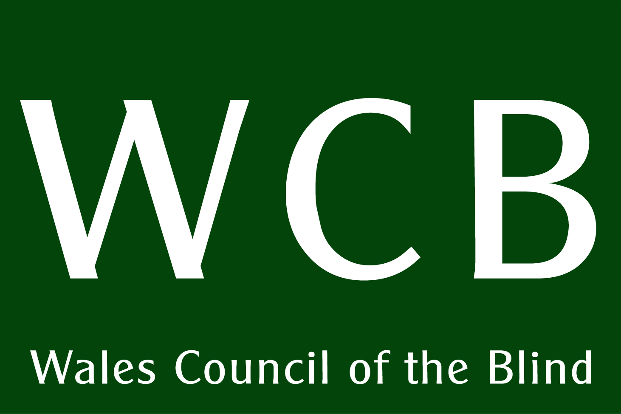

Making meetings accessible for people with sensory loss.

1. Basic principles.

Accessibility is a right for disabled people. Also, failing to address the access needs of people with sensory loss means - at a pragmatic level - failing to get views or contributions from an important section of your audience.

People with sensory loss are a rich and varied group of people. There will be different levels of sight loss and types of sight, and different levels of hearing loss. There may be combinations of both sight and hearing loss. Some people may have been born with sensory loss or may develop it late in life, or anywhere in between, in varying degrees, sometimes progressively, sometimes overnight. People will prefer to use digital access to information: emails, Word documents. Some will prefer large print, audio, Braille. Some will need the use of a British Sign Language interpreter or perhaps rely heavily on lip-reading. These choices often arise from decisions made for them when they were young or may arise from socio-economic and cultural circumstances. Age, for instance, may have an impact on computer literacy or may reduce the likelihood of taking up Braille. Many Deaf people cannot understand conventional print but are fully able to understand complex ideas through BSL and express them through speech. There is no one-size-fits-all solution to communication.

This document aims to guide you through some of the considerations when making meetings – online, via telephone and face-to-face – accessible for people with sensory impairments.

2. Guidance for chairing meetings.

A strong chairperson is essential for making every person know that they are able to contribute equally to a discussion. This will mean allowing for BSL interpreters to keep up with the discussion so that Deaf people are not left behind. The Chair should keep an awareness of disabling practices being used excessively, such as visual modes of communication that disadvantages a blind or partially sighted person.

People must be allowed to use different methods to indicate their intention to interject. Be mindful that BSL users might be slightly behind in the conversation, or that vision-impaired people might not register a facial gesture that indicates that someone has finished talking. There is a risk in both of these instances of sensory impaired people being ‘trumped’ by others whenever there is a chance to speak. A good Chair will notice these moments and ensure that everyone has the opportunity to contribute.

Ensure that people introduce themselves and their organisations at the start. There may also be a need, in some circumstances such as large meetings, to name the person before they speak, to aid people with sensory loss.

Chairing online and telephone meetings is perhaps more complicated. Don’t assume that everyone is skilled at using the technologies available, such as the chat room. Some people might wish to indicate their intention to speak by raising their hand. Some will use the chat room. Some may use brute force. Whichever method is used, the Chair, or an assistant, needs to keep an awareness of these and act on them. There is more on online meetings below.

3. Accessible meeting papers.

A meeting cannot be accessible if the papers being used within it are not accessible. This is how you can make them inclusive.

Use numerical indexing.
One of the benefits of minutes of meetings (and other legal documents) is that they are often indexed numerically. Instead of references being made to pages or headings, it is more likely to refer to point numbers. This makes an improvement in access for people with print disabilities. Therefore, try to maintain this approach and apply it, where possible, to supporting papers, such as discussion papers and, importantly, make use of them during discussions.

Word processing.
With a range of supporting technologies now available, it makes sense to write papers in a format that is easily portable to other formats. A document written plainly (without tables where possible) in a word processor such as Microsoft Word, can be easily transformed into Braille, speech, enlarged text on screen and printed page and web pages (HTML).

Heading levels.
Try to use the correct heading levels for each heading. The main heading should be Heading 1, while the other headings should be labelled hierarchically so that sub headings (Heading 2) and sub-sub headings (Heading 3) and so on are distinguishable. In HTML (web pages) this is achieved with the <h1><h2> etc tags. In Word, it is achieved through the style sheet settings. In this document, the main heading is Heading 1, while all subsequent headings are Heading 2.

Colour coding.
Avoid colour-coding parts of the document (eg. red/amber/green status colours). If you must use them, combine them with the appropriate words.

Track changes.
Avoid using the 'track changes' function within MS Word for collaborative working. This is not accessible to many people. It is better to mark changes within the body of the document with square brackets and initials, for instance, or some other agreed protocol.

Avoid tables.
Try to format minutes using tabulation (tabs) rather than tables. This is because some speech engines do not navigate tables very well. Also, Braille tends to be limited to a number of characters in a line that does not translate table data very reliably. So, action points, for example, are better placed underneath each item rather than in a column at the right.

Justification.
Align text to the left and leave it ragged to the right (left justify, in other words). This enables people to differentiate the lines easier.

Don't rely on PDF.
Papers in PDF format often cause problems for speech engines. This is sometimes caused by the ‘conversion software’ treating formatting marks differently. The results can be unpredictable for speech engines, such as rearranging the order of the text, or treating each line as a separate paragraph.

Not just email.
Requests for specific formats, such as large print, Braille or audio, should be met. Although many people now receive meeting papers via email, this is not always practical for the recipient. (There are agencies that can help with conversion into other media – contact Wales Council of the Blind for advice).

Customise the format.
If material is sent out in the post in print, efforts should be made to customise the font size and paper colour where specific requirements have been specified by the recipient. Someone may ask for 24 point Times New Roman on yellow paper. This will be a job of work that often gets pushed aside over more pressing matters, but it is important if you wish to ensure full access and avoid criticism.

Minimum font size.
A minimum font size of 14pt is recommended where specific requests have not been made. Individual requests should be met, of course, and is not uncommon for font sizes of 24pt or more to be required.

Font styles.
Avoid cursive fonts. Arial, apart from some unclear areas, such as there being little to distinguish an el (l) from a capital 'i' (I), is good as a sans-serif font.

Don't leave it to the last minute.
With the pressure of getting things done to short timescales, it is common to find papers being brought to meetings that haven't been prepared for other formats. Indeed, they may not have been circulated via email prior to the meeting. Avoid this as far as is practicable. It is truly disempowering to be excluded from the information being passed around the table. If it is unavoidable, then make sure the content is read out if it forms part of the discussion on the day. If it is not to be discussed, then apologise and make sure they are sent on in the right format after the meeting!

Powerpoint.
Powerpoint presentations require describing fully. Don't rely on everyone reading the points off the screen while you talk. If it's important enough to be put in a bullet point, then you'll need to read it out loud. Also, if giving the presentation as handouts, think about how accessible these are and remember that you are disadvantaging anyone who is unable to follow these during the presentation. A plain word-processed version of the content should be available as a more accessible format for handouts, which can be converted to other formats such as Braille or DAISY when sent electronically.

4. Accessible presentations.

WCB hosts conferences at which one or more people with sight loss will be present. This sight loss ranges from total blindness to a variety of eye conditions that inhibit access to the material being presented to the audience, including hand-outs.

There are a number of things we would like presenters to do to communicate effectively to blind and partially-sighted people:

Read and describe: Don’t assume the on-screen text is being read by the audience – some may not see it at all and some with difficulty. Read the bullet points as part of your talk. Describe any diagrams or charts: a bar chart may seems obvious to many but some individuals may not be able to see it. If the figures are important, read them out in a structured way.

Keep the presentations visually clean and simple. Avoid fussy layout and too many bullet points per slide. Ideally, make the text large, static and in black on a white, or very light, background. Try not to lay text over a background image. Avoid animated text effects (other than simple ‘appearing text’ techniques).

Videos in presentations present obvious challenges to blind and partially-sighted people. These challenges are increased by the fact that the presenter has no control over the pace and flow of the narrative. There is not the normal opportunity to interrupt the narrative to ask a question or seek explanation. Bear this in mind when using fixed media.

Avoid the use of visual cues and gestures: For example, don’t point to items on the screen and assume that the audience knows what you’re referring to. Try not to talk with your hands.

Ask people to identify themselves during Q&A sessions. This helps blind and partially-sighted people to understand the context of the question and discussion.

Avoid using hand-outs unless they are truly necessary.

If hand-outs are required, please make them available in a range of formats: large print (18pt and 22pt black on white unless specified otherwise); audio CD, Braille. These formats can be produced by Wales Council for the Blind and would generally need to be ordered at least a week in advance.

It is often helpful to make your presentation available after the conference. If this is possible, let the conference organisers know that you will make a copy available.

In general: Try to find out if any of the audience has particular requirements with regard to access to your presentation. Do this by asking the conference organisers either before or on the day. This information will help you to tailor your presentation to the specific needs of your audience.

5. Online and telephone meetings.

Zoom, Microsoft Teams, Skype and other platforms are becoming popular ways of holding meetings. They have the advantage of transcending geographical barriers, which might be a considerable advantage for some communities of interest. However, apart from some technical problems associated with sensory loss, there is a clear impact on communication in its broadest sense. The usual protocols employed in face-to-face meetings have to be extended to allow for technical limitations imposed by the medium. Furthermore, the casual benefits of face-to-face meetings are limited by the formalities imposed by new technology: chatting in the breaks; having one-to-one conversations; in short, the parts of meetings where the interesting work is done! These meetings are structured along more proscriptive lines – some people prefer that, others feel it reduces flexibility.

Consideration should be given to the availability of the technology. Not everyone is digitally enabled and, where they are, that technology shall vary from person to person. Some people will use laptops or desktops, some will use landlines and mobiles. This is true of disabled and non-disabled people alike. So, to make such meetings fully accessible, you must make inquiries with participants into what can and cannot be achieved. For instance, it may be necessary to allow participants to dial-in via telephone wherever possible.

Some people will access text on-screen using text-to-speech software. First of all the software will, depending on the product, have varying degrees of access to the platform being used in the meeting. For instance, the chat room may not be accessible or, if it is, the user will be listening to two streams of speech at once. Therefore, if you have a participant using text-to-speech, it may be a courtesy to limit the use of the chat room to, for example, requests to speak or posting links to resources.

Where a meeting is to be accessed by a web link, make sure that there is an active hyperlink to the meeting and that the underlying address is visible in case it needs to be typed into another device. Also, passwords would ideally be in lower case without too many additional characters such as underscores. This is because screen readers often do not differentiate between upper and lower case and the additional characters are not always easy to locate.

Preparation.

At the earliest opportunity, liaise with the Deaf or blind/ps persons involved in the meetings.

Request names and contact numbers of interpreters to contact. These details are important to ensure contact can be reestablished when things go wrong, and to establish any requirements up-front.

Liaise with interpreters re availability, secure the time-slots with them and make this the date of the next meeting.

Check with participants as to their technical requirements: do they need papers/presentations in large print or another medium in advance; are they able to use the chosen meeting platform? The important thing is to ask early enough to ensure that the right support is in place.

If this is one of a series of meetings, it would be prudent to arrange a series of dates, so that everyone can put these dates in the diary as a pre-booked meeting, interpreters arranged so that the flow continues from meeting to meeting. Whilst most people could rearrange for a meeting to happen, Deaf people need to arrange interpreters and this is not a quick process.

Recording and transcripts.

Recording of meetings may be requested by Deaf and blind/ps participants. Deaf people may find it difficult to make notes if watching an interpreter. Blind or partially-sighted people may similarly have difficulty with making notes and would benefit from an audio recording. If video/audio recording is not possible, then an additional ‘note taker’ will be required to make an accurate transcript of the meeting.

Make inquiries with your participants well in advance to determine what is needed.

If transcripts are available, then these may prove useful, however, do not assume that all Deaf people will be able to access this version easily. Also, ensure that transcripts are shared in the formats of choice: this might involve making audio recordings, Braille, large print etc.

Similarly, minutes of the meeting may require transcription into another format. Check with the participants in advance.

During the Meeting.

Only once everyone is present should the rules of conduct be shared. While it is tempting to fill time by sharing these casually while waiting for others to join, it should be reserved as a formal introduction to the meeting when everyone is present.

The organiser or Host of the meeting should allow people to join in the following order:

  - Interpreters first.
  - Deaf people so that they can ‘pin’ the interpreters and each other to ensure clear communication throughout.
  - Then others in any order of need.

(This would be no different to a face to face meeting, where interpreters would make a point of arriving at a meeting prior to the Deaf person/s to facilitate immediately on their arrival.)

Protocols should be set by the Host/Organiser so that everyone can interact effectively:

  - Everyone in the meeting should have their microphone muted as this reduces feedback and unnecessary noise
  - Unmute only when the individual is speaking
  - The ‘hand up’ to speak tab should be used and this should be monitored by the Host. The host should also been aware of people actually raising their hand to indicate their wish to speak.
  - Other comments can be added to the Comments section such as:

            - I am leaving the meeting at 1.30pm or
            - That is a good point made by X or
            - I would like to come in on the previous point please.

These comments should be available to everyone taking part but remember that some people will not have easy access to them during the meeting, so they need to form part of the transcript. Also, the chair should ensure that a conversation, that would be interesting to the meeting as a whole, gets shared.

Names should be given prior to speaking on each occasion as this clearly identifies who is speaking and if necessary the organisation they represent. This makes it clear for everyone as on-line it may be more difficult to assess who is making comment. For people with sight loss, any names appearing on-screen may be invisible to them.

If screen sharing is used, then it can inhibit the view of the interpreter on screen for the Deaf Person, as the ‘pinned’ interpreter will go into a gallery format [on some computers] making it difficult if not impossible to see the interpreter and what is being said.

(A work around for this would be to send emails with handouts etc. so that they can be viewed on a different screen or printed for the meetings. These can be numbered to be easily recognisable for the meeting.)

Interpreters will inform when the ‘change over’ happens so that this process is smooth for the Deaf participants of the meeting.

At the end of the meeting.

The Host should ensure that all information has finished being interpreted for the Deaf participants and not just ‘End meeting for All’.

Remember that there is often a delay in passing the information in BSL and as such any information could be lost with no way to get the connection back.

Also the Deaf person may need to clarify that last piece of information and again could not do so if connection is cut.

Information for Attendees.

Some tips for improving the quality of your video connection that have been used and has worked.

- On sending the ‘invite’ to the meeting, ensure that people do not ‘jazz up’ their screens with backgrounds etc.
- Make sure you are well lit, the darker you are the more processing work your computer does. Natural light is best, but not direct sunlight and avoid harsh shadows.
- A wall directly behind individuals look better than those that have walls further in to the distance, and this is also less work for the video camera to do, which could hinder performance levels
- Plain background, plain clothes is best for being viewed by the Deaf person. Similarly, good colour contrast between the person and the plain background is helpful for people with sight difficulties.

Improving Computer performance.

- A direct Ethernet connection will help. If your laptop doesn’t have an Ethernet port you can purchase a USB to Ethernet converter fairly cheaply. However, the USB port must be USB-3 or USB-C
- Don’t be too far from the Wi-Fi router. The Wi-Fi router is not always the problem as the Wi-Fi range is usually pretty good on most routers, but the Wi-Fi range of the antenna in the laptop might be limited and struggling to respond.
- Other people watching Netflix etc. or using the computer at the same time as Video Conferencing should only have a minimal influence, as most broadband speeds exceed the minimum requirements for VC.
- However, Microwaves, hairdryers and other wireless signals can affect the Wi-Fi signals.

This document was co-written by Wales Council for Deaf People and Wales Council of the Blind. Please contact either organisation for further advice and guidance.

Wales Council for Deaf People
Glenview House,
Courthouse Street,
Pontypridd,
CF37 1JY
www.wcdeaf.org.uk
mail@wcdeaf.org.uk
Telephone: 01443 485 687
Mobile: 07572 023052

Wales Council of the Blind
Unit 2.2, Hastings House,
off Fitzalan Road,
Cardiff CF24 0BL.
www.wcb-ccd.org.uk
richard@wcb-ccd.org.uk
Telephone 02920 473 954.

